**The British College**

**KATHMANDU**

**Coursework Submission Coversheet**(individual coursework only)

**Faculty of Arts, Environment and Technology LBU Student Id:**

77202323

Please ensure all information is complete and correct and attach this form securely to the front of your work before posting it in a coursework collection box.

Award name: BSc Hons in Computing

Module code: 15781

Module name: Advance Database System (ADS)

Module run: 2020/21

Coursework title: Data warehouse Design and Development

Due Date: 22 December, 2020

Module leader: (In LBU): Jackie Campbell, Sanela Lazarevski

Module tutor: (In TBC): Dibya Tara Shakya

**TURNITIN** Checked: YES NO ***(please circle)***

Submission date& time: Date: 22 December, 2020 Time: After evening

**Total Word Count: 15350 approx. Total Number of Pages (including this front sheet): 117**

**In submitting this form with your assignment, you make the following declaration:**  
I declare, that the coursework submitted is my own work and has not (either in whole or part) been submitted towards the award of any other qualification either at LBU or elsewhere. I have fully attributed/referenced all sources of information used during the completion of my assignment, and I am aware that failure to do so constitutes an assessment offence.

Signed: Avhimanhu Sapkota Date: 22 December, 2020

**You are strongly advised to retain a second copy of your work in case of any query about the assignment.**

**For completion by the faculty:**

**This mark is provisional and subject to moderation and approval by the relevant examining board**

**Teacher's Feedback**

**Teacher's Signature: __________________________________ Date: _________________**

Contents

Task 1: Data Warehouse (DW) Star Schema Design 4

Introduction to Data warehouse 4

Identify 3-5 reports that your star schema will support. 4

Document the star schema (SS) design model to support the reports. 5

Use the data dictionary template from tutorials to document the data model of the project 8

Data Dictionary: Supports data sourcing and data integration 9

Data Dictionary: ETL required for star schema 14

Select one of the reports you have suggested. Illustrate the expected data in the star schema to support the report. 18

Task 2: Pre-processing: Gather the data sources prior to ETL 22

Collect only the data you require to populate the star schema into the data staging area 22

Star Schema Set Up (DM environment) 30

Task 3: Extract, Transform and Load (ETL) script to populate the Star Schema (DM) with data 39

Extraction 39

Transformation 51

Transformation: Bad Data Identification, Segregation and Insert 51

Transformation: Good Data Identification and Insert 60

Transformation: Bad Data Cleaning and Insert into Clean Tables 66

Transformation: Into Transform Tables 76

Loading 84

Task 4: Data Analysis/OLAP/Mining Investigation 97

Data Analysis 97

Business Intelligence 97

Online Analytical Processing (OLAP) 97

Tableau: Reports, Charts and Dashboards 97

Additional Excel Sheet Reports 107

Drilled Down Reports 109

Task 5 111

Introduction 111

Bill Inmon’s Approach 111

Ralph Kimball’s Approach 113

Key Differences between Ralph Kimball’s Approach and Bill Inmon’s Approach 114

Conclusion 114

References 116

# Task 1: Data Warehouse (DW) Star Schema Design

## Introduction to Data warehouse

Data Warehouse is a collection of integrated databases designed to support a Decision Support System (DSS). According to Bill Inmon, data warehouse is a collection of integrated, subject-oriented databases designed to support the DSS function, where each unit of data is non-volatile and relevant to some moment in time.

The prime purpose of Data Warehouse is to support decision making which will perhaps be used for evaluating future strategy. Thus, it is also used as the basics of business decision making, business intelligence solutions and data analytics dashboards and applications. It can be used to convert raw data into meaningful information which results in enhanced business and sustainable decision making, which can also be stated as Business Intelligence. It fundamentally combines information from several sources into one comprehensive database making data analysis, decision making and data mining possible. The proper analysis of data warehouse can benefit a company in product development, marketing, pricing strategy, historical analysis and customer satisfaction which further helps them to adapt changing business conditions. (*InvestingAnswers, 2020).*

Data warehouse is a large repository of data that contains information from heterogenous sources which can be used for various purposes within an organization. The data warehouse can be further divided into Data Marts in order to perform specific business-oriented analysis. Data Mart is basically a subset of data warehouse which contains prototypes of summarized data obtained, within an organization, for analysis on a specific section. (Panoply.IO, 2020)

Some more detail advantages of Data warehouse can be listed as:

* It allows business to quickly access data insights
* It helps to reduce time for analysis and visual data representations
* It helps users to analyze data from different time periods to identify trends (Guru99, 2020)

For instance, FlyU airline company, in the assignment case study, has recorded their data of flights and its details, customers, weather details and complaints. A data warehouse of the raw data of FlyU can be analysed, which may benefit them in quality service delivery, customer satisfaction and upliftment of the company by increasing sales and profits. However, data mart is concerned with the specific data analysis rather than analysing every aspect of FlyU.

Being assigned a role of an analyst/developer on a Data Mart project, we were supposed to choose one Key Performance Indicators (KPI) which were considered by FlyU airline company.As quoted by Tony Alessandra, ‘Being on par in terms of price and quality gets you into the game. Service wins the game.’ I believe that quality service is the key to organization’s sustainable growth. Thus, I have chosen KPI 1 which is concerned with the quality of their services and provide good flight experience to their customers.

## Identify 3-5 reports that your star schema will support.

After the detail study and investigation of raw data provided via detailed flight information for 2017 and 2018, weather information, and FlyU complaints system, some reports, which will inform FlyU in order to meet their business objectives being based on quality services, have been identified as follows:

1. **Total number of flights cancelled on the basis of cancellation reasons.**

One of the factors determining quality of service in an airline company is ‘flight cancellation’. Therefore, in order to improve the quality service, FlyU must be aware of total number of flights that were cancelled along with their reason. The study of such data will make them prepared and hence they can resolve the cancellation reasons before the flight gets cancelled. For instance, if most of the flights have been cancelled due to computer glitches then the company can ensure that all the computer glitches are checked and tested before every flight is scheduled.

1. **List of airlines whose flights were delayed, in the year 2018, along with the total delayed time.**

Although FlyU is an airline company, they also facilitate their customers with other associate airlines. Hence, the report will help them identify airlines whose flights are being delayed along with total delayed time. As a result, for instance, they may cancel or shorten contracts with airline companies whose flights are frequently delayed which will ensure their quality service as most airlines whose flights are usually delayed will no more be their associate partners.

1. **List of top 10 aircraft delayed due to air system delay including their delayed time.**

Air system delay refers to delay usually caused because of some mechanical issues in an aircraft. Thus, this report will inform FlyU’s concerned officials to identify ten most problematic aircraft so that they can repair, discard or manage those problematic aircraft for future flights. Proper maintenance of aircrafts always results in quality service for any airline company.

1. **Total arrival delay time for each month in the year 2018**

As delay time affects the quality of service directly, the report identified will inform FlyU airline company regarding total arrival delay of each flight on the basis of months in the year of 2018. This will help them to make decisions on total number of flights to book in those months in the future.

1. **List of average PRCP, average AWND and average TAVG of weather on the basis of quarter of the year.**

The above report will inform FlyU about the average weather data on the basis of seasons (quarter) so that they can plan the number of flights to book in those quarter of the year being based on the weather predictions and historical data to ensure less flight delays and cancellation due to weather conditions.

## Document the star schema (SS) design model to support the reports.

Data warehouse system is necessary in order to produce these reports. The foremost step to start building a data warehouse begins with designing a model of data warehouse. There are two main multidimensional schemas designed to address the requirements of large databases. I propose star schema to design the data warehouse architecture.

Star schema is a data warehouse schema in which the centre of the star can have one fact table and many other associated dimension tables.

Some of the characteristics of star schema are:

* Every dimension is represented with one-dimension table which should contain attributes.
* Dimension table is joined to fact table using foreign key but they are not joined to each other.
* Dimension tables are not normalized

The other data warehouse design methodology is snowflake schema. It is a logical arrangement of tables, which is an extension of a Star Schema where dimension tables are normalized and can be connected to each other.

Some of the characteristics of snowflake schema are:

* It uses smaller disk space during data warehouse design
* Due to multiple tables connection, query implementation is reduced.
* It is easier to implement dimension tables along with the facts. (Guru99, 2020)

Hence, I propose star schema over snowflake schema as the data warehouse designing model because it is optimized for querying large data sets to generate appropriate reports. Furthermore, it is easy to understand and provides optimal disk usages which is more feasible and applicable. Whereas, snowflake schema will have many dimension tables resulting in complex database design which will require many joins to fetch the data. Therefore, I believe star schema is the best design methodology to design data warehouse for FlyU airlines company.

The foremost stage to design a star schema is to document the fact tables, dimensions, attributes, keys and measures which have been identified as follows:

**Fact Table:** Flights

**Measures:** Flight_number (alias: flight_serial_no), cancellation (alias: cancellation_flag), departure_delay, arrival_delay, weather_delay

**Dimension Tables and attributes:**

* Delayed_Flights: delayed_flight_id, flight_number, tail_number, air_system_delay, security_delay, airline_delay, late_aircraft_delay, weather_delay, flights_airline.
* Cancelled_Flights: cancelled_flight_id, flight_number, tail_number, flights_airline, cancellation_reason.
* Weather_data: weather_data_id, weather_station, AWND, PRCP, TAVG.
* Time: time_id, month, quarter, year

The star schema model for FlyU airline company to improve quality of service:



The Star Shema above has FACT_FLIGHTS as the fact table which has been derived from the data of Flights_2017, Flights_2018 and FlyU_Flights. A surrogate key: surrogate_flight_id has been added because flights data provided did not have a specific primary key column. The measure flight_serial_no is alias name for flight_number of the provided data. It is necessary to know the flight number of each flight hence it has been added as a measure for the fact. Similarly, cancellation_flag is an alias name for cancellation data of the provided data, which stores 0 if flight was not cancelled and 1 if the flight is cancelled, which helps to ensure whether the flight was cancelled or not. The measure arrival_delay has been identified in order to know whether each flight have been delayed or not. Finally, weather_delay has been added as a measure to confirm if the flight has been delayed because of weather conditions.

The dimension table DIM_DELAYED_FLIGHTS has been derived from the data of Flights_2017, and Flights_2018. A surrogate key: delayed_flight_id has been added as primary key because the flights data provided did not have a specific primary key column. The dimension will store all the data of delayed flights including flight_number, tail_number, air_system_delay, security_delay, airline_delay, late_aircraft_delay, weather_delay, and flights_airline. All of the data has been added from the data sources provided however, flights_airline is an alias name for airline provided in Flights_2018.

The dimension table DIM_CANCELLED_FLIGHTS has also been derived from the data of Flights_2017, Flights_2018 and FlyU_Flights. A surrogate key: cancelled_flight_id has been added as primary key because the flights data provided did not have a specific primary key column. The dimension will store all the data of cancelled flights including, flight_number, tail_number, flights_airline and cancellation_reason. All of the data added are from the data sources provided however, flights_airline is an alias for airline provided in Flights_2018.

The dimension table DIM_WEATHER_DATA has been derived from the data of Weather_data. A surrogate key: weather_data_id has been added as primary key as the weather data provided did not have a specific primary key column. The dimension will store weather data including information of weather_station, weather_date, AWND, PRCP, and TAVG.

The dimension table DIM_TIME stores the time data month, quarter (on the basis of seasons) and year which has been derived from all the data sources provided so that the reports can be filtered on the basis of month and quarter of each year.

## Use the data dictionary template from tutorials to document the data model of the project

**Granularity of data**

Firstly, granular data is simply known as detailed low-level data that is in pieces in order to be more defined and detailed. The granular data can be molded in any way which can help in producing meaningful information to add up to business intelligence and data analysis. In the context of data warehouse, granularity is a measure of the degree of detail presented in a fact table. Hence, the necessary data have been identified from the provided source and they have been documented below.

**Data Dictionary**

A data dictionary is a description of data including data about the data such as datatypes, details of structure, and security restrictions. It results in higher-quality metadata as it is a disciplined and systematic approach to managing definitions (Dataversity.net, 2017). Data dictionary, in general, is data about the database. It contains information related to the database including what is in the database, where was the data brought from, data quality issues, and what actions were taken to resolve those issues. The data dictionary which describes the data of FlyU airline company has been documented as follows:

### Data Dictionary: Supports data sourcing and data integration

|  |  |  |  |  |  |  |  |
| --- | --- | --- | --- | --- | --- | --- | --- |
| **Data Source(s)** | **Field Name** | **Data Type** | **Key** | **DQ Source** | **Data Quality Check** | **Data quality Issues** | **Action Note** |
| Flights_2017 | tail_number | Varchar2 | No | Flights_2017 | Incomplete data | Many data missing for aircraft’s tail number | Add data with ‘UNKNOWN’ data for empty fields |
| Flights_2018 | Varchar2 | No | Flights_2018 | N/A | N/A | Import the data without any changes |
| FlyU_Flights | Varchar2 | No | FlyU_Flights | N/A | N/A | Import the data without any changes |
| Definition: | Column which stores the unique tail number of an aircraft. | | | | | | |
| Notes: | tail_number exists in all data sources however one data source has missing values which may affect the report data as tail_number is required to identify aircraft. | | | | | | |
| **Data Source(s)** | **Field Name** | **Data Type** | **Key** | **DQ Source** | **Data Quality Check** | **Data quality Issues** | **Action Note** |
| Flights_2017 | flights_airline | No Data | No | Flights_2017 | Incomplete data | Data not available | Add data with ‘UNKNOWN’ data for empty fields |
| Flights_2018 | Varchar2 | No | Flights_2018 | N/A | N/A | Import the data without any changes |
| FlyU_flights | No Data | No | FlyU_flights | Incomplete data | Data not available | Add data with ‘UNKNOWN’ data for empty fields |
| Definition: | Column which stores the abbreviation of airline companies such as ‘DL’, ‘US’, ‘EV’, etc. | | | | | | |
| Notes: | Flights_airline exists in flight_2018 only which is necessary to identify airlines. However, it does not exist in flight_2017 and FlyU_Flights. Although it value is not required, random data which clarifies null is better than keeping the column. | | | | | | |
| **Data Source(s)** | **Field Name** | **Data Type** | **Key** | **DQ Source** | **Data Quality Check** | **Data quality Issues** | **Action Note** |
| Flights_2017 | cancellation_reason | Varchar2 | No | Flights_2017 | Unclear data | ‘Char’ data provided which is unclear | Change the char data with data which give proper reasons for cancellation |
| Flights_2018 | Varchar2 | No | Flights_2018 | Unclear data | ‘Char’ data provided which is unclear | Change the char data with data which give proper reasons for cancellation |
| FlyU_flights | Varchar2 | No | FlyU_flights | Unclear data | ‘Char’ data provided which is unclear | Change the char data with data which give proper reasons for cancellation |
| Definition: | Column which stores the reason of flight cancellation. | | | | | | |
| Notes: | Cancellation_reason exists in all data sources however they are meaningless as they contain reasons like ‘A’, ‘B’ or ‘C’. Thus, a proper cancellation reason is necessary to display. | | | | | | |
| **Data Source(s)** | **Field Name** | **Data Type** | **Key** | **DQ Source** | **Data Quality Check** | **Data quality Issues** | **Action Note** |
| Flights_2017 | air_system_delay | Number | No | Flights_2017 | Inconsistent data | ‘0’ for some rows while null value for some rows | Change null data with ‘0’ to maintain consistency and to manage incomplete data |
| Incomplete data | Many rows contain null values if no-delay |
| Flights_2018 | Number | No | Flights_2018 | Inconsistent data | ‘0’ for some rows while null value for some rows | Change null data with ‘0’ to maintain consistency and to manage incomplete data |
|  |  | Incomplete data | Many rows contain null values if no-delay |
| Definition: | Column which stores minutes as number which represents the delayed minutes due to air_system_delay. | | | | | | |
| Notes: | Air_system_delay exists in both data which stores total minutes delayed because of the particular reason. It is necessary to calculate reports identified in task 1. | | | | | | |
| **Data Source(s)** | **Field Name** | **Data Type** | **Key** | **DQ Source** | **Data Quality Check** | **Data quality Issues** | **Action Note** |
| Flights_2017 | security_delay | Number | No | Flights_2017 | Inconsistent data | ‘0’ for some rows while null value for some rows | Change null data with ‘0’ to maintain consistency and to manage incomplete data |
| Incomplete data | Many rows contain null values if no-delay |
| Flights_2018 | Number | No | Flights_2018 | Inconsistent data | ‘0’ for some rows while null value for some rows | Change null data with ‘0’ to maintain consistency and to manage incomplete data |
| Incomplete data | Many rows contain null values if no-delay |
| Definition: | Column which stores minutes as number which represents the delayed minutes due to security_delay . | | | | | | |
| Notes: | security_delay exists in both data which stores total minutes delayed because of the particular reason. It is necessary to calculate reports identified in task 1. | | | | | | |
| **Data Source(s)** | **Field Name** | **Data Type** | **Key** | **DQ Source** | **Data Quality Check** | **Data quality Issues** | **Action Note** |
| Flights_2017 | airline_delay | Number | No | Flights_2017 | Inconsistent data | ‘0’ for some rows while null value for some rows | Change null data with ‘0’ to maintain consistency and to manage incomplete data |
| Incomplete data | Many rows contain null values if no-delay |
| Flights_2018 | Number | No | Flights_2018 | Inconsistent data | ‘0’ for some rows while null value for some rows | Change null data with ‘0’ to maintain consistency and to manage incomplete data |
| Incomplete data | Many rows contain null values if no-delay |
| Definition: | Column which stores minutes as number which represents the delayed minutes due to airline_delay . | | | | | | |
| Notes: | airline_delay exists in both data which stores total minutes delayed because of the particular reason. It is necessary to calculate reports identified in task 1. | | | | | | |
| **Data Source(s)** | **Field Name** | **Data Type** | **Key** | **DQ Source** | **Data Quality Check** | **Data quality Issues** | **Action Note** |
| Flights_2017 | Late_aircraft_delay | Number | No | Flights_2017 | Inconsistent data | ‘0’ for some rows while null value for some rows | Change null data with ‘0’ to maintain consistency and to manage incomplete data |
| Incomplete data | Many rows contain null values if no-delay |
| Flights_2018 | Number | No | Flights_2018 | Inconsistent data | ‘0’ for some rows while null value for some rows | Change null data with ‘0’ to maintain consistency and to manage incomplete data |
| Incomplete data | Many rows contain null values if no-delay |
| Definition: | Column which stores minutes as number which represents the delayed minutes due to Late_aircraft_delay . | | | | | | |
| Notes: | Late_aircraft_delay exists in both data which stores total minutes delayed because of the particular reason. It is necessary to calculate reports identified in task 1. | | | | | | |
| **Data Source(s)** | **Field Name** | **Data Type** | **Key** | **DQ Source** | **Data Quality Check** | **Data quality Issues** | **Action Note** |
| Flights_2017 | weather_delay | Number | No | Flights_2017 | Inconsistent data | ‘0’ for some rows while null value for some rows | Change null data with ‘0’ to maintain consistency and to manage incomplete data |
| Incomplete data | Many rows contain null values if no-delay |
| Flights_2018 | Number | No | Flights_2018 | Inconsistent data | ‘0’ for some rows while null value for some rows | Change null data with ‘0’ to maintain consistency and to manage incomplete data |
| Incomplete data | Many rows contain null values if no-delay |
| Definition: | Column which stores minutes as number which represents the delayed minutes due to weather_delay . | | | | | | |
| Notes: | weather_delay exists in both data which stores total minutes delayed because of the particular reason. It is necessary to calculate reports identified in task 1. | | | | | | |
| **Data Source(s)** | **Field Name** | **Data Type** | **Key** | **DQ Source** | **Data Quality Check** | **Data quality Issues** | **Action Note** |
| Weather_Data | Weather_date | Varchar | No | Weather_Data | Inconsistent data | Date are stored as:  01/03/2017 and  2/3/2017 which creates issues while transferring | Extracting data using / as delimiter and changing those to same format. |
| Definition: | Column which stores date of weather as varchar. | | | | | | |
| Notes: | Weather_date exists in weather_Data only however it is necessary to produce report number 5 identified in task 1. | | | | | | |

### Data Dictionary: ETL required for star schema

|  |  |  |  |  |  |  |  |
| --- | --- | --- | --- | --- | --- | --- | --- |
| **Star schema table** | **Attribute name** | **Data Type** | **Key** | **DQ Source** | **Data source field (mapping)** | **Data quality Issues** | **Transformation** |
| DIM_DELAYED_FLIGHTS | delayed_flight_id | number | Yes | Automatically generated as surrogate key | N/A | N/A | Create a sequence and trigger to generate key and to assign them when a new row is inserted. |
| flight_number | number | No | Flights_2017, Flights_2018 | Flights_2017.  flight_number  Flights_2018.  flight_number | N/A | Merge the data from both sources. |
| tail_number | varchar | No | Flights_2017, Flights_2018 | Flights_2017.  tail_number  Flight_2018.  tail_number | Missing values in 2017 | Clean by inserting ‘UNKNOWN’ where null and extract then insert data. |
| air_system_delay | number | No | Flights_2017, Flights_2018 | Flights_2017. air_system_delay  Flight_2018. air_system_delay | Missing values | Clean by inserting 0 where null and extract then insert data. |
| security_delay | number | No | Flights_2017, Flights_2018 | Flights_2017. security_delay  Flight_2018. security_delay | Missing values | Clean by inserting 0 where null and extract then insert data. |
| airline_delay | number | No | Flights_2017, Flights_2018 | Flights_2017. airline_delay  Flight_2018. airline_delay | Missing values | Clean by inserting 0 where null and extract then insert data. |
| late_aircraft_delay | number | No | Flights_2017, Flights_2018 | Flights_2017. late_aircraft_delay  Flight_2018. late_aircraft_delay | Missing values | Clean by inserting 0 where null and extract then insert data. |
| weather_delay | number | No | Flights_2017, Flights_2018 | Flights_2017. weather_delay Flight_2018. weather_delay | Missing values | Clean by inserting 0 where null and extract then insert data. |
| flights_airline | varchar | No | Flights_2018 | Flight_2018.  airlines | Missing in Flights_2017 | Clean by inserting ‘UNKNOWN’ for flights_2017 |
| Definition: | Dim_delayed_flights holds the data of flights which has been delayed either during departure or during arrival. It has delay reasons along with delayed minutes which will be helpful to produce reports based on actual delayed time (in minutes). | | | | | | |
| Notes: | Although, data from arrival and departure delay are stored, only the arrival delay data will be linked with fact table. | | | | | | |
| **Star schema table** | **Attribute name** | **Data Type** | **Key** | **DQ Source** | **Data source field (mapping)** | **Data quality Issues** | **Transformation** |
| DIM_CANCELLED_FLIGHTS | cancelled_flight_id | number | Yes | Automatically generated as surrogate key | N/A | N/A | Create a sequence and trigger to generate key and to assign them when a new row is inserted. |
| flight_number | number | No | Flights_2017,  Flights_2018, Flyu_flights | Flights_2017.  flight_number  Flights_2018.  flight_number  Flyu_flights.  flight_number | N/A | Merge the data from all three sources. |
| tail_number | varchar | No | Flights_2017,  Flights_2018, Flyu_flights | Flights_2017.  tail_number  Flight_2018.  tail_number  Flyu_flights.  tail_number | Missing values in 2017 and flyu_flights | Clean by inserting ‘UNKNOWN’ where null and extract then insert data. |
| flights_airline | varchar | No | Flights_2018 | Flight_2018. Airlines | Missing in Flights_2017 and flyu_flights | Clean by inserting ‘UNKNOWN’ for flights_2017 |
| cancellation_reason | varchar | No | Flights_2017,  Flights_2018, Flyu_flights | Flights_2017.  cancellation_reason  Flight_2018. cancellation_reason  Flyu_flights.  cancelled_reason | Unclear data in all tables | Clean by self-analyzing and inserting clear reasoning consistently and extract then insert data. |
| Definition: | Dim_cancelled_flights holds the data of cancelled flights along with the reason. It will help in producing reports where cancelled flights and reasons are necessary. | | | | | | |
| Notes: |  | | | | | | |
| **Star schema table** | **Attribute name** | **Data Type** | **Key** | **DQ Source** | **Data source field (mapping)** | **Data quality Issues** | **Transformation** |
| DIM_WEATHER_DATA | weather_data_id | number | Yes | Automatically generated as surrogate key | N/A | N/A | Create a sequence and trigger to generate key and to assign them when a new row is inserted. |
| weather_station | varchar | No | Weather_data. | Weather_data.  weather_station | N/A | Upload the data from the table into DM without any changes |
| weather_date | date | No | Weather_data. | Weather_data.  weather_date | Inconsistent data | Change the varchar value to date by making the data consistent and extract then insert data. |
| AWND | float | No | Weather_data. | Weather_data.  AWND | N/A | Upload the data from the table into DM without any changes |
| PRCP | float | No | Weather_data. | Weather_data.  PRCP | N/A | Upload the data from the table into DM without any changes |
| TAVG | number | No | Weather_data. | Weather_data.  TAVG | N/A | Upload the data from the table into DM without any changes |
| Definition: | Dim_weather_data holds the weather_data of 2017 and 2018 along with the months and day which will be useful in producing reports along with weather condition of that particular date. | | | | | | |
| Notes: | Although the data of 2017 and 2018 are uploaded to dim_­weather_data, data of 2018 and flyuflights will only be used in fact as 2017 has no month and day column to relate to weather_data. | | | | | | |
| **Star schema table** | **Attribute name** | **Data Type** | **Key** | **DQ Source** | **Data source field (mapping)** | **Data quality Issues** | **Transformation** |
| DIM_TIME | time_id | number | Yes | Automatically generated as surrogate key | N/A | N/A | Create a sequence and trigger to generate key and to assign them when a new row is inserted. |
| month | number | No | weather_Data | Weather_data.  weather_date | year, month & day stored as single value date | Extract distinct month from weather_date and insert data. |
|  | quarter | number | No | Check month and map with seasons to insert data | N/A | N/A | Create PL/SQL to identify month and map with seasons then insert data as 1, 2, 3, 4 being based on seasons |
|  | year | number | No | weather_data  Flights_2017,  Flights_2018,  FlyU_flights | Weather_data.  weather_date,  Flights_2017.year,  Flights_2018.year,  FlyU_flights.flight_the_year | year, month & day stored as single value date | Extract distinct year from weather_date, flights_2017, flights_2018 and flyu_flights and insert data. |
| Definition: | Dim_time holds the time interval of all the data inserted into the DM which will help to produce reports on various time stamps. | | | | | | |
| Notes: | Two columns with only year has been inserted firstly in order to match the flights to dim_time whose month and year is not provided. | | | | | | |

## Select one of the reports you have suggested. Illustrate the expected data in the star schema to support the report.

Firstly, to identify and produce expected reports, all the data in fact and dimensions have to be inserted. Hence, the expected Fact table and Dimension tables have been presented below as a prerequisite to the expected report with data.

Expected: DIM_DELAYED_FLIGHTS

|  |  |  |  |  |  |  |  |  |  |
| --- | --- | --- | --- | --- | --- | --- | --- | --- | --- |
| **DELAYED_FLIGHT_ID** | **FLIGHT_NUMBER** | **TAIL_NUMBER** | **AIR_SYSTEM_DELAY** | **SECURITY_DELAY** | **AIRLINE_DELAY** | **LATE_AIRCRAFT_DELAY** | **WEATHER_DELAY** | **FLIGHTS_AIRLINE** | **DATA_SOURCE** |
| 1 | 1096 | N3ENAA | 43 | 0 | 0 | 0 | 0 | UNKNOWN | flights_2017 |
| 2 | 2314 | N3ENAA | 31 | 0 | 0 | 34 | 0 | UNKNOWN | flights_2017 |
| 3 | 1096 | N3HUAA | 0 | 0 | 0 | 0 | 0 | UNKNOWN | flights_2017 |
| 4 | 84 | N3KUAA | 26 | 0 | 0 | 0 | 8 | UNKNOWN | flights_2017 |
| 5 | 1653 | N3ETAA | 0 | 0 | 0 | 20 | 0 | UNKNOWN | flights_2017 |
| 6 | 193 | N3GFAA | 9 | 0 | 7 | 0 | 0 | UNKNOWN | flights_2017 |
| 7 | 2314 | N3HXAA | 0 | 0 | 0 | 39 | 0 | UNKNOWN | flights_2017 |
| 8 | 1096 | N3DCAA | 34 | 0 | 0 | 0 | 0 | UNKNOWN | flights_2017 |
| 9 | 2314 | N3DCAA | 0 | 0 | 0 | 0 | 0 | UNKNOWN | flights_2017 |
| 10 | 84 | N3GUAA | 0 | 0 | 0 | 0 | 28 | UNKNOWN | flights_2017 |
| 11 | 2684 | N956AT | 0 | 0 | 0 | 0 | 0 | DL | flights_2018 |
| 12 | 2162 | N947UW | 10 | 0 | 0 | 5 | 0 | US | flights_2018 |
| 13 | 2694 | N977AT | 0 | 0 | 0 | 0 | 0 | DL | flights_2018 |
| 14 | 2150 | N956UW | 0 | 0 | 0 | 0 | 0 | US | flights_2018 |
| 15 | 2696 | N961AT | 0 | 0 | 0 | 0 | 0 | DL | flights_2018 |
| 16 | 2152 | N967UW | 21 | 0 | 0 | 0 | 5 | US | flights_2018 |
| 17 | 2136 | N965UW | 0 | 0 | 0 | 0 | 0 | US | flights_2018 |
| 18 | 2686 | N892AT | 56 | 0 | 0 | 0 | 0 | DL | flights_2018 |
| 19 | 2136 | N956UW | 0 | 0 | 0 | 0 | 0 | US | flights_2018 |
| 20 | 2692 | N953AT | 63 | 0 | 10 | 0 | 0 | DL | flights_2018 |

Expected: DIM_CANCELLED_FLIGHTS

|  |  |  |  |  |  |
| --- | --- | --- | --- | --- | --- |
| **CANCELLED_FLIGHT_ID** | **FLIGHT_NUMBER** | **TAIL_NUMBER** | **FLIGHTS_AIRLINE** | **CANCELLATION_REASON** | **DATA_SOURCE** |
| 1 | 291 | UNKNOWN | UNKNOWN | AIR TRAFFIC RESTRICTIONS | flights_2017 |
| 2 | 2314 | UNKNOWN | UNKNOWN | AIR TRAFFIC RESTRICTIONS | flights_2017 |
| 3 | 84 | UNKNOWN | UNKNOWN | AIR TRAFFIC RESTRICTIONS | flights_2017 |
| 4 | 1653 | UNKNOWN | UNKNOWN | AIR TRAFFIC RESTRICTIONS | flights_2017 |
| 5 | 193 | UNKNOWN | UNKNOWN | AIR TRAFFIC RESTRICTIONS | flights_2017 |
| 6 | 1096 | N3DAAA | UNKNOWN | AIR TRAFFIC RESTRICTIONS | flights_2017 |
| 7 | 2314 | N3DAAA | UNKNOWN | AIR TRAFFIC RESTRICTIONS | flights_2017 |
| 8 | 84 | N3HSAA | UNKNOWN | AIR TRAFFIC RESTRICTIONS | flights_2017 |
| 9 | 1653 | N3DMAA | UNKNOWN | AIR TRAFFIC RESTRICTIONS | flights_2017 |
| 10 | 193 | UNKNOWN | UNKNOWN | AIR TRAFFIC RESTRICTIONS | flights_2017 |
| 11 | 2172 | N957UW | AA | AIR SYSTEM / MECHANICAL ISSUES | flights_2018 |
| 12 | 291 | N3DNAA | UNKNOWN | ADVERSE WEATHER CONDITION | flyu_flights |
| 13 | 193 | N3FMAA | UNKNOWN | AIR TRAFFIC RESTRICTIONS | flyu_flights |
| 14 | 1096 | N3AKAA | UNKNOWN | AIR TRAFFIC RESTRICTIONS | flyu_flights |
| 15 | 291 | N3JFAA | UNKNOWN | AIR TRAFFIC RESTRICTIONS | flyu_flights |
| 16 | 2314 | N3AKAA | UNKNOWN | AIR TRAFFIC RESTRICTIONS | flyu_flights |
| 17 | 1096 | N3DAAA | UNKNOWN | AIR TRAFFIC RESTRICTIONS | flyu_flights |
| 18 | 2314 | N3DAAA | UNKNOWN | AIR TRAFFIC RESTRICTIONS | flyu_flights |
| 19 | 84 | N3HSAA | UNKNOWN | AIR TRAFFIC RESTRICTIONS | flyu_flights |
| 20 | 1096 | N3LHAA | UNKNOWN | AIR TRAFFIC RESTRICTIONS | flyu_flights |

Expected: DIM_WEATHER_DATA

|  |  |  |  |  |  |
| --- | --- | --- | --- | --- | --- |
| **WEATHER_DATA_ID** | **WEATHER_STATION** | **WEATHER_DATE** | **AWND** | **PRCP** | **TAVG** |
| 1 | USW00094789 | 1/1/2017 | 17.2 | 0 | 33 |
| 2 | USW00094789 | 1/2/2017 | 13.7 | 0 | 39 |
| 3 | USW00094789 | 1/3/2017 | 9.17 | 0.94 | 36 |
| 4 | USW00094789 | 1/4/2017 | 10.1 | 0.47 | 47 |
| 5 | USW00094789 | 1/5/2017 | 19.7 | 0 | 43 |
| 6 | USW00094789 | 1/6/2017 | 8.5 | 0.07 | 22 |
| 7 | USW00094789 | 1/7/2017 | 21.5 | 0 | 22 |
| 8 | USW00094789 | 1/8/2017 | 17.2 | 0 | 14 |
| 9 | USW00094789 | 1/9/2017 | 19.7 | 0.07 | 26 |
| 10 | USW00094789 | 1/10/2017 | 16.6 | 0 | 22 |

Expected: DIM_TIME

|  |  |  |  |
| --- | --- | --- | --- |
| **TIME_ID** | **MONTH** | **QUARTER** | **YEAR** |
| 1 | - | - | 2017 |
| 2 | - | - | 2018 |
| 3 | 1 | 4 | 2017 |
| 4 | 2 | 4 | 2017 |
| 5 | 3 | 1 | 2017 |
| 6 | 4 | 1 | 2017 |
| 7 | 5 | 1 | 2017 |
| 8 | 6 | 2 | 2017 |
| 9 | 7 | 2 | 2017 |
| 10 | 8 | 2 | 2017 |
| 11 | 9 | 3 | 2017 |
| 12 | 10 | 3 | 2017 |
| 13 | 11 | 3 | 2017 |
| 14 | 12 | 4 | 2017 |
| 15 | 1 | 4 | 2018 |
| 16 | 2 | 4 | 2018 |
| 17 | 3 | 1 | 2018 |
| 18 | 4 | 1 | 2018 |
| 19 | 5 | 1 | 2018 |
| 20 | 6 | 2 | 2018 |
| 21 | 7 | 2 | 2018 |
| 22 | 8 | 2 | 2018 |
| 23 | 9 | 3 | 2018 |
| 24 | 10 | 3 | 2018 |
| 25 | 11 | 3 | 2018 |
| 26 | 12 | 4 | 2018 |

Expected: Fact_Flights

|  |  |  |  |  |  |  |  |  |
| --- | --- | --- | --- | --- | --- | --- | --- | --- |
| **SURROGATE_FLIGHT_ID** | **FLIGHT_SERIAL_NO** | **CANCELLATION_FLAG** | **ARRIVAL_DELAY** | **WEATHER_DELAY** | **FK1_DELAYED_FLIGHT_ID** | **FK2_CANCELLED_FLIGHT_ID** | **FK3_TIME_ID** | **FK4_WEATHER_DATA_ID** |
| 1 | 1096 | 0 | 43 | 0 | 1 | - | 1 | - |
| 2 | 2314 | 0 | 65 | 0 | 2 | - | 1 | - |
| 3 | 1096 | 0 | 0 | 0 | 3 | - | 1 | - |
| 4 | 84 | 0 | 34 | 8 | 4 | - | 1 | - |
| 5 | 1653 | 0 | 20 | 0 | 5 | - | 1 | - |
| 6 | 193 | 0 | 16 | 0 | 6 | - | 1 | - |
| 7 | 2314 | 0 | 39 | 0 | 7 | - | 1 | - |
| 8 | 1096 | 0 | 34 | 0 | 8 | - | 1 | - |
| 9 | 2314 | 0 | 0 | 0 | 9 | - | 1 | - |
| 10 | 84 | 0 | 28 | 28 | 10 | - | 1 | - |
| 11 | 2684 | 0 | 0 | 0 | 11 | - | 2 | 10 |
| 12 | 2162 | 0 | 15 | 0 | 12 | - | 15 | 1 |
| 13 | 2694 | 0 | 0 | 0 | 13 | - | 17 | 2 |
| 14 | 2150 | 0 | 0 | 0 | 14 | - | 1 | 3 |
| 15 | 2696 | 0 | 0 | 0 | 15 | - | 1 | 4 |
| 16 | 2152 | 0 | 26 | 0 | 16 | - | 1 | 5 |
| 17 | 2136 | 0 | 0 | 0 | 17 | - | 1 | 6 |
| 18 | 2686 | 0 | 56 | 0 | 18 | - | 1 | 7 |
| 19 | 2136 | 0 | 0 | 0 | 19 | - | 1 | 8 |
| 20 | 2692 | 0 | 73 | 0 | 20 | - | 1 | 9 |
| 21 | 291 | 1 | - | - | - | 1 | 1 | - |
| 22 | 2314 | 1 | - | - | - | 2 | 1 | - |
| 23 | 84 | 1 | - | - | - | 3 | 1 | - |
| 24 | 1653 | 1 | - | - | - | 4 | 1 | - |
| 25 | 193 | 1 | - | - | - | 5 | 1 | - |
| 26 | 1096 | 1 | - | - | - | 6 | 1 | - |
| 27 | 2314 | 1 | - | - | - | 7 | 1 | - |
| 28 | 84 | 1 | - | - | - | 8 | 1 | - |
| 29 | 1653 | 1 | - | - | - | 9 | 1 | - |
| 30 | 193 | 1 | - | - | - | 10 | 1 | - |
| 31 | 2172 | 1 | - | - | - | 11 | 3 | - |
| 32 | 291 | 1 | - | - | - | 12 | 1 | - |
| 33 | 193 | 1 | - | - | - | 13 | 1 | - |
| 34 | 1096 | 1 | - | - | - | 14 | 1 | - |
| 35 | 291 | 1 | - | - | - | 15 | 1 | - |
| 36 | 2314 | 1 | - | - | - | 16 | 1 | - |
| 37 | 1096 | 1 | - | - | - | 17 | 1 | - |
| 38 | 2314 | 1 | - | - | - | 18 | 1 | - |
| 39 | 84 | 1 | - | - | - | 19 | 1 | - |
| 40 | 1096 | 1 | - | - | - | 20 | 1 | - |

Although most of the data have been inserted as it is supposed to be, some data may not be exactly similar to these however the datatype will be the same. Finally, I chose the first report to present the expected data, hence the expected report would be like:

1. Total number of flights cancelled on the basis of cancellation reasons.

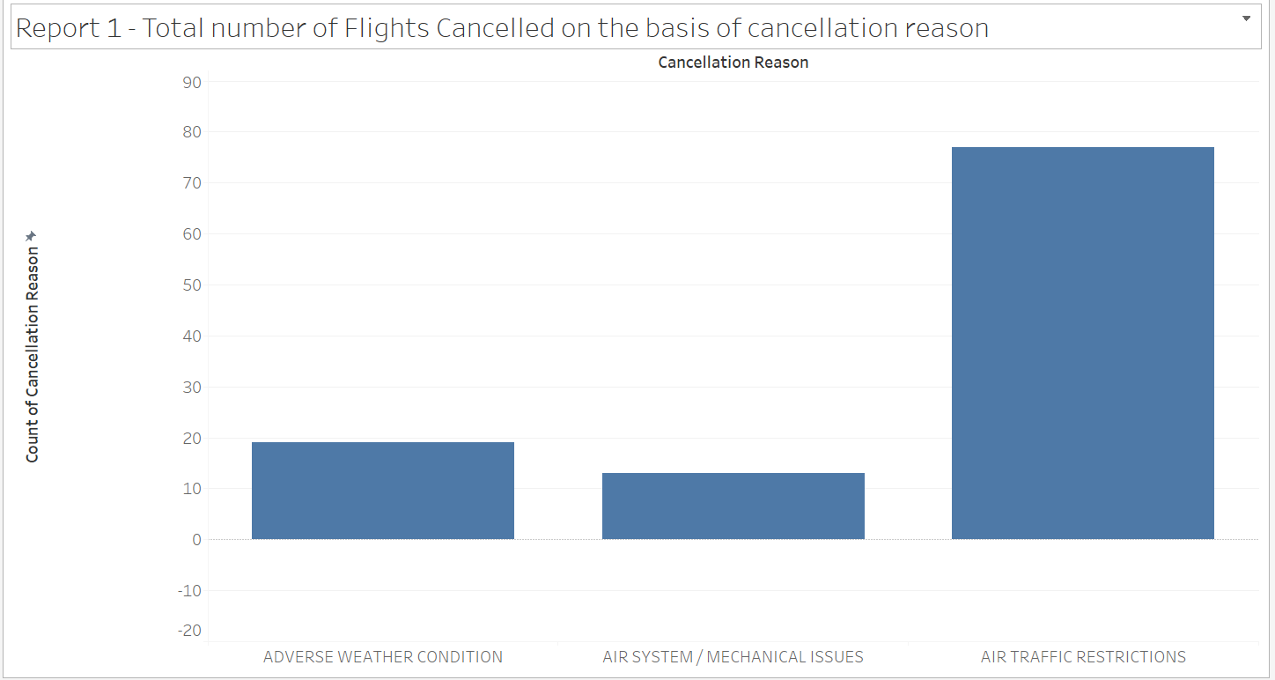

# Task 2: Pre-processing: Gather the data sources prior to ETL

## Collect only the data you require to populate the star schema into the data staging area

The first stage of data warehouse development is the data staging area. In order to first collect the data into data staging area, the original data provided has to be uploaded to the database. Hence, the excel sheets data (.xlsx) was converted to excel sheet (.csv) file. Then, these excel sheet data were uploaded to the apex oracle database via application imports. Finally, all the data from Flights_2017, Flights_2018, FlyU_Flights and Weather_Data has been uploaded into the apex oracle database.

Screenshots: Upload data of Flights_2017 into the database.

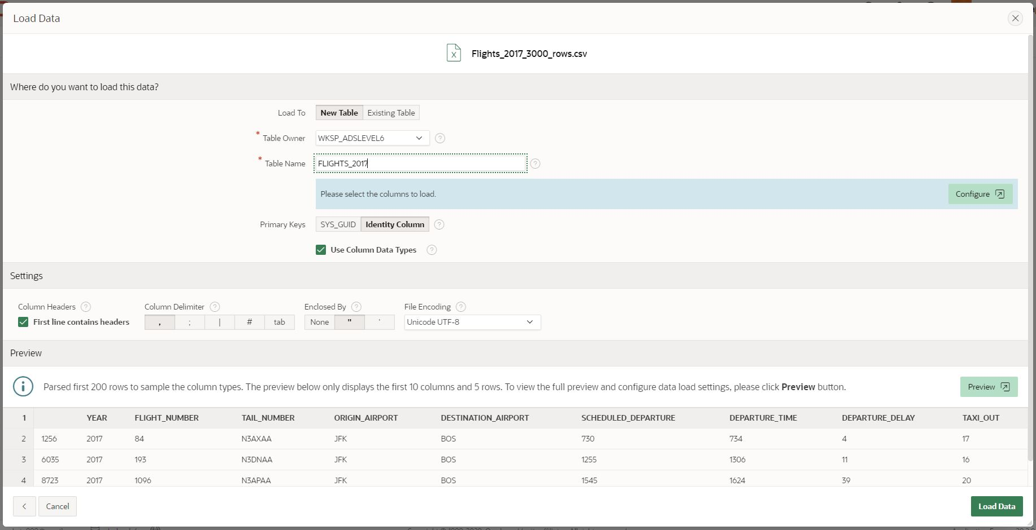

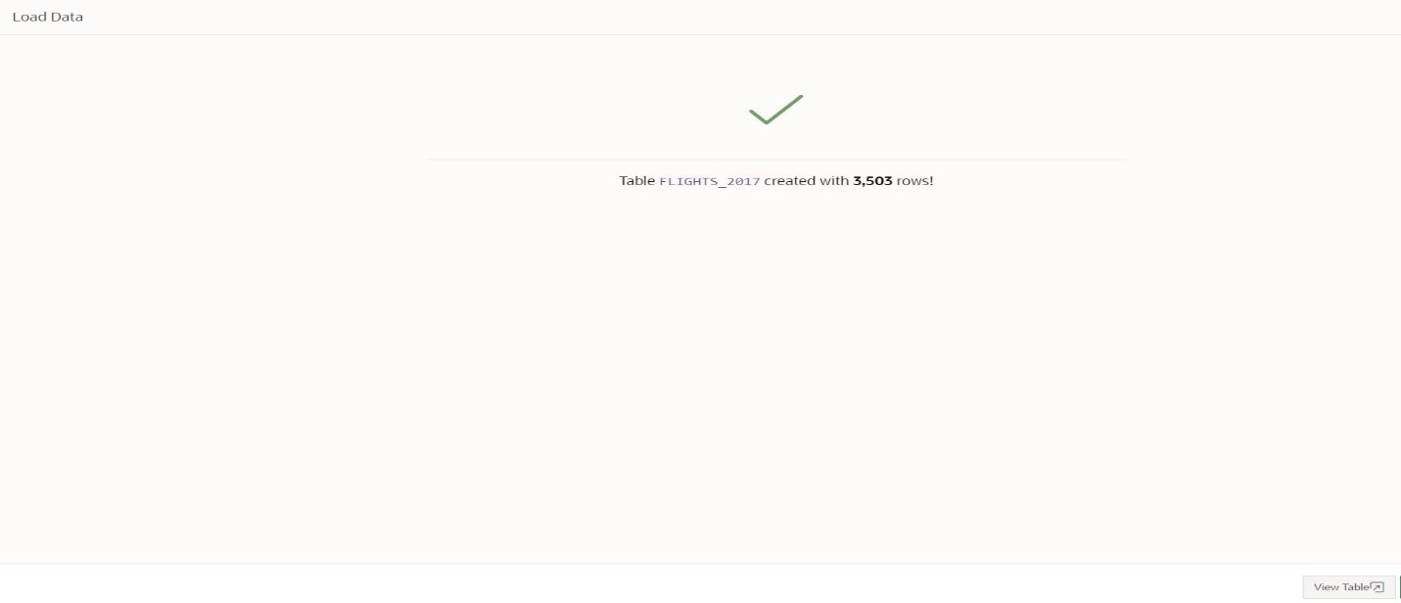

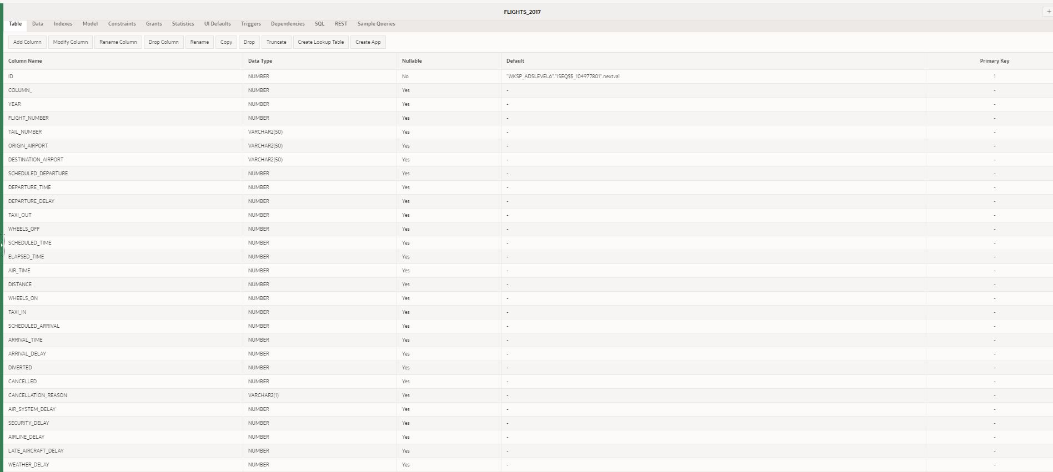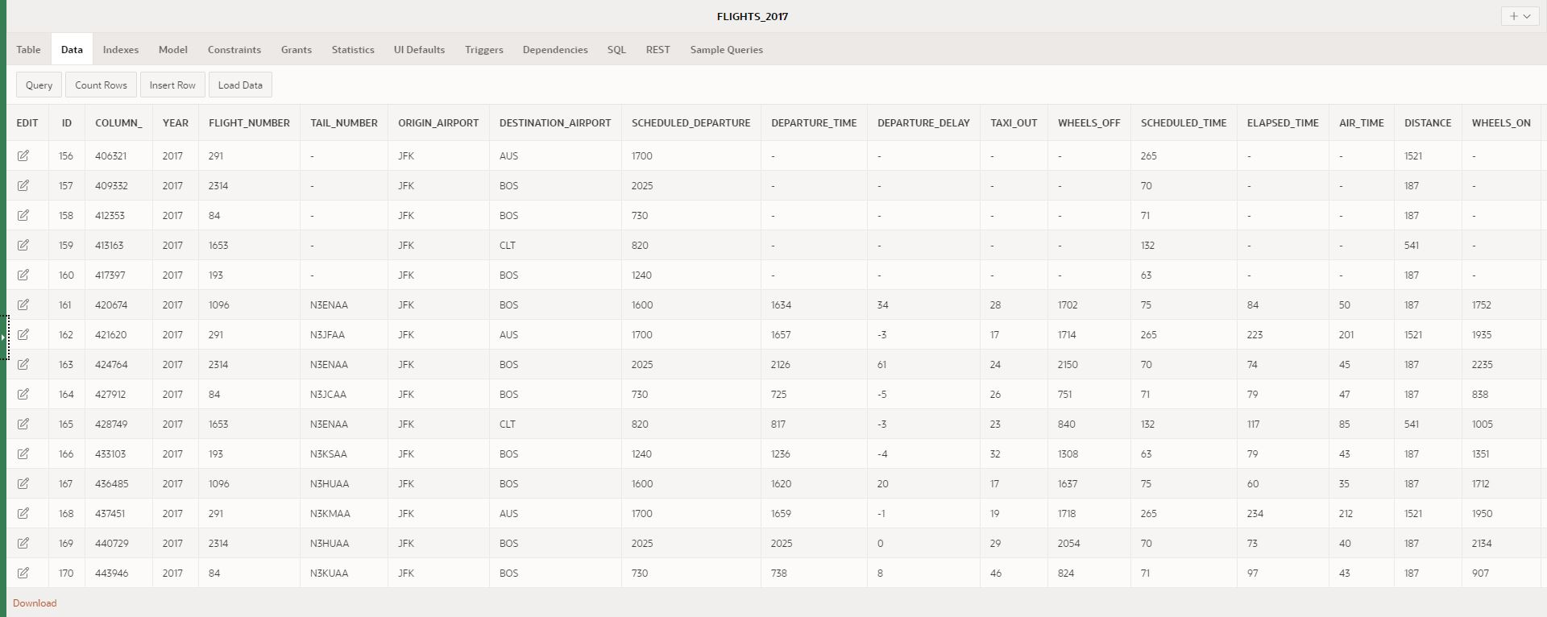

Screenshots: Upload data of Flights_2018 into the database.

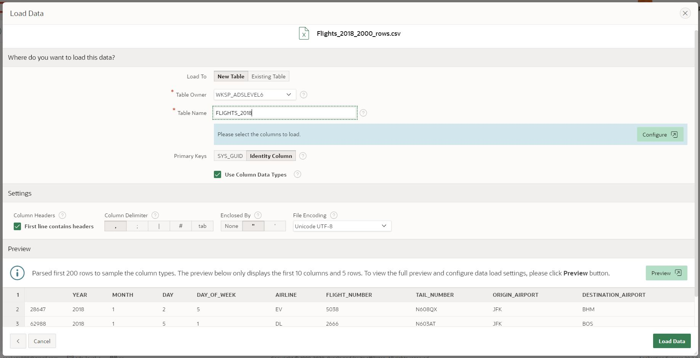

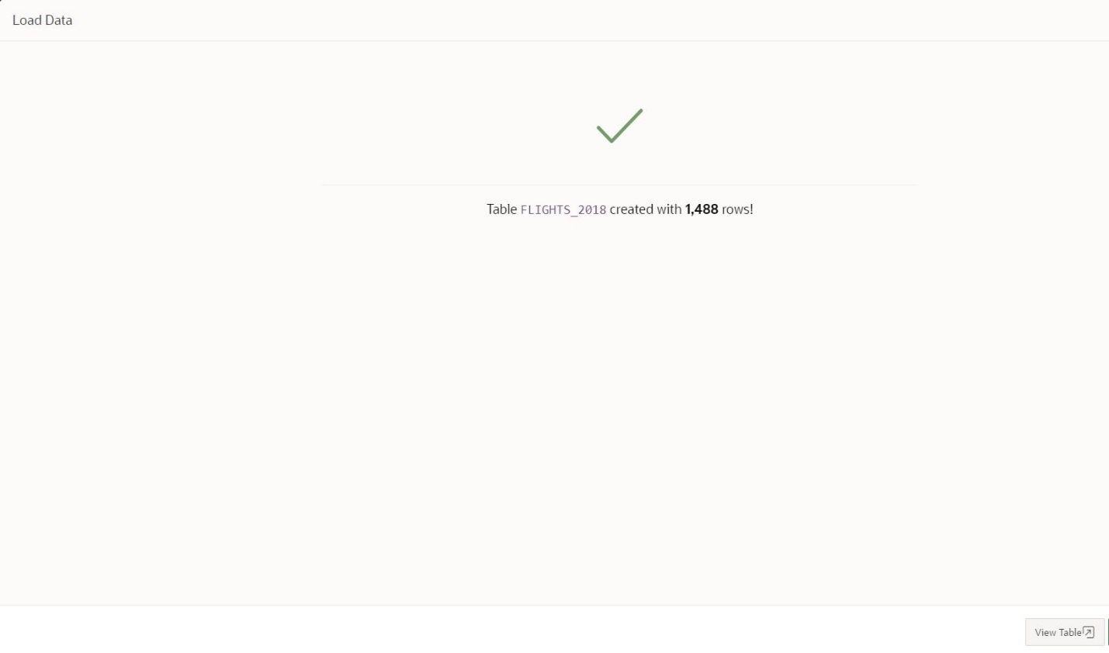

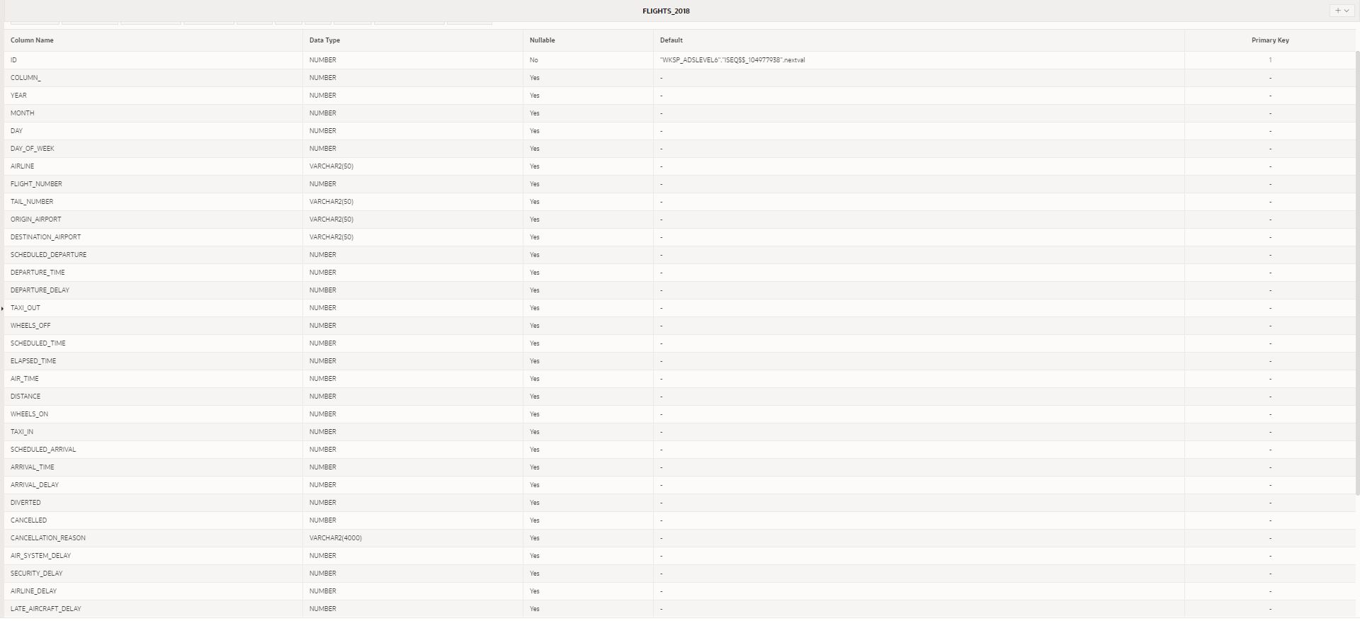



Screenshots: Upload data of Weather_Data into the database.

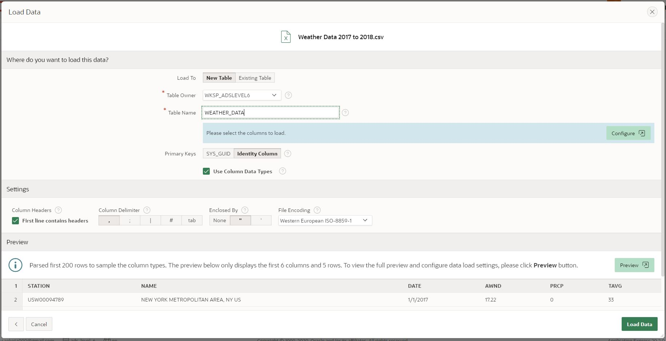 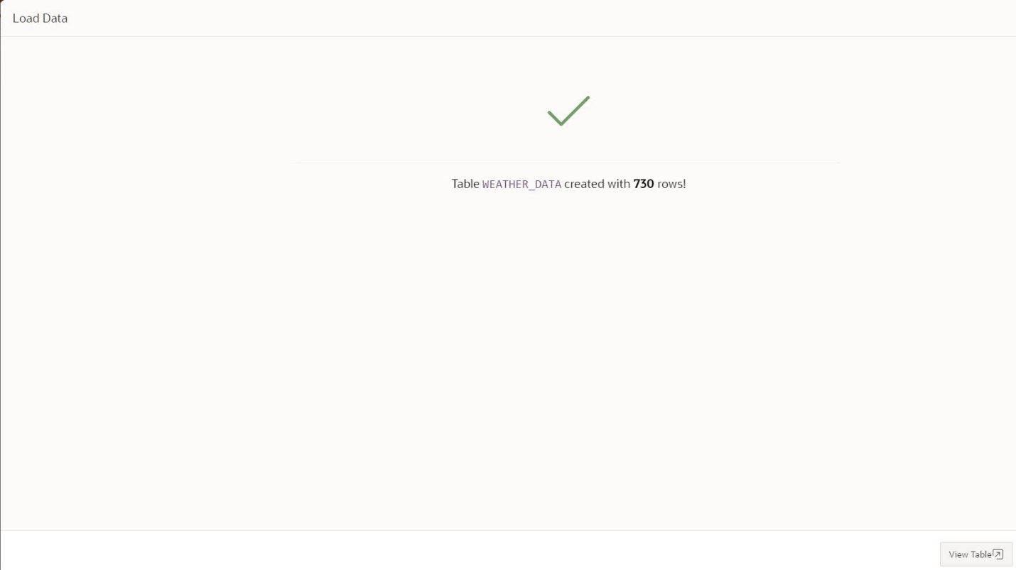

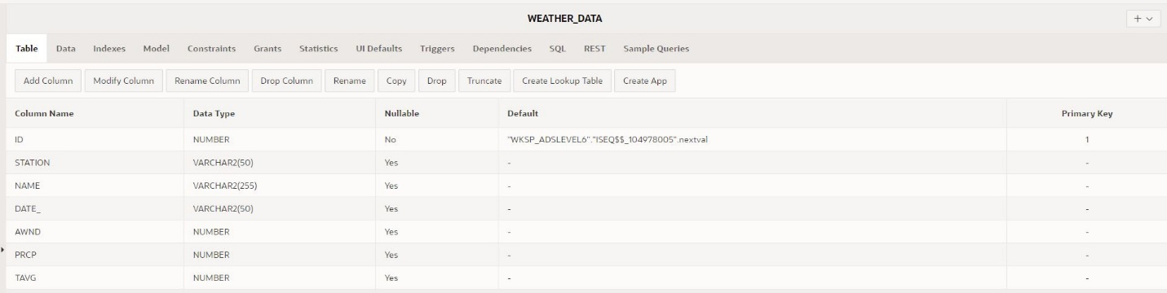 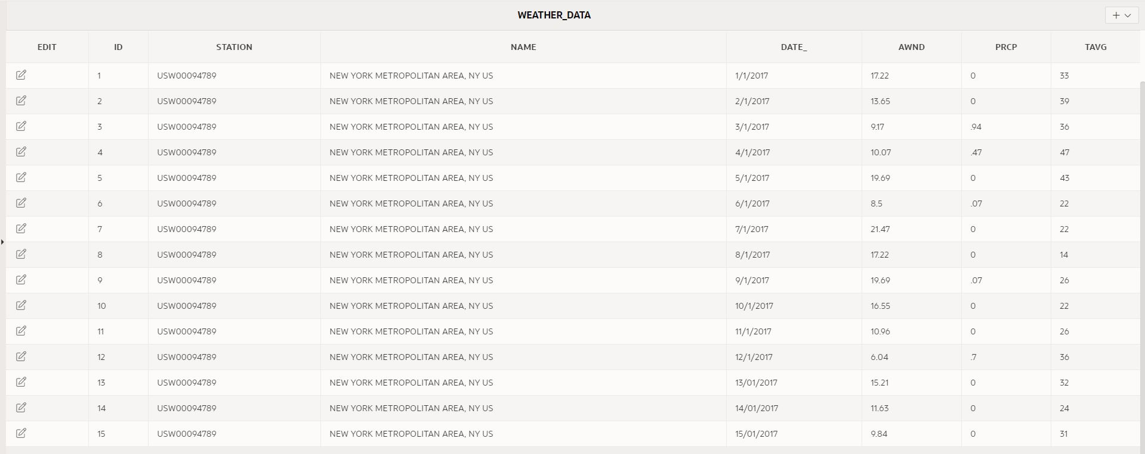

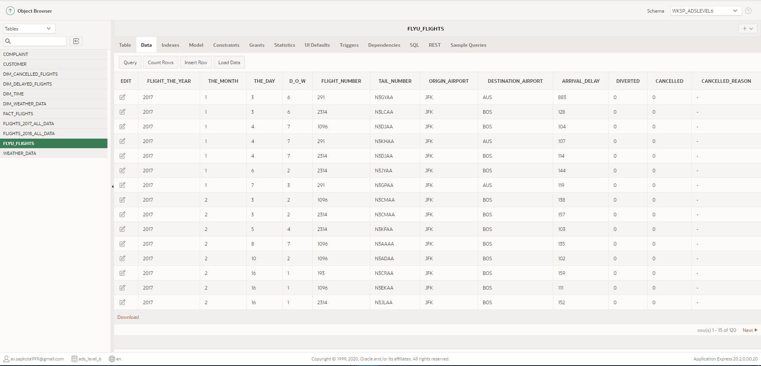

Although the data of SQL file which contains customer and complaint are not required to produce reports identified in task 1, they have been uploaded to apex oracle because they may be used for other references and evidence which may be necessary in other parts of data analysis.

Screenshot: SQL Successfully uploaded and tables created.

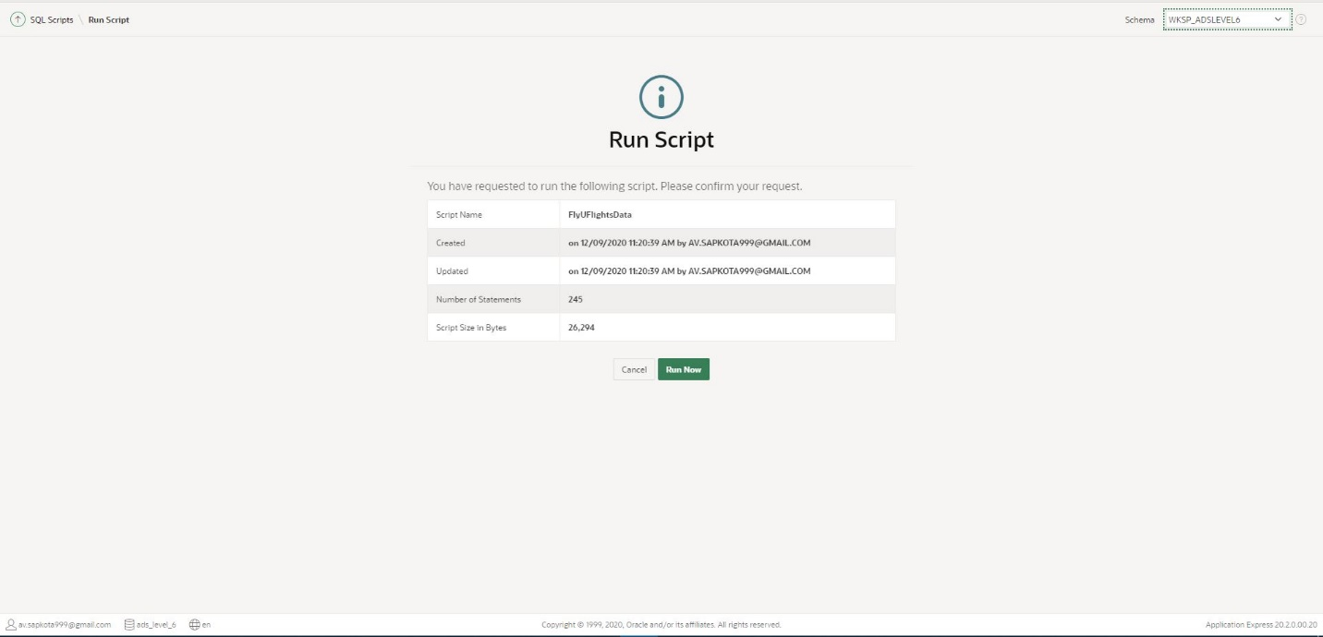

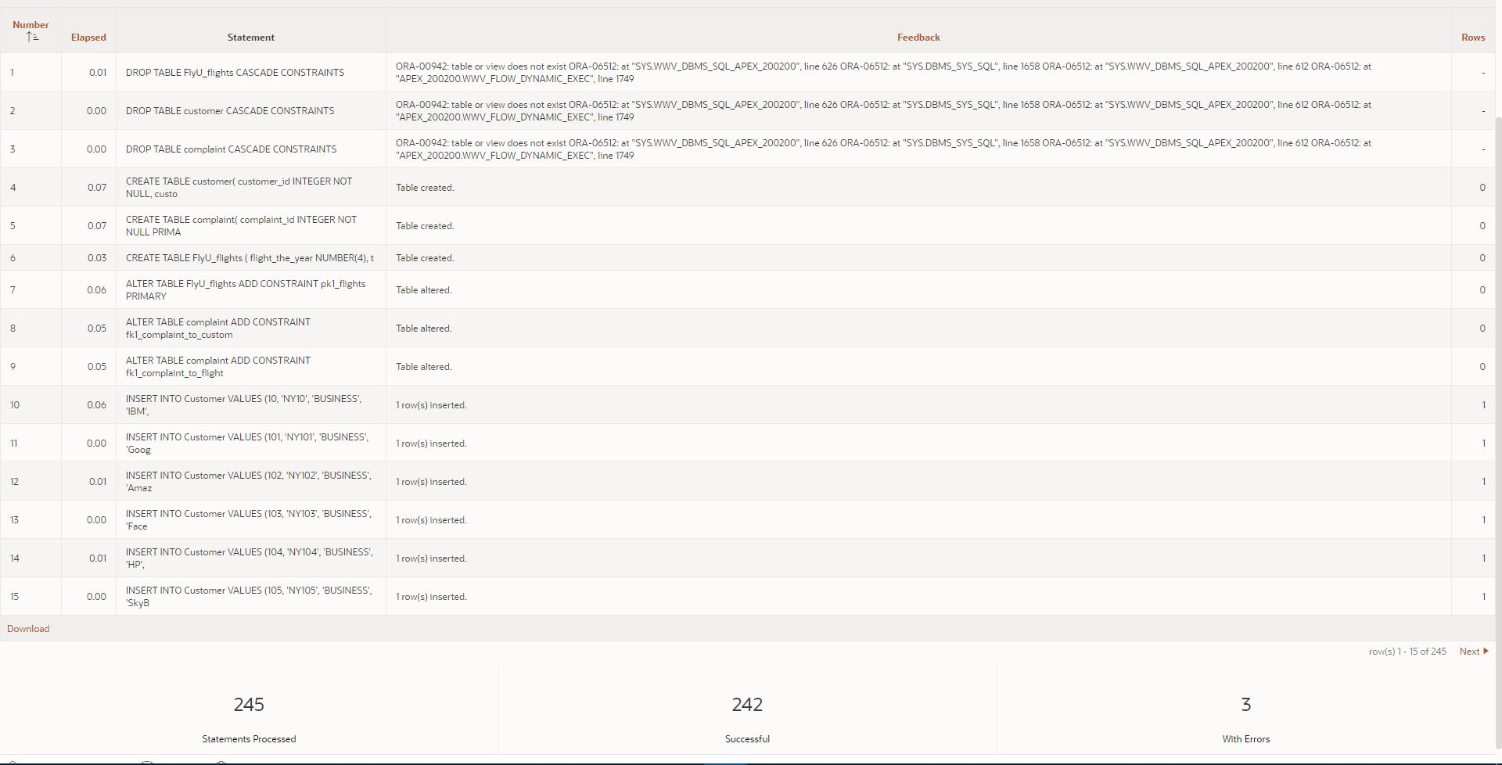

Three errors have been identified in the first three statements because table has been dropped before it is created. This error is supposed to be solved when the script is run again. Hence, it can be safely discarded and can be counted as a successful upload.

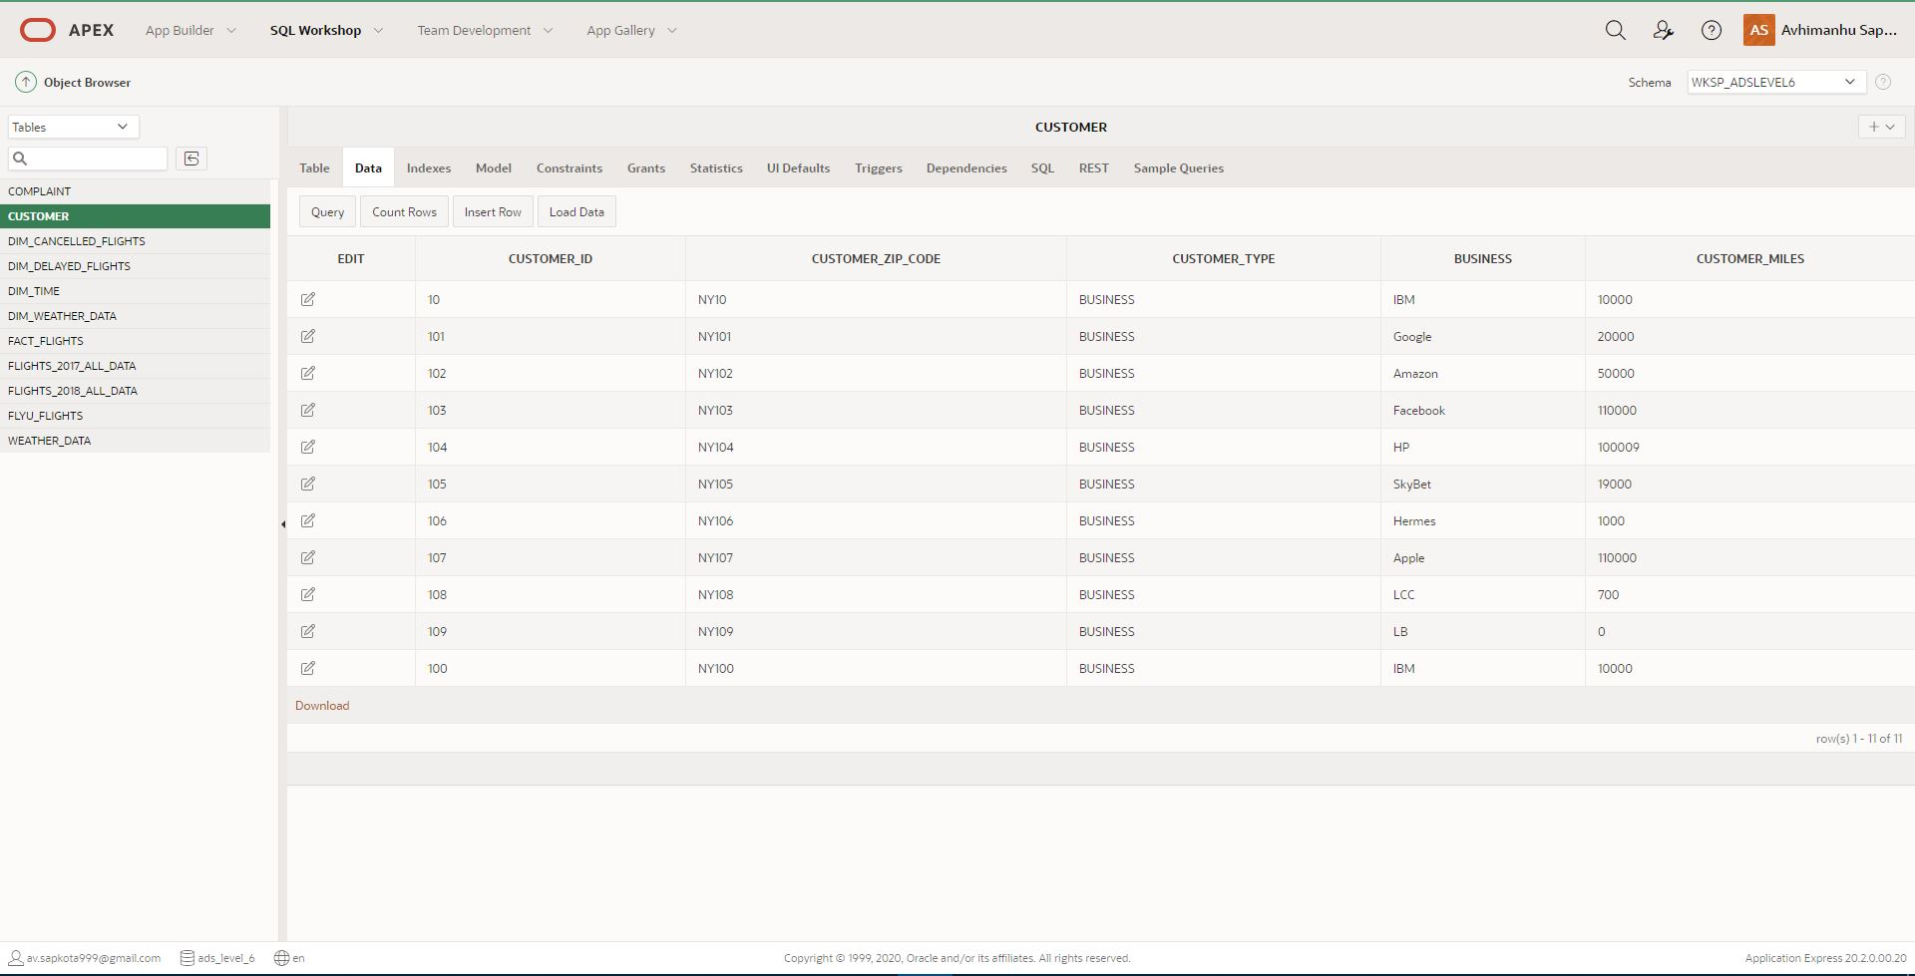

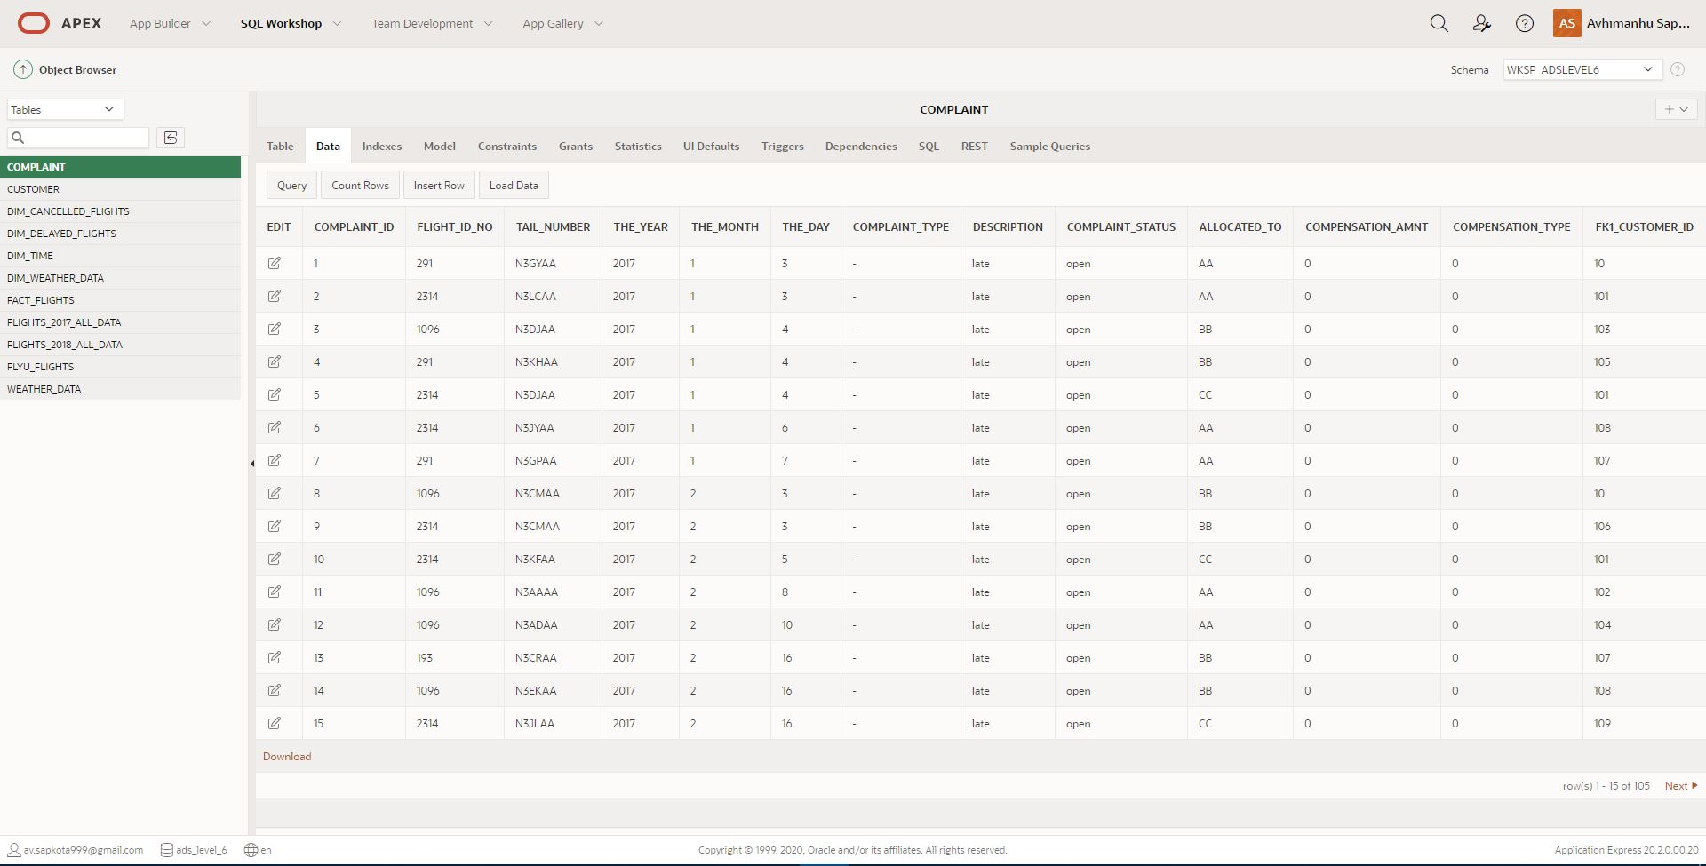

## Star Schema Set Up (DM environment)

The star schema in task 1 was designed using QSEE which will also help in generating database script in SQL. The generated script was uploaded to the apex oracle database.

Screenshot: Generated Script Run Report

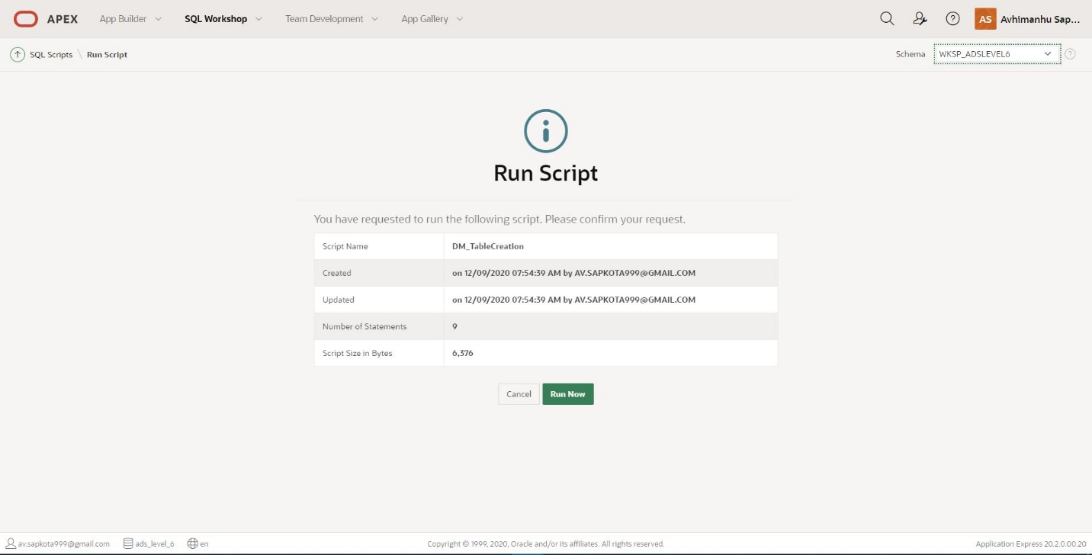

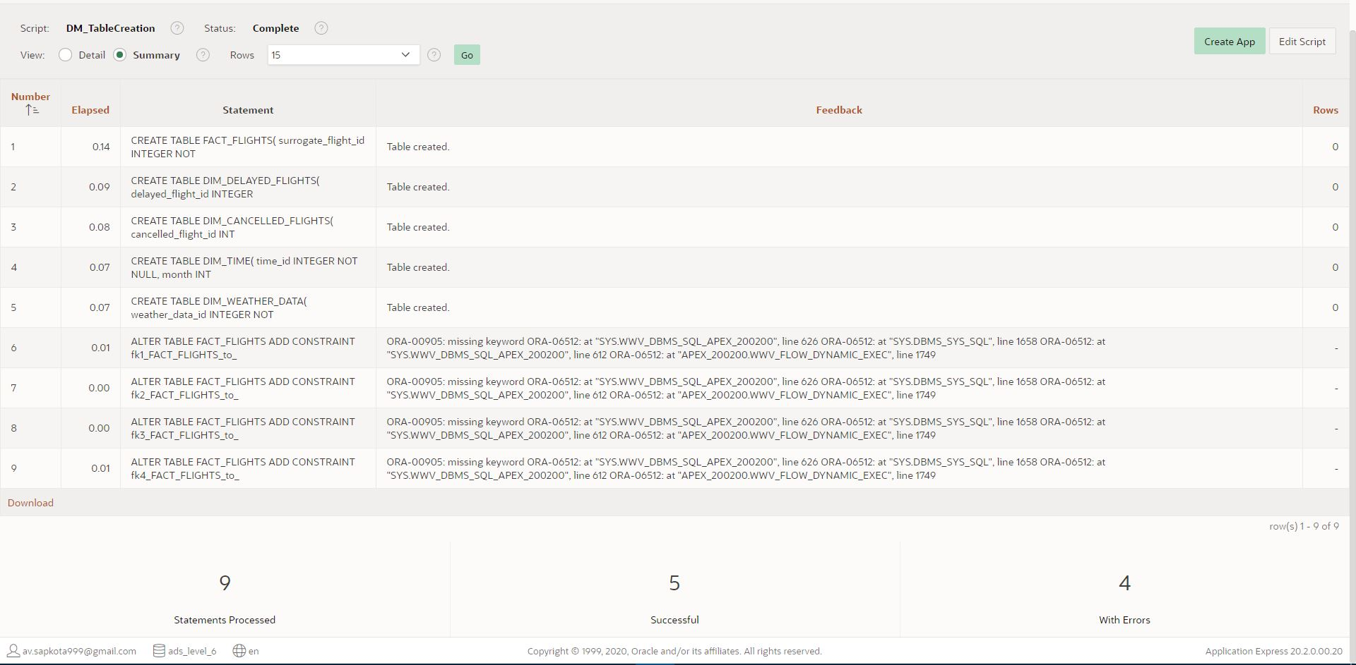

Screenshot of script where errors were generated:

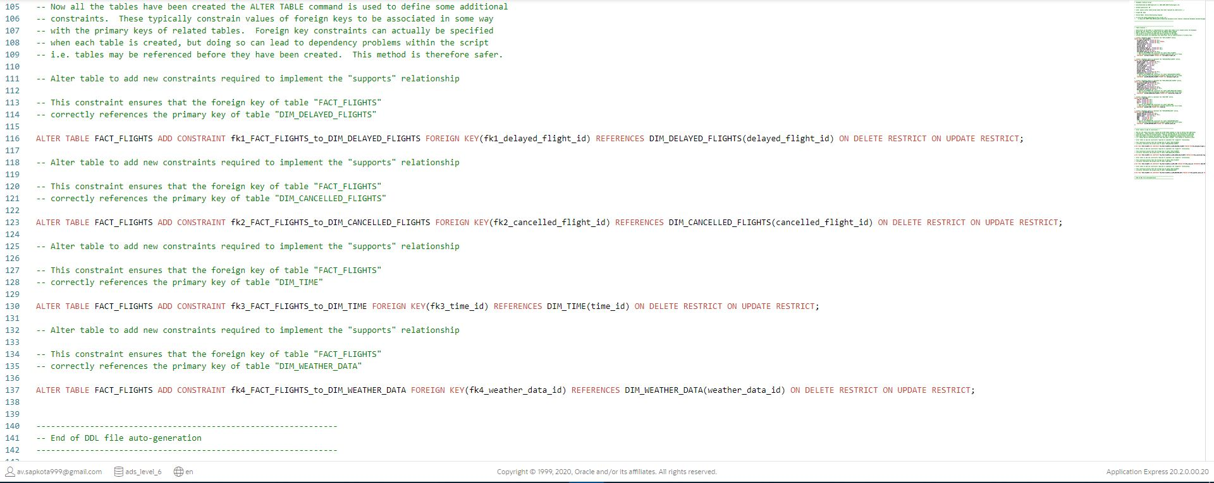

The auto-generated script had errors hence four errors were encountered. Thus, the code highlighted in the screenshot above were removed and drop table script was added in the same script for convenient table generation, every time the script is run.

The final script without any errors:

N.B. You can also find these codes in a separate file: ‘Task 2 – DDL Script (Auto-generated from Star Schema Design)’ in the attached folder: ‘SQL Scripts’

--------------------------------------------------------------

-- Database table removal script

-- Auto-Generated by QSEE-SuperLite (c) 2001-2004 QSEE-Technologies Ltd.

-- note: spaces within table names have been replaced by underscores (_)

-- Target DB: SQL2

-- Entity Model: Entity Relationship Diagram

-- Use this script to drop the tables created by -

--   'C:\Users\AV.FUNKY-YOGA.000\Documents\UnderGrad Documents\Level 6\Block 1\Advanced Database Systems\Assignment\Task 2\FLYU_DM_Tables1.sql'

-- Dropping a table has the effect of removing it from the Database.  All existing data is lost

-- as well as the definition of the table itself (stored as meta-data).  Dropping the tables allows

-- them to be re-created within the Database, even if they already exist.

--------------------------------------------------------------

-- Drop tables --

DROP TABLE FACT_FLIGHTS;

DROP TABLE DIM_DELAYED_FLIGHTS;

DROP TABLE DIM_CANCELLED_FLIGHTS;

DROP TABLE DIM_TIME;

DROP TABLE DIM_WEATHER_DATA;

--------------------------------------------------------------

-- End of DDL DROP file auto-generation

--------------------------------------------------------------

--------------------------------------------------------------

-- Database creation Script

-- Auto-Generated by QSEE-SuperLite (c) 2001-2004 QSEE-Technologies Ltd.

-- Verbose generation: ON

-- note: spaces within table/column names have been replaced by underscores (_)

-- Target DB: SQL2

-- Entity Model: Entity Relationship Diagram

-- To drop the tables generated by this script run -

--   'C:\Users\AV.FUNKY-YOGA.000\Documents\UnderGrad Documents\Level 6\Block 1\Advanced Database Systems\Assignment\Task 2\FLYU_DM_Tables1_drop.sql'

--------------------------------------------------------------

--------------------------------------------------------------

-- Table Creation --

-- Each entity on the model is represented by a table that needs to be created within the Database.

-- Within SQL new tables are created using the CREATE TABLE command.

-- When a table is created its name and its attributes are defined.

-- The values of which are derived from those specified on the model.

-- Certain constraints are sometimes also specified, such as identification of primary keys.

-- Create a Database table to represent the "FACT_FLIGHTS" entity.

CREATE TABLE FACT_FLIGHTS(

    surrogate_flight_id INTEGER NOT NULL,

    flight_serial_no    INTEGER NOT NULL,

    cancellation_flag   INTEGER NOT NULL,

    arrival_delay   INTEGER NOT NULL,

    weather_delay   INTEGER NOT NULL,

    fk1_delayed_flight_id   INTEGER,

    fk2_cancelled_flight_id INTEGER,

    fk3_time_id INTEGER NOT NULL,

    fk4_weather_data_id INTEGER,

    -- Specify the PRIMARY KEY constraint for table "FACT_FLIGHTS".

    -- This indicates which attribute(s) uniquely identify each row of data.

    CONSTRAINT  pk_FACT_FLIGHTS PRIMARY KEY (surrogate_flight_id)

);

-- Create a Database table to represent the "DIM_DELAYED_FLIGHTS" entity.

CREATE TABLE DIM_DELAYED_FLIGHTS(

    delayed_flight_id   INTEGER NOT NULL,

    flight_number   INTEGER NOT NULL,

    tail_number VARCHAR(50) NOT NULL,

    air_system_delay    INTEGER,

    security_delay  INTEGER,

    airline_delay   INTEGER,

    late_aircraft_delay INTEGER,

    weather_delay   INTEGER,

    flights_airline VARCHAR(20) NOT NULL,

    Data_Source VARCHAR(20) NOT NULL,

    -- Specify the PRIMARY KEY constraint for table "DIM_DELAYED_FLIGHTS".

    -- This indicates which attribute(s) uniquely identify each row of data.

    CONSTRAINT  pk_DIM_DELAYED_FLIGHTS PRIMARY KEY (delayed_flight_id)

);

-- Create a Database table to represent the "DIM_CANCELLED_FLIGHTS" entity.

CREATE TABLE DIM_CANCELLED_FLIGHTS(

    cancelled_flight_id INTEGER NOT NULL,

    flight_number   INTEGER NOT NULL,

    tail_number VARCHAR(50) NOT NULL,

    flights_airline VARCHAR(20) NOT NULL,

    cancellation_reason VARCHAR(120) NOT NULL,

    Data_Source VARCHAR(20) NOT NULL,

    -- Specify the PRIMARY KEY constraint for table "DIM_CANCELLED_FLIGHTS".

    -- This indicates which attribute(s) uniquely identify each row of data.

    CONSTRAINT  pk_DIM_CANCELLED_FLIGHTS PRIMARY KEY (cancelled_flight_id)

);

-- Create a Database table to represent the "DIM_TIME" entity.

CREATE TABLE DIM_TIME(

    time_id INTEGER NOT NULL,

    month   INTEGER,

    quarter INTEGER,

    year    INTEGER NOT NULL,

    -- Specify the PRIMARY KEY constraint for table "DIM_TIME".

    -- This indicates which attribute(s) uniquely identify each row of data.

    CONSTRAINT  pk_DIM_TIME PRIMARY KEY (time_id)

);

-- Create a Database table to represent the "DIM_WEATHER_DATA" entity.

CREATE TABLE DIM_WEATHER_DATA(

    weather_data_id INTEGER NOT NULL,

    weather_station VARCHAR(20) NOT NULL,

    weather_date    DATE NOT NULL,

    AWND    FLOAT(8) NOT NULL,

    PRCP    FLOAT(8) NOT NULL,

    TAVG    INTEGER NOT NULL,

    -- Specify the PRIMARY KEY constraint for table "DIM_WEATHER_DATA".

    -- This indicates which attribute(s) uniquely identify each row of data.

    CONSTRAINT  pk_DIM_WEATHER_DATA PRIMARY KEY (weather_data_id)

);

--------------------------------------------------------------

-- Alter Tables to add fk constraints --

-- Now all the tables have been created the ALTER TABLE command is used to define some additional

-- constraints.  These typically constrain values of foreign keys to be associated in some way

-- with the primary keys of related tables.  Foreign key constraints can actually be specified

-- when each table is created, but doing so can lead to dependency problems within the script

-- i.e. tables may be referenced before they have been created.  This method is therefore safer.

-- Alter table to add new constraints required to implement the "supports" relationship

-- This constraint ensures that the foreign key of table "FACT_FLIGHTS"

-- correctly references the primary key of table "DIM_DELAYED_FLIGHTS"

ALTER TABLE FACT_FLIGHTS ADD CONSTRAINT fk1_FACT_FLIGHTS_to_DIM_DELAYED_FLIGHTS FOREIGN KEY(fk1_delayed_flight_id) REFERENCES DIM_DELAYED_FLIGHTS(delayed_flight_id);

-- Alter table to add new constraints required to implement the "supports" relationship

-- This constraint ensures that the foreign key of table "FACT_FLIGHTS"

-- correctly references the primary key of table "DIM_CANCELLED_FLIGHTS"

ALTER TABLE FACT_FLIGHTS ADD CONSTRAINT fk2_FACT_FLIGHTS_to_DIM_CANCELLED_FLIGHTS FOREIGN KEY(fk2_cancelled_flight_id) REFERENCES DIM_CANCELLED_FLIGHTS(cancelled_flight_id);

-- Alter table to add new constraints required to implement the "supports" relationship

-- This constraint ensures that the foreign key of table "FACT_FLIGHTS"

-- correctly references the primary key of table "DIM_TIME"

ALTER TABLE FACT_FLIGHTS ADD CONSTRAINT fk3_FACT_FLIGHTS_to_DIM_TIME FOREIGN KEY(fk3_time_id) REFERENCES DIM_TIME(time_id);

-- Alter table to add new constraints required to implement the "supports" relationship

-- This constraint ensures that the foreign key of table "FACT_FLIGHTS"

-- correctly references the primary key of table "DIM_WEATHER_DATA"

ALTER TABLE FACT_FLIGHTS ADD CONSTRAINT fk4_FACT_FLIGHTS_to_DIM_WEATHER_DATA FOREIGN KEY(fk4_weather_data_id) REFERENCES DIM_WEATHER_DATA(weather_data_id);

--------------------------------------------------------------

-- End of DDL file auto-generation

--------------------------------------------------------------

Finally, the script was run in the database again which successfully created the data mart tables.

Screenshots: Table created Report and All tables along with their columns.

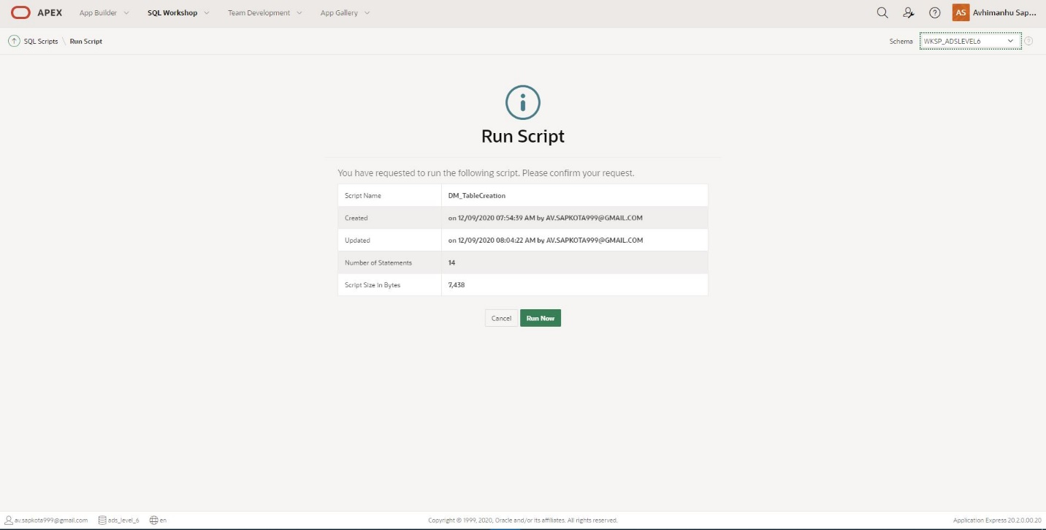

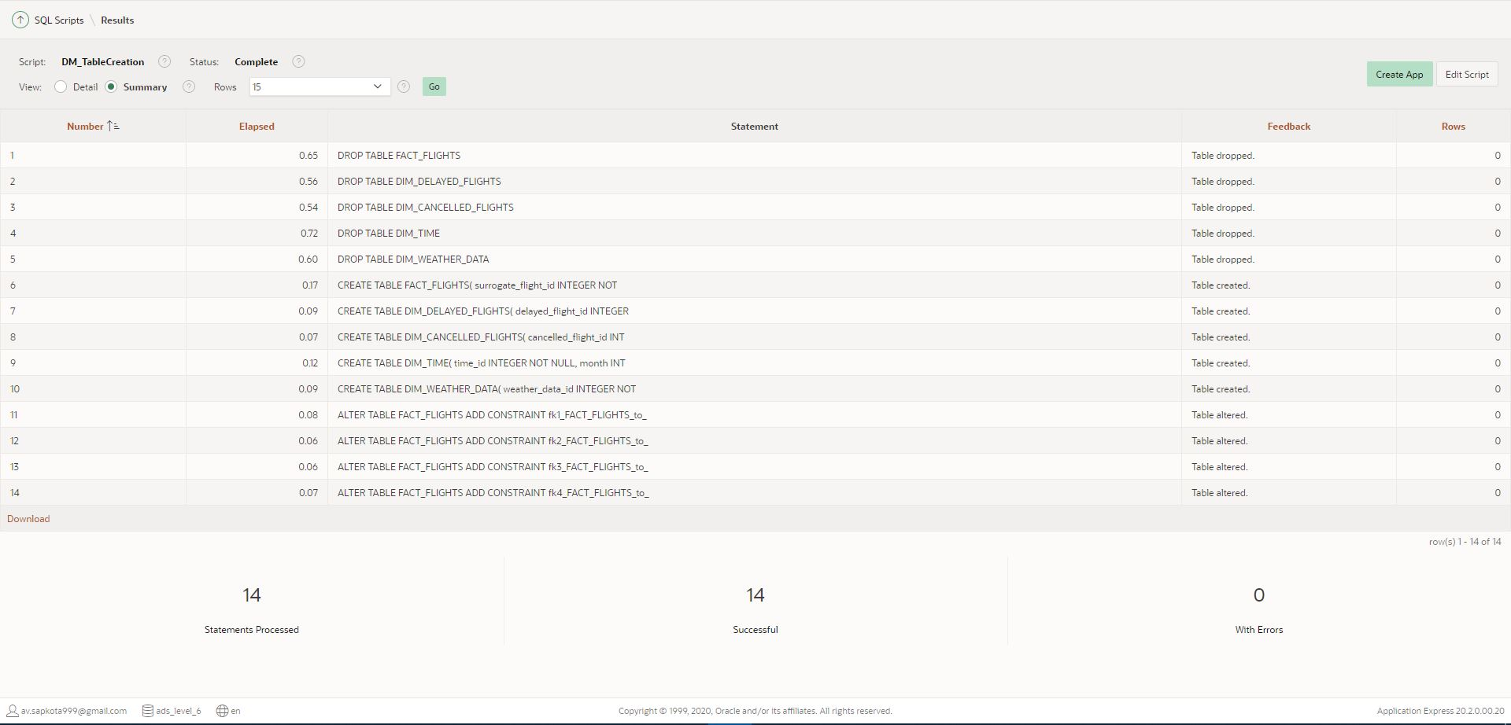

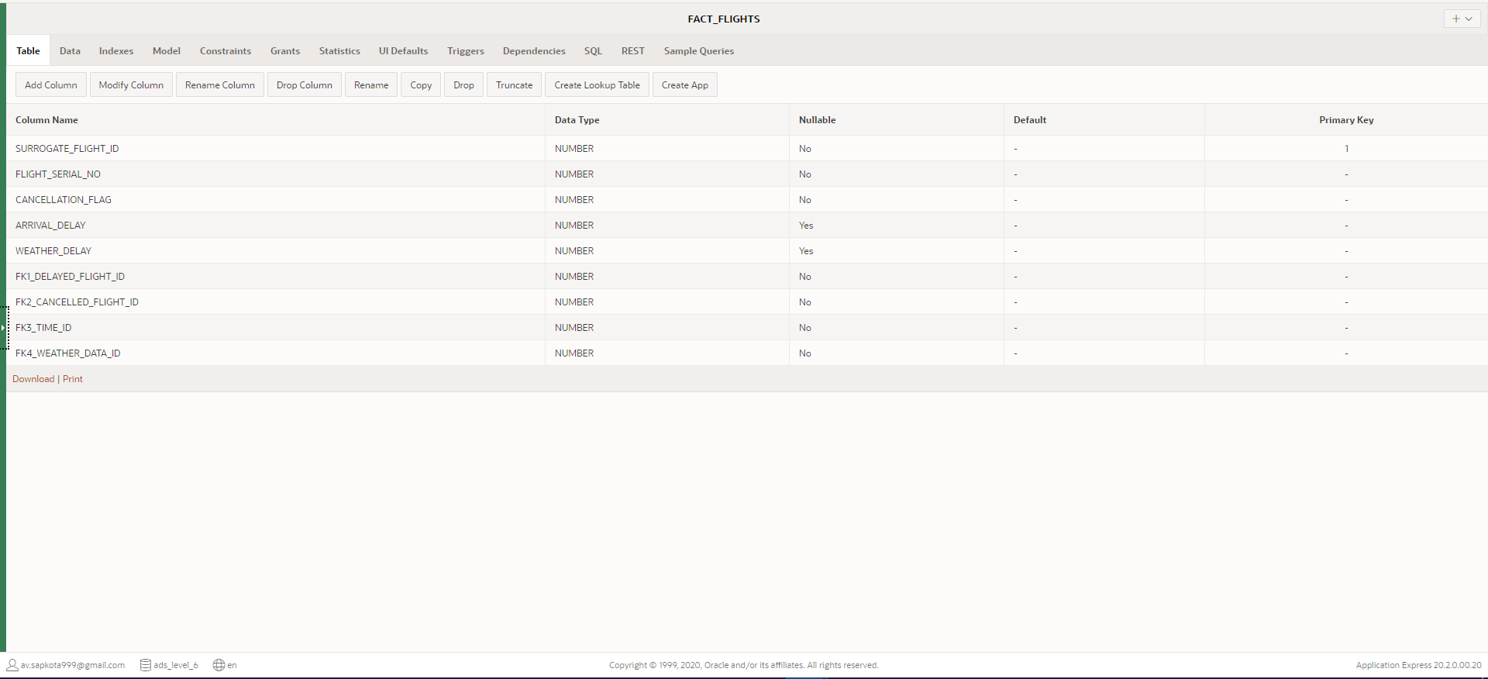

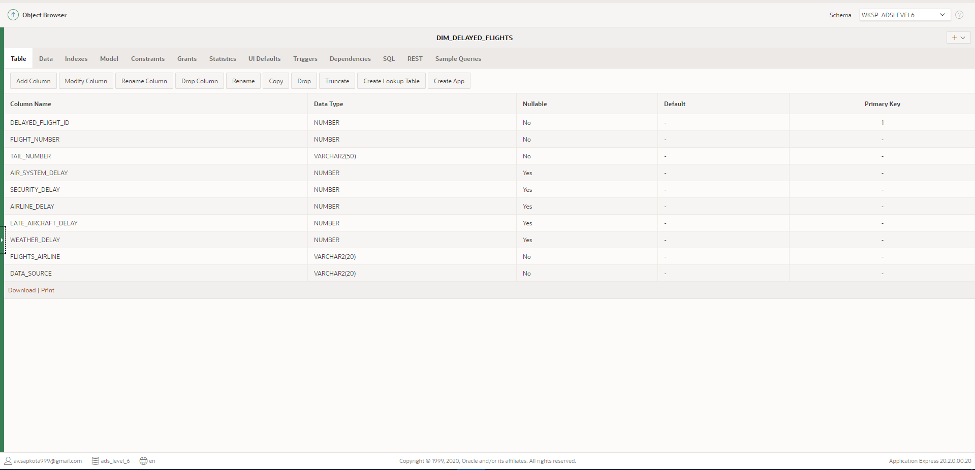

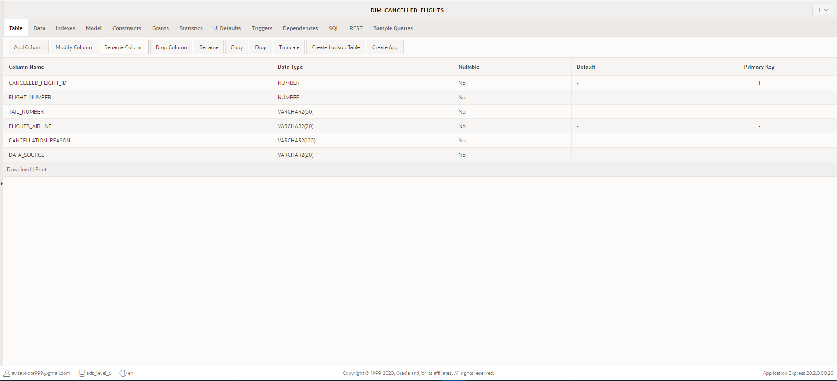

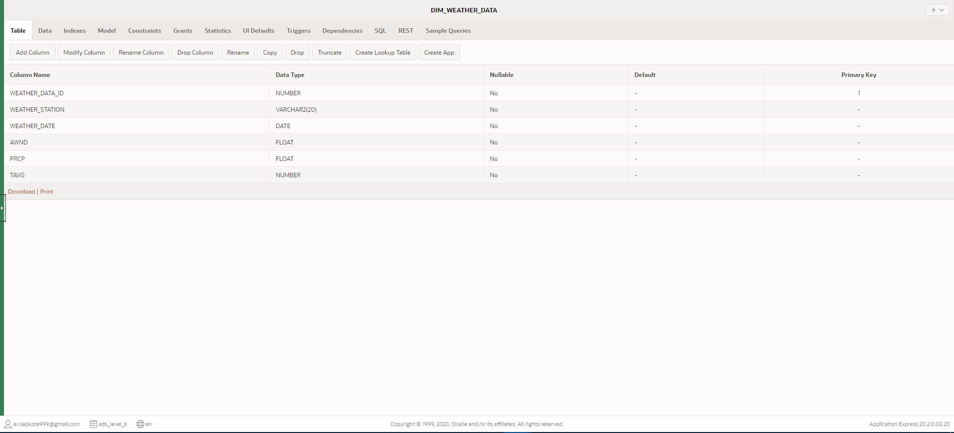

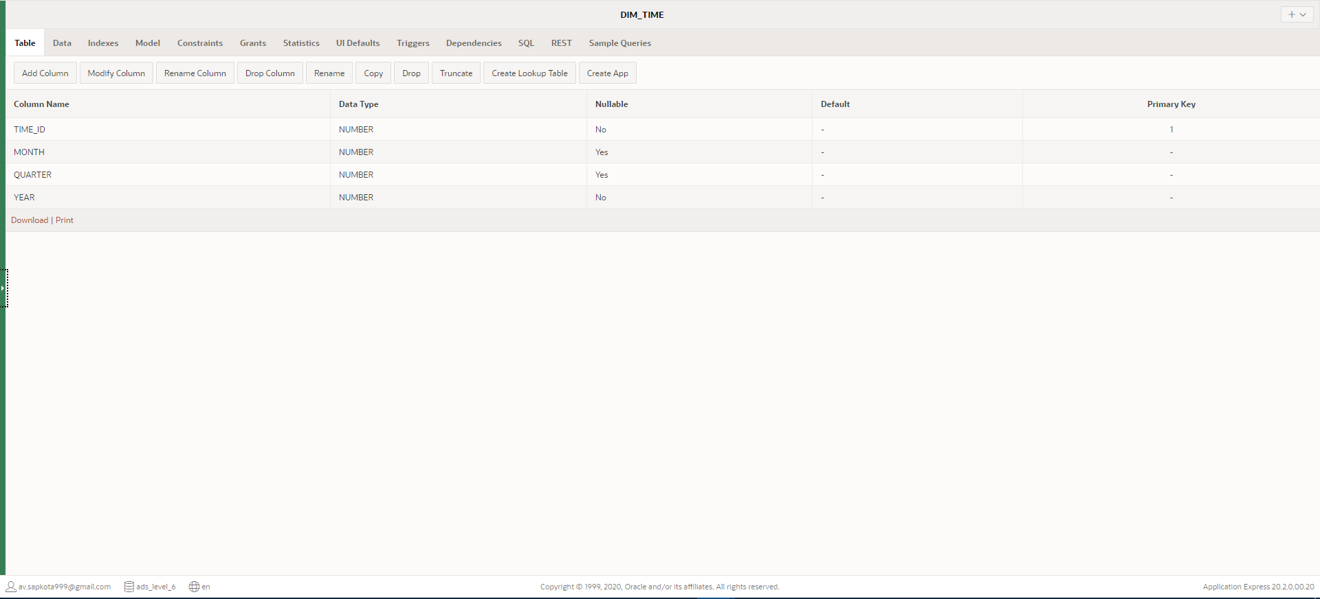

# Task 3: Extract, Transform and Load (ETL) script to populate the Star Schema (DM) with data

The data sources of FlyU Flights including Flights_2017, Flights_2018 and Weather_Data has been uploaded into the database. Secondly, the data mart (data warehouse) framework has been created using the auto-generated SQL file. According to task 3, we are supposed to extract the data from data source and transform and load those data to the data mart tables. However, there are several stages within the ETL process. ETL is a process of extracting data from various sources, then transforming the data by applying various calculations and measures and finally loading the data into the data warehouse system.

## Extraction

The first step of ETL is Extraction where data is extracted from the source system into the staging area. All the data is collected from the OLTP database and all the required data is loaded into the staging tables. Thus, in case of FlyU airlines data has been provided on various basis. Thus, to store data into staging area staging tables has been created. In addition, sequence and trigger has also been created for each staging table. These sequences will increase the value stored in primary_key sequentially starting from 1. The trigger has been created to change the value of sequence automatically before every insert in each table. The script used to create staging tables, their sequence and trigger:

N.B. You can also find these codes in a separate file: ‘Task 3 - Staging - Create Tables, Sequences and Triggers’ in the attached folder: ‘SQL Scripts’

--------------------------- STAGING AREA - TABLES -------------------------------

---------------------------------------------------------------------------------

---------------------------------------------------------------------------------

-- ALL SQL AND PL/SQL CODE REQUIRED FOR STAGING TABLE: DIM_DELAYED_FLIGHTS

---------------------------------------------------------------------------------

-- DROP TABLE STAGING_DELAYED_FLIGHTS BEFORE CREATION

DROP TABLE STAGING_DELAYED_FLIGHTS;

-- CREATE TABLE STAGING_DELAYED_FLIGHTS

CREATE TABLE STAGING_DELAYED_FLIGHTS(

    delayed_flight_id  INTEGER NOT NULL,

    flight_number  INTEGER,

    tail_number VARCHAR(50),

    air_system_delay    INTEGER,

    security_delay INTEGER,

    airline_delay   INTEGER,

    late_aircraft_delay INTEGER,

    weather_delay   INTEGER,

    flights_airline VARCHAR(20),

    Data_Source VARCHAR(20) NOT NULL,

    CONSTRAINT  pk_STAGING_DELAYED_FLIGHTS PRIMARY KEY (delayed_flight_id)

);

-- DROP SEQUENCE STAGING_DELAYED_FLIGHTS_SEQ BEFORE CREATION

DROP SEQUENCE STAGING_DELAYED_FLIGHTS_SEQ;

-- CREATE SEQUENCE STAGING_DELAYED_FLIGHTS_SEQ

CREATE SEQUENCE STAGING_DELAYED_FLIGHTS_SEQ INCREMENT BY 1 START WITH 1;

-- CREATE TRIGGER WHICH INCREASES THE VALUE OF PRIMARY KEY EVERY TIME A NEW DATA IS INSERTED.

CREATE OR REPLACE TRIGGER STAGING_DELAYED_FLIGHTS_TRIGGER

BEFORE INSERT ON STAGING_DELAYED_FLIGHTS

FOR EACH ROW

BEGIN

    :new.delayed_flight_id := STAGING_DELAYED_FLIGHTS_SEQ.NEXTVAL;

END;

/

---------------------------------------------------------------------------------

---------------------------------------------------------------------------------

---------------------------------------------------------------------------------

-- ALL SQL AND PL/SQL CODE REQUIRED FOR STAGING TABLE: DIM_CANCELLED_FLIGHTS

---------------------------------------------------------------------------------

-- DROP TABLE STAGING_CANCELLED_FLIGHTS BEFORE CREATION

DROP TABLE STAGING_CANCELLED_FLIGHTS;

-- CREATE TABLE STAGING_CANCELLED_FLIGHTS

CREATE TABLE STAGING_CANCELLED_FLIGHTS(

    cancelled_flight_id INTEGER NOT NULL,

    flight_number   INTEGER,

    tail_number VARCHAR(50),

    flights_airline VARCHAR(20),

    cancellation_reason VARCHAR(8),

    Data_Source VARCHAR(20) NOT NULL,

    CONSTRAINT  pk_STAGING_CANCELLED_FLIGHTS PRIMARY KEY (cancelled_flight_id)

);

-- DROP SEQUENCE STAGING_CANCELLED_FLIGHTS_SEQ BEFORE CREATION

DROP SEQUENCE STAGING_CANCELLED_FLIGHTS_SEQ;

-- CREATE SEQUENCE STAGING_CANCELLED_FLIGHTS_SEQ

CREATE SEQUENCE STAGING_CANCELLED_FLIGHTS_SEQ INCREMENT BY 1 START WITH 1;

-- CREATE TRIGGER WHICH INCREASES THE VALUE OF PRIMARY KEY EVERY TIME A NEW DATA IS INSERTED.

CREATE OR REPLACE TRIGGER STAGING_CANCELLED_FLIGHTS_TRIGGER

BEFORE INSERT ON STAGING_CANCELLED_FLIGHTS

FOR EACH ROW

BEGIN

    :new.cancelled_flight_id := STAGING_CANCELLED_FLIGHTS_SEQ.NEXTVAL;

END;

/

---------------------------------------------------------------------------------

---------------------------------------------------------------------------------

---------------------------------------------------------------------------------

-- ALL SQL AND PL/SQL CODE REQUIRED FOR STAGING TABLE: DIM_WEATHER_DATA

---------------------------------------------------------------------------------

-- DROP TABLE STAGING_WEATHER_DATA BEFORE CREATION

DROP TABLE STAGING_WEATHER_DATA;

-- CREATE TABLE STAGING_WEATHER_DATA

CREATE TABLE STAGING_WEATHER_DATA(

    weather_data_id INTEGER NOT NULL,

    weather_station VARCHAR(20),

    weather_date    VARCHAR(50),

    AWND    FLOAT(8),

    PRCP    FLOAT(8),

    TAVG    INTEGER,

    CONSTRAINT  pk_STAGING_WEATHER_DATA PRIMARY KEY (weather_data_id)

);

-- DROP SEQUENCE STAGING_WEATHER_DATA_SEQ BEFORE CREATION

DROP SEQUENCE STAGING_WEATHER_DATA_SEQ;

-- CREATE SEQUENCE STAGING_WEATHER_DATA_SEQ

CREATE SEQUENCE STAGING_WEATHER_DATA_SEQ INCREMENT BY 1 START WITH 1;

-- CREATE TRIGGER WHICH INCREASES THE VALUE OF PRIMARY KEY EVERY TIME A NEW DATA IS INSERTED.

CREATE OR REPLACE TRIGGER STAGING_WEATHER_DATA_TRIGGER

BEFORE INSERT ON STAGING_WEATHER_DATA

FOR EACH ROW

BEGIN

    :new.weather_data_id := STAGING_WEATHER_DATA_SEQ.NEXTVAL;

END;

/

---------------------------------------------------------------------------------

-------------------------- END OF STAGING TABLE SCRIPT --------------------------

---------------------------------------------------------------------------------

Screenshots: Staging table Script Run Reports, tables, sequences and triggers created.

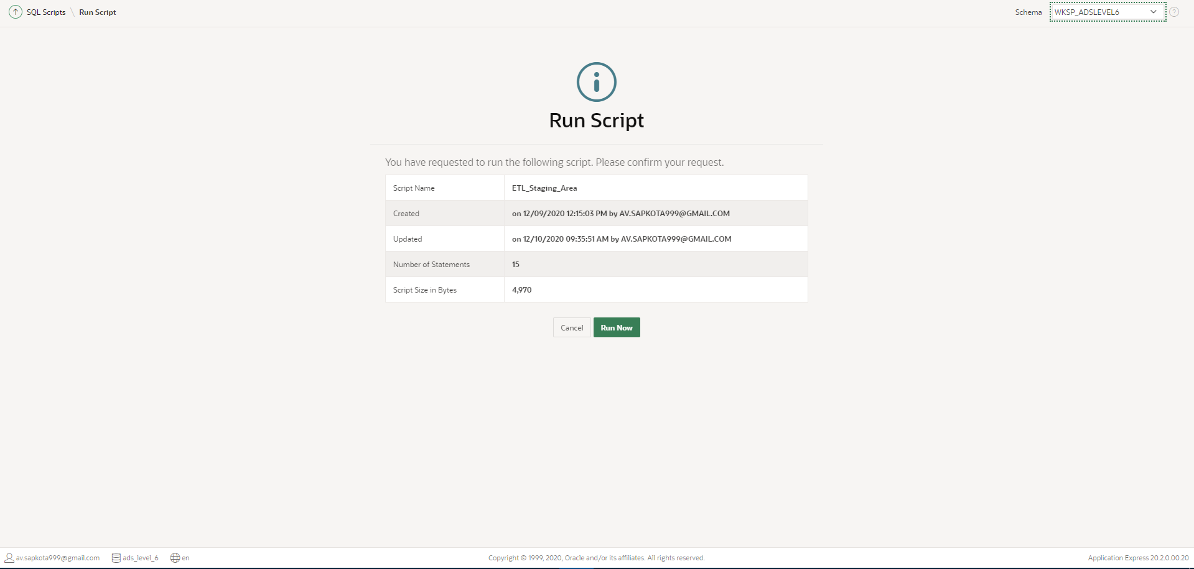

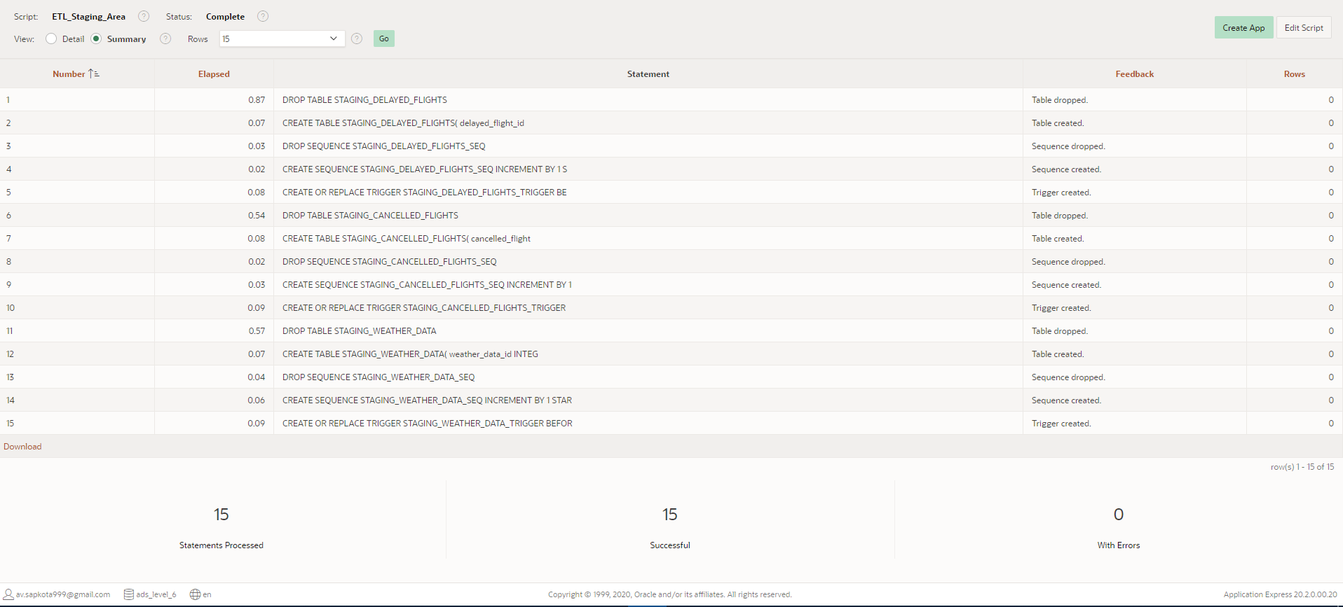

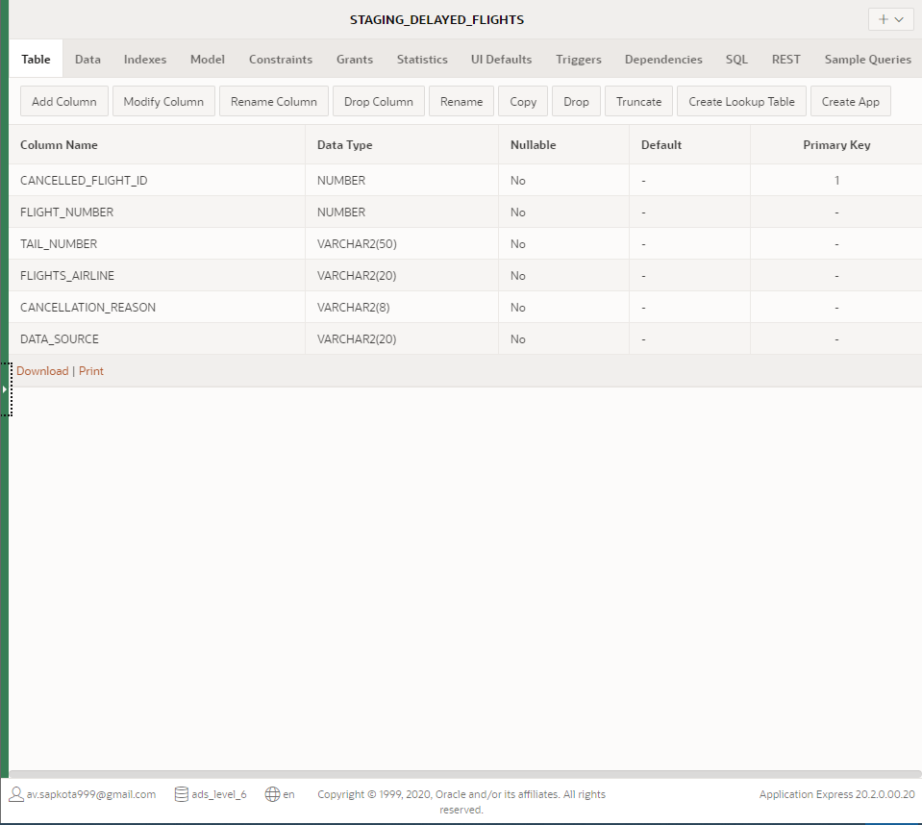

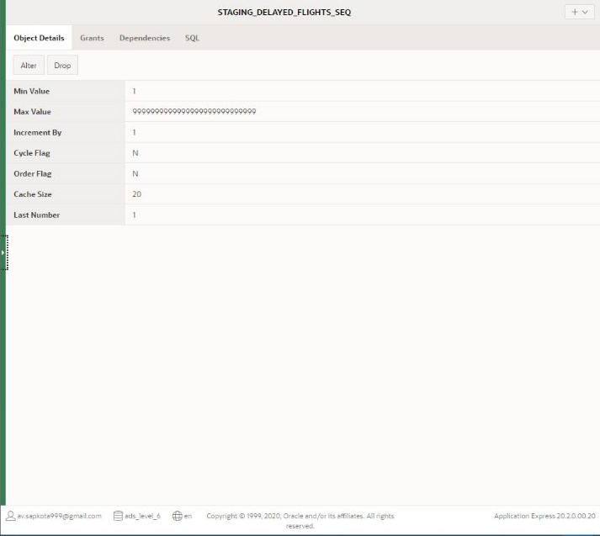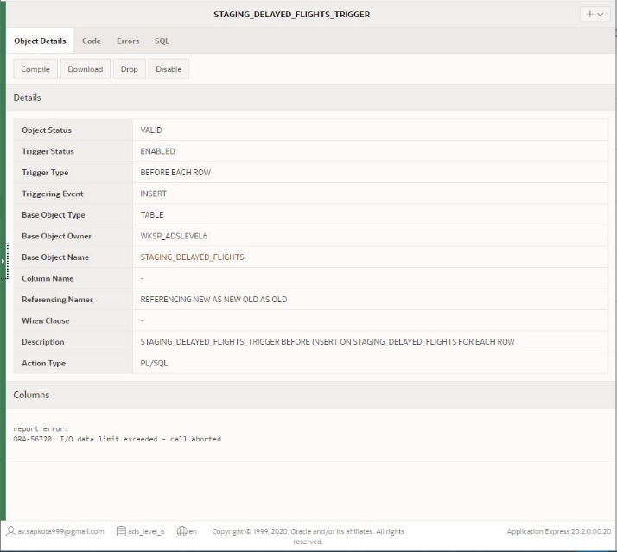

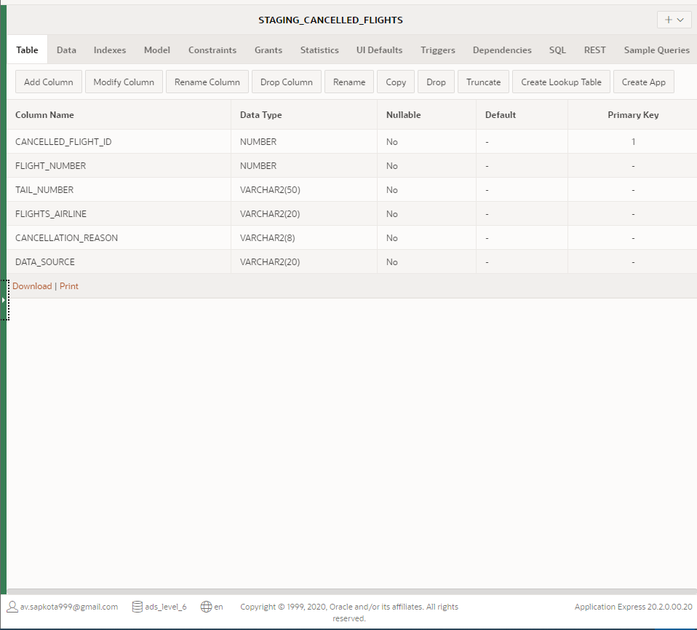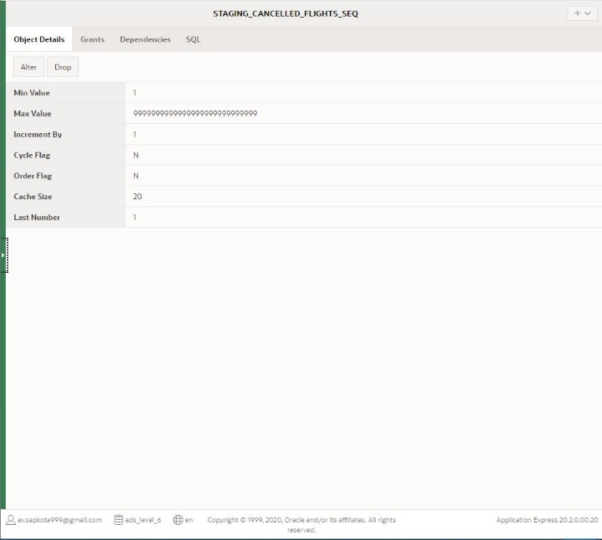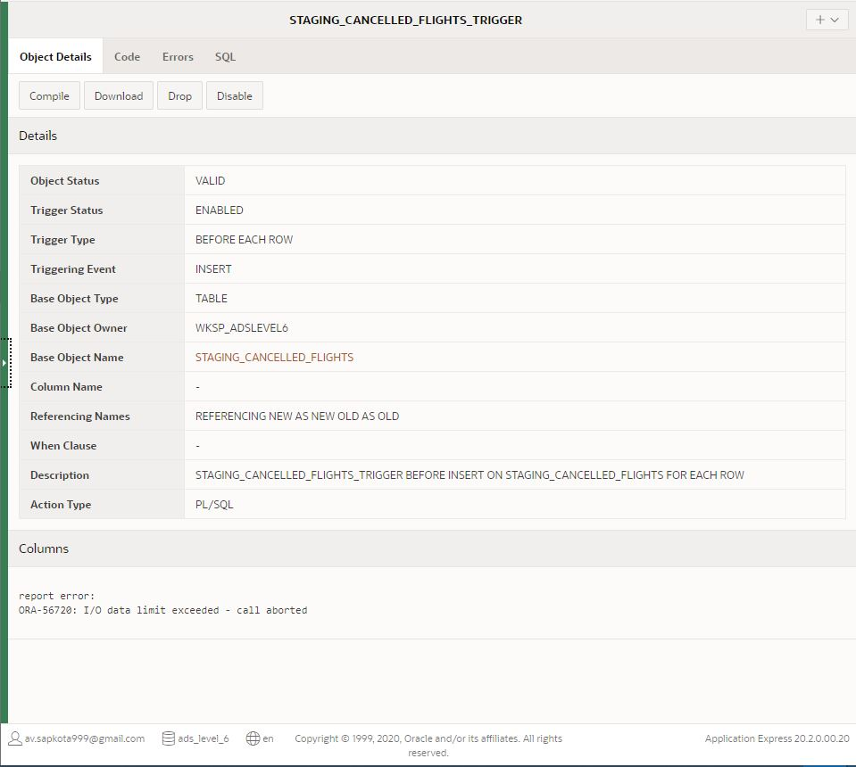

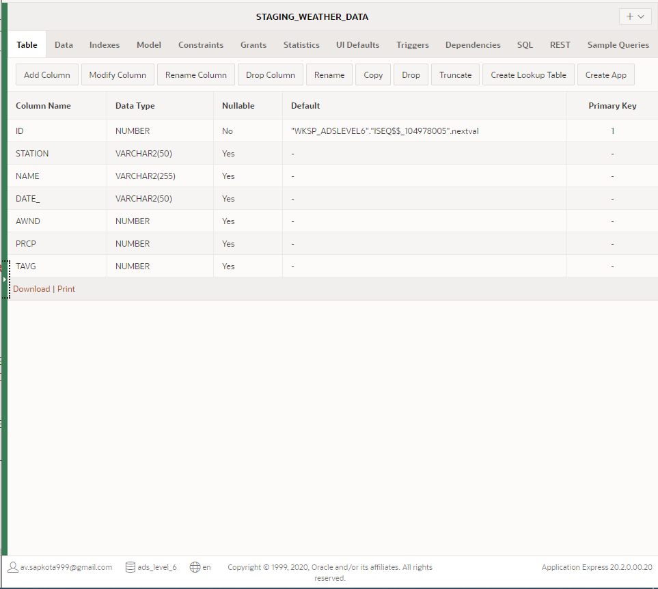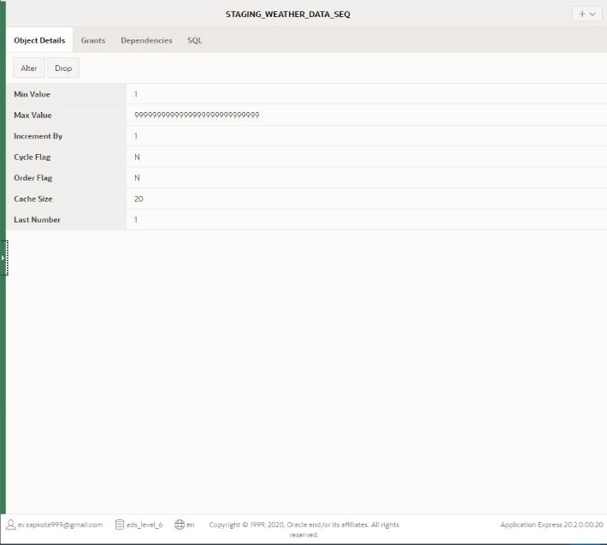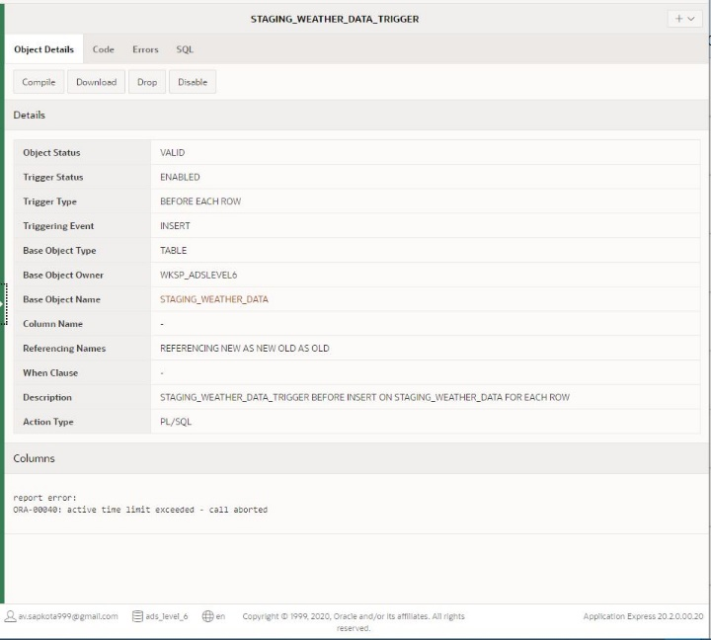

By this time, all the staging tables along with sequences and triggers have been created successfully so, the next step of staging area is to insert only the necessary data into those staging tables. Thus, in order to insert data from multiple tables into the staging tables, procedures were created and executed using following codes:

N.B. You can also find these codes in a separate file: ‘Task 3 - Staging - Insert Data SQL and PLSQL’ in the attached folder: ‘SQL Scripts’

---------------------------------------------------------------------------------

-- PROCEDURE WHICH INSERTS DATA INTO THE STAGING TABLES

---------------------------------------------------------------------------------

-- PROCEDURE TO INSERT DATA INTO STAGING_DELAYED_FLIGHTS

CREATE OR REPLACE  PROCEDURE PR_STAGING_DELAYED_FLIGHTS

AS

BEGIN

-- SELECT AND INSERT ONLY REQUIRED DATA FROM FLIGHTS_2017 TO STAGING AREA

    FOR I IN (SELECT * FROM FLIGHTS_2017 WHERE DEPARTURE_DELAY > 0 OR AIRLINE_DELAY > 0) LOOP

        INSERT INTO STAGING_DELAYED_FLIGHTS (FLIGHT_NUMBER, TAIL_NUMBER, AIR_SYSTEM_DELAY, SECURITY_DELAY, AIRLINE_DELAY, LATE_AIRCRAFT_DELAY, WEATHER_DELAY, FLIGHTS_AIRLINE, DATA_SOURCE)

        VALUES (I.FLIGHT_NUMBER, I.TAIL_NUMBER, I.AIR_SYSTEM_DELAY, I.SECURITY_DELAY, I.AIRLINE_DELAY, I.LATE_AIRCRAFT_DELAY, I.WEATHER_DELAY, NULL, 'flights_2017');

    END LOOP;

-- SELECT AND INSERT ONLY REQUIRED DATA FROM FLIGHTS_2018 TO STAGING AREA

    FOR I IN (SELECT * FROM FLIGHTS_2018 WHERE DEPARTURE_DELAY > 0 OR AIRLINE_DELAY > 0) LOOP

        INSERT INTO STAGING_DELAYED_FLIGHTS (FLIGHT_NUMBER, TAIL_NUMBER, AIR_SYSTEM_DELAY, SECURITY_DELAY, AIRLINE_DELAY, LATE_AIRCRAFT_DELAY, WEATHER_DELAY, FLIGHTS_AIRLINE, DATA_SOURCE)

        VALUES (I.FLIGHT_NUMBER, I.TAIL_NUMBER, I.AIR_SYSTEM_DELAY, I.SECURITY_DELAY, I.AIRLINE_DELAY, I.LATE_AIRCRAFT_DELAY, I.WEATHER_DELAY, I.AIRLINE, 'flights_2018');

    END LOOP;

END;

/

-- EXECUTE PROCEDURE PR_STAGING_CANCELLED_FLIGHTS

BEGIN

    PR_STAGING_DELAYED_FLIGHTS;

END;

/

---------------------------------------------------------------------------------

---------------------------------------------------------------------------------

-- PROCEDURE TO INSERT DATA INTO STAGING_CANCELLED_FLIGHTS

CREATE OR REPLACE PROCEDURE PR_STAGING_CANCELLED_FLIGHTS

AS

BEGIN

-- SELECT AND INSERT ONLY REQUIRED DATA FROM FLIGHTS_2017 TO STAGING AREA

    FOR I IN (SELECT * FROM FLIGHTS_2017 WHERE CANCELLED = 1) LOOP

        INSERT INTO STAGING_CANCELLED_FLIGHTS (FLIGHT_NUMBER, TAIL_NUMBER, FLIGHTS_AIRLINE, CANCELLATION_REASON, DATA_SOURCE)

        VALUES (I.FLIGHT_NUMBER, I.TAIL_NUMBER, NULL, I.CANCELLATION_REASON, 'flights_2017');

    END LOOP;

-- SELECT AND INSERT ONLY REQUIRED DATA FROM FLIGHTS_2018 TO STAGING AREA

    FOR I IN (SELECT * FROM FLIGHTS_2018 WHERE CANCELLED = 1) LOOP

        INSERT INTO STAGING_CANCELLED_FLIGHTS (FLIGHT_NUMBER, TAIL_NUMBER, FLIGHTS_AIRLINE, CANCELLATION_REASON, DATA_SOURCE)

        VALUES (I.FLIGHT_NUMBER, I.TAIL_NUMBER, I.AIRLINE, I.CANCELLATION_REASON, 'flights_2018');

    END LOOP;

-- SELECT AND INSERT ONLY REQUIRED DATA FROM FLYU_FLIGHTS TO STAGING AREA

    FOR I IN (SELECT * FROM FLYU_FLIGHTS WHERE CANCELLED = 1) LOOP

        INSERT INTO STAGING_CANCELLED_FLIGHTS (FLIGHT_NUMBER, TAIL_NUMBER, FLIGHTS_AIRLINE, CANCELLATION_REASON, DATA_SOURCE)

        VALUES (I.FLIGHT_NUMBER, I.TAIL_NUMBER, NULL, I.CANCELLED_REASON, 'flyu_flights');

    END LOOP;

END;

/

-- EXECUTE PROCEDURE PR_STAGING_CANCELLED_FLIGHTS

BEGIN

    PR_STAGING_CANCELLED_FLIGHTS;

END;

/

---------------------------------------------------------------------------------

---------------------------------------------------------------------------------

-- PROCEDURE TO INSERT DATA INTO STAGING_WEATHER_DATA

CREATE OR REPLACE  PROCEDURE PR_STAGING_WEATHER_DATA

AS

BEGIN

-- SELECT AND INSERT ALL DATA FROM FLIGHTS_2017 TO STAGING AREA

    FOR I IN (SELECT * FROM WEATHER_DATA) LOOP

        INSERT INTO STAGING_WEATHER_DATA (WEATHER_STATION, WEATHER_DATE, AWND, PRCP, TAVG)

        VALUES (I.STATION, I.DATE_, I.AWND, I.PRCP, I.TAVG);

    END LOOP;

END;

/

-- EXECUTE PROCEDURE PR_STAGING_WEATHER_DATA

BEGIN

    PR_STAGING_WEATHER_DATA;

END;

/

---------------------------------------------------------------------------------

------------------------------ END OF PROCEDURE CODES ---------------------------

---------------------------------------------------------------------------------

Screenshots: Procedure Created and Executed along with data inserted into the tables.

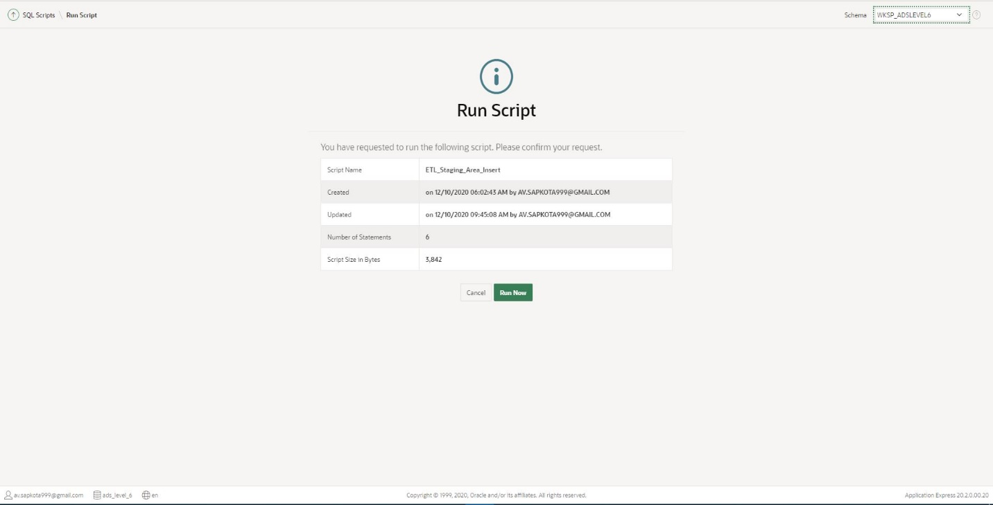

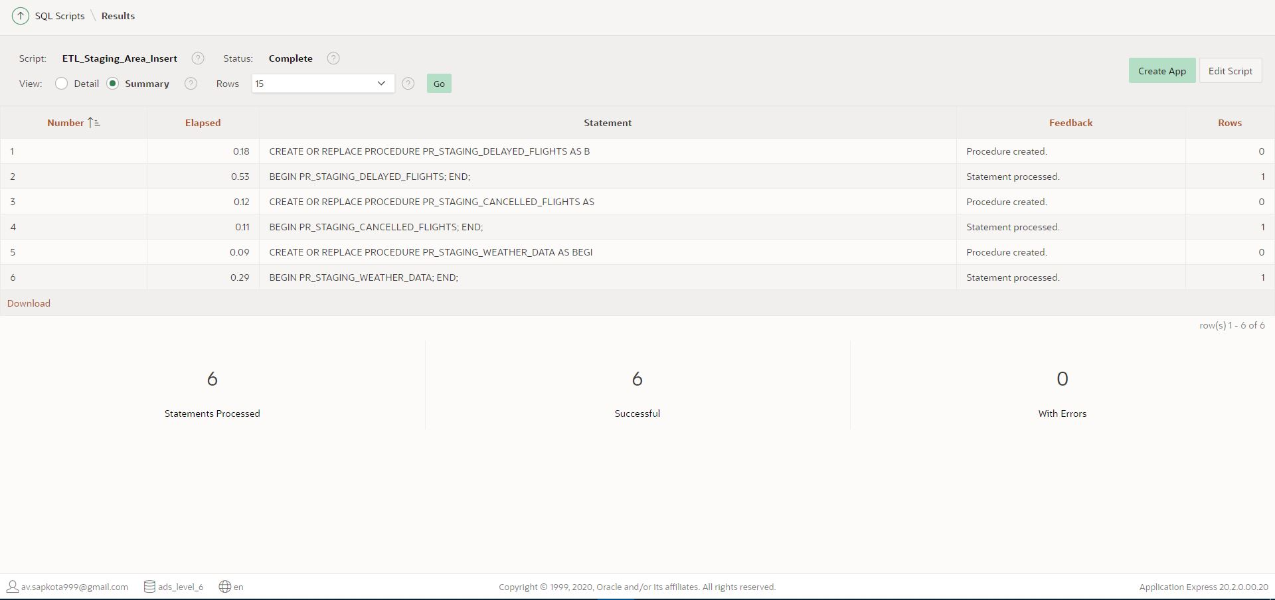

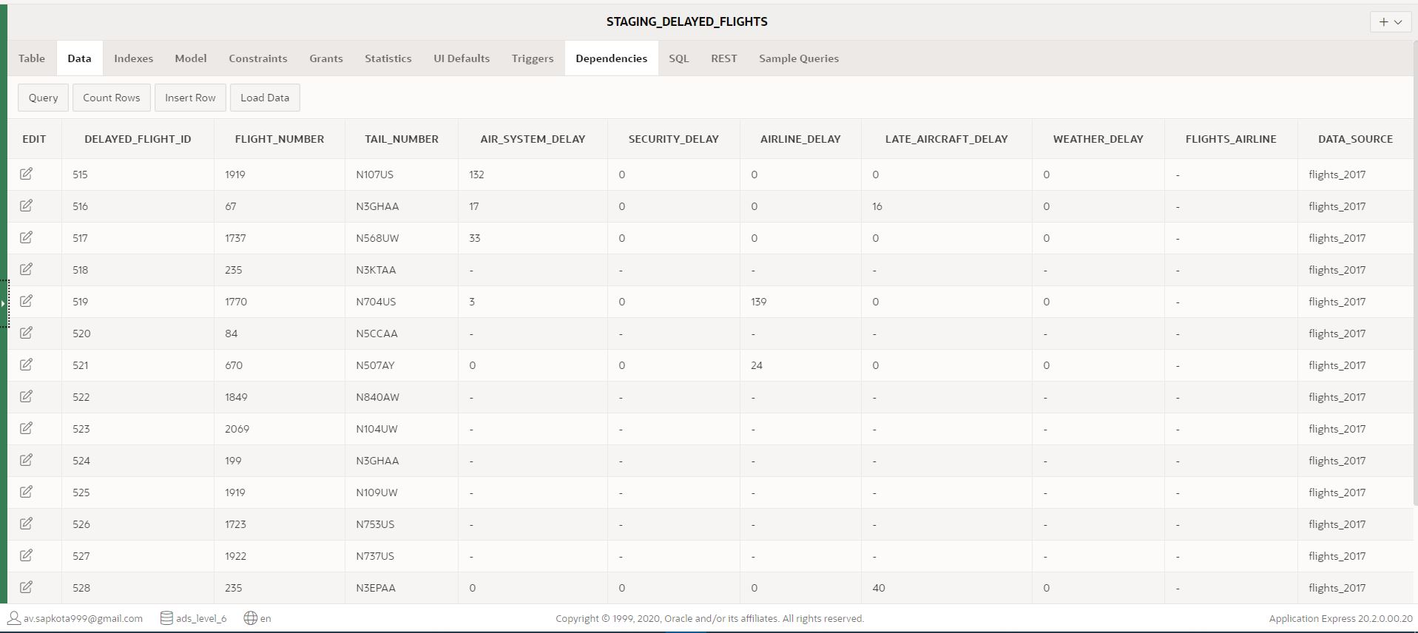

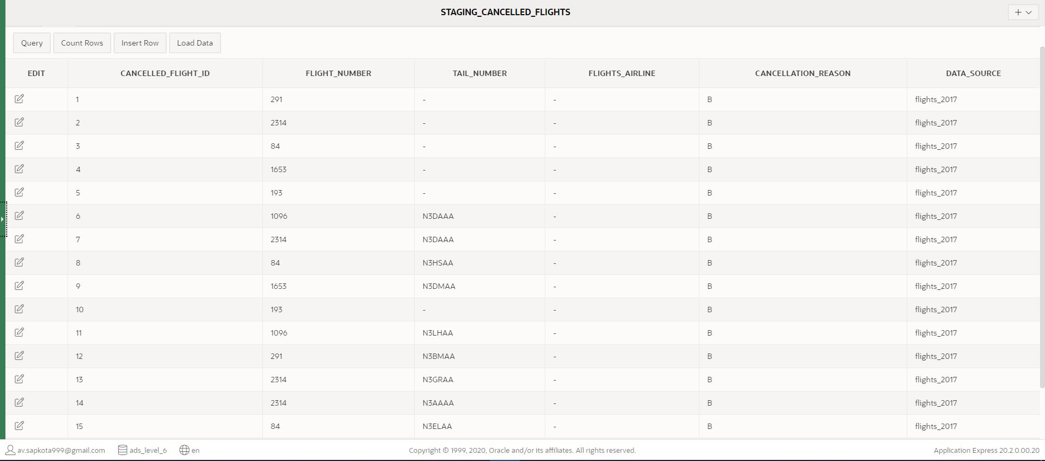

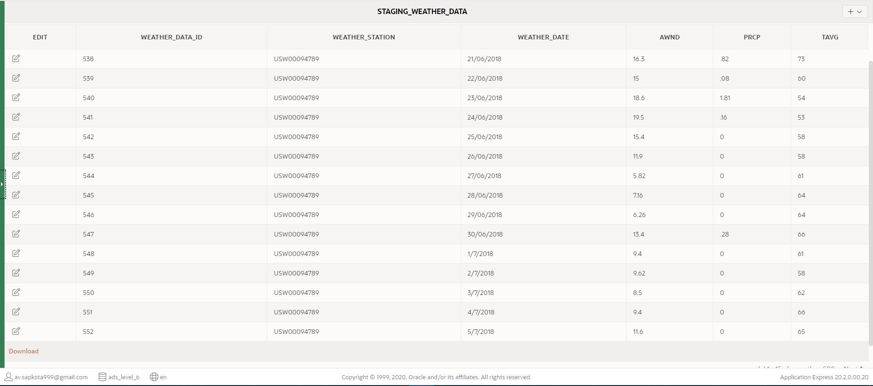

## Transformation

Data extracted from the source may or may not be useable or are raw as they are in their unique form hence, they are firstly supposed to be cleaned, mapped and then transform.

### Transformation: Bad Data Identification, Segregation and Insert

The next stage of the ETL process requires to address data quality issues. As documented in the data dictionary, many data quality issues have been identified. Hence, in this stage good quality data is transferred to clean table and bad quality data are migrated to bad table where those values are collectively managed and solved. After the successful addressment of bad data, they are further migrated to clean table.

Firstly, bad data tables were created, along with the sequence and triggers to insert primary key value, for each staging table using following codes:

N.B. You can also find these codes in a separate file: ‘Task 3 - Transformation - Bad Table Create SQL’ in the attached folder: ‘SQL Scripts’

------------------------------- BAD DATA - TABLES -------------------------------

---------------------------------------------------------------------------------

---------------------------------------------------------------------------------

-- ALL SQL AND PL/SQL CODE REQUIRED FOR BAD DATA TABLE: DIM_DELAYED_FLIGHTS

---------------------------------------------------------------------------------

-- DROP TABLE BAD_DELAYED_FLIGHTS BEFORE CREATION

DROP TABLE BAD_DELAYED_FLIGHTS;

-- CREATE TABLE BAD_DELAYED_FLIGHTS

CREATE TABLE BAD_DELAYED_FLIGHTS(

    bad_delayed_flight_id  INTEGER NOT NULL,

    delayed_flight_id  INTEGER NOT NULL,

    flight_number  INTEGER,

    tail_number VARCHAR(50),

    air_system_delay    INTEGER,

    security_delay INTEGER,

    airline_delay   INTEGER,

    late_aircraft_delay INTEGER,

    weather_delay   INTEGER,

    flights_airline VARCHAR(20),

    Data_Source VARCHAR(20) NOT NULL,

    error_description VARCHAR(120),

    error_status VARCHAR(20),

    resolution_date DATE,

    CONSTRAINT  pk_BAD_DELAYED_FLIGHTS PRIMARY KEY (bad_delayed_flight_id)

);

-- DROP SEQUENCE BAD_DELAYED_FLIGHTS_SEQ BEFORE CREATION

DROP SEQUENCE BAD_DELAYED_FLIGHTS_SEQ;

-- CREATE SEQUENCE BAD_DELAYED_FLIGHTS_SEQ

CREATE SEQUENCE BAD_DELAYED_FLIGHTS_SEQ INCREMENT BY 1 START WITH 1;

-- CREATE TRIGGER WHICH INCREASES THE VALUE OF PRIMARY KEY EVERY TIME A NEW DATA IS INSERTED.

CREATE OR REPLACE TRIGGER BAD_DELAYED_FLIGHTS_TRIGGER

BEFORE INSERT ON BAD_DELAYED_FLIGHTS

FOR EACH ROW

BEGIN

    :new.bad_delayed_flight_id := BAD_DELAYED_FLIGHTS_SEQ.NEXTVAL;

END;

/

---------------------------------------------------------------------------------

---------------------------------------------------------------------------------

---------------------------------------------------------------------------------

-- ALL SQL AND PL/SQL CODE REQUIRED FOR BAD TABLE: DIM_CANCELLED_FLIGHTS

---------------------------------------------------------------------------------

-- DROP TABLE BAD_CANCELLED_FLIGHTS BEFORE CREATION

DROP TABLE BAD_CANCELLED_FLIGHTS;

-- CREATE TABLE BAD_CANCELLED_FLIGHTS

CREATE TABLE BAD_CANCELLED_FLIGHTS(

    bad_cancelled_flight_id INTEGER NOT NULL,

    cancelled_flight_id INTEGER NOT NULL,

    flight_number   INTEGER,

    tail_number VARCHAR(50),

    flights_airline VARCHAR(20),

    cancellation_reason VARCHAR(8),

    Data_Source VARCHAR(20) NOT NULL,

    error_description VARCHAR(120),

    error_status VARCHAR(20),

    resolution_date DATE,

    CONSTRAINT  pk_BAD_CANCELLED_FLIGHTS PRIMARY KEY (bad_cancelled_flight_id)

);

-- DROP SEQUENCE BAD_CANCELLED_FLIGHTS_SEQ BEFORE CREATION

DROP SEQUENCE BAD_CANCELLED_FLIGHTS_SEQ;

-- CREATE SEQUENCE BAD_CANCELLED_FLIGHTS_SEQ

CREATE SEQUENCE BAD_CANCELLED_FLIGHTS_SEQ INCREMENT BY 1 START WITH 1;

-- CREATE TRIGGER WHICH INCREASES THE VALUE OF PRIMARY KEY EVERY TIME A NEW DATA IS INSERTED.

CREATE OR REPLACE TRIGGER BAD_CANCELLED_FLIGHTS_TRIGGER

BEFORE INSERT ON BAD_CANCELLED_FLIGHTS

FOR EACH ROW

BEGIN

    :new.bad_cancelled_flight_id := BAD_CANCELLED_FLIGHTS_SEQ.NEXTVAL;

END;

/

---------------------------------------------------------------------------------

---------------------------------------------------------------------------------

---------------------------------------------------------------------------------

-- ALL SQL AND PL/SQL CODE REQUIRED FOR BAD TABLE: DIM_WEATHER_DATA

---------------------------------------------------------------------------------

-- DROP TABLE BAD_WEATHER_DATA BEFORE CREATION

DROP TABLE BAD_WEATHER_DATA;

-- CREATE TABLE BAD_WEATHER_DATA

CREATE TABLE BAD_WEATHER_DATA(

    bad_weather_data_id INTEGER NOT NULL,

    weather_data_id INTEGER NOT NULL,

    weather_station VARCHAR(20),

    weather_date    VARCHAR(50),

    AWND    FLOAT(8),

    PRCP    FLOAT(8),

    TAVG    INTEGER,

    error_description VARCHAR(120),

    error_status VARCHAR(20),

    resolution_date DATE,

    CONSTRAINT  pk_BAD_WEATHER_DATA PRIMARY KEY (bad_weather_data_id)

);

-- DROP SEQUENCE BAD_WEATHER_DATA_SEQ BEFORE CREATION

DROP SEQUENCE BAD_WEATHER_DATA_SEQ;

-- CREATE SEQUENCE BAD_WEATHER_DATA_SEQ

CREATE SEQUENCE BAD_WEATHER_DATA_SEQ INCREMENT BY 1 START WITH 1;

-- CREATE TRIGGER WHICH INCREASES THE VALUE OF PRIMARY KEY EVERY TIME A NEW DATA IS INSERTED.

CREATE OR REPLACE TRIGGER BAD_WEATHER_DATA_TRIGGER

BEFORE INSERT ON BAD_WEATHER_DATA

FOR EACH ROW

BEGIN

    :new.bad_weather_data_id := BAD_WEATHER_DATA_SEQ.NEXTVAL;

END;

/

---------------------------------------------------------------------------------

---------------------------- END OF BAD DATA TABLE CREATION ---------------------

---------------------------------------------------------------------------------

Screenshots: Bad data table, sequence and trigger creation run and successfully created report.

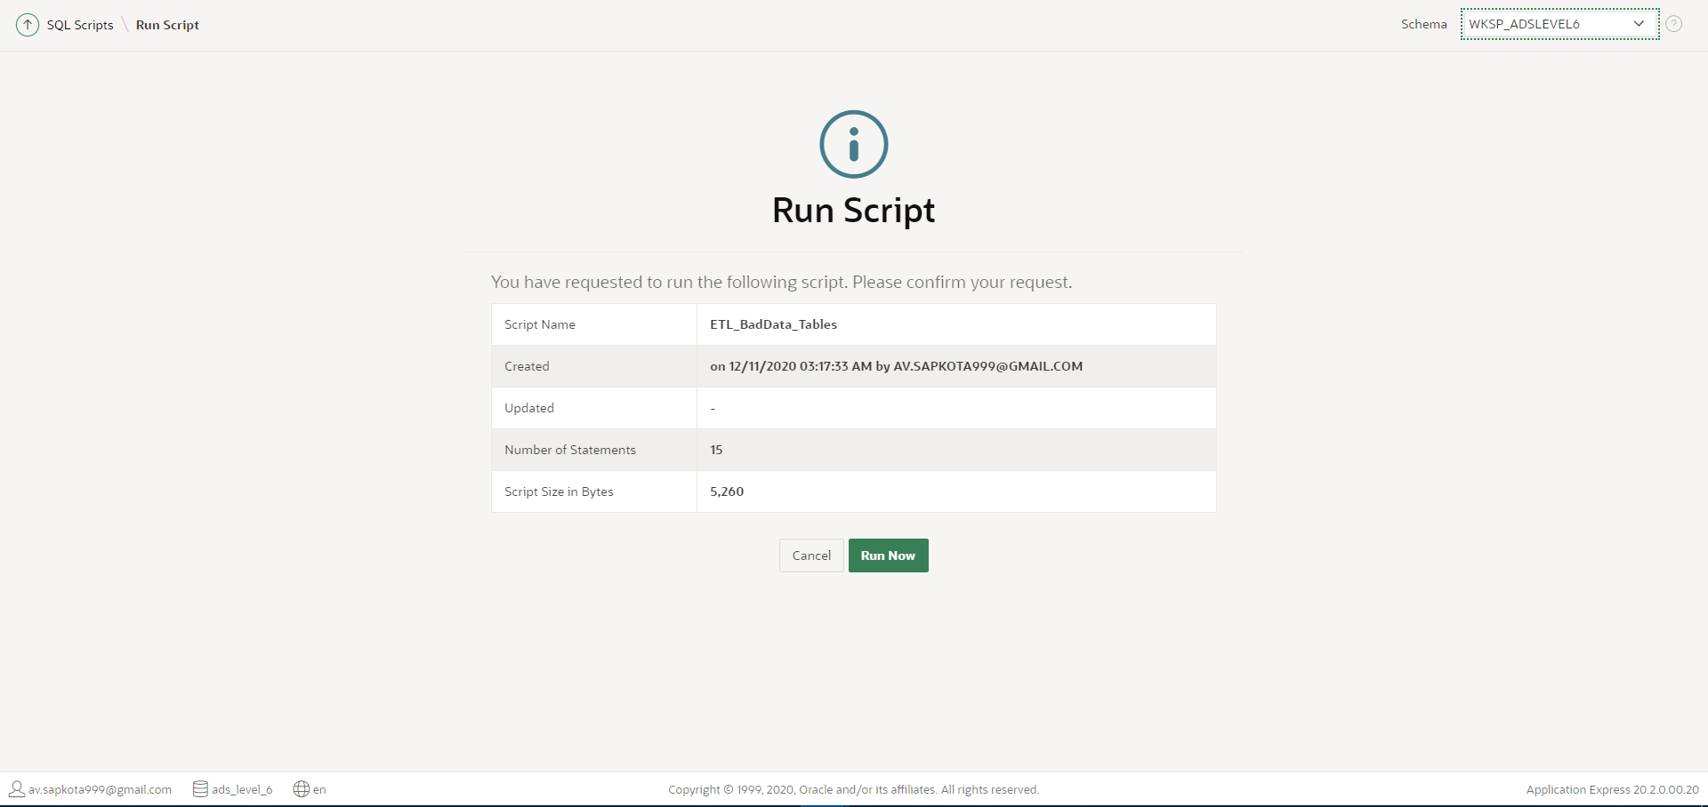

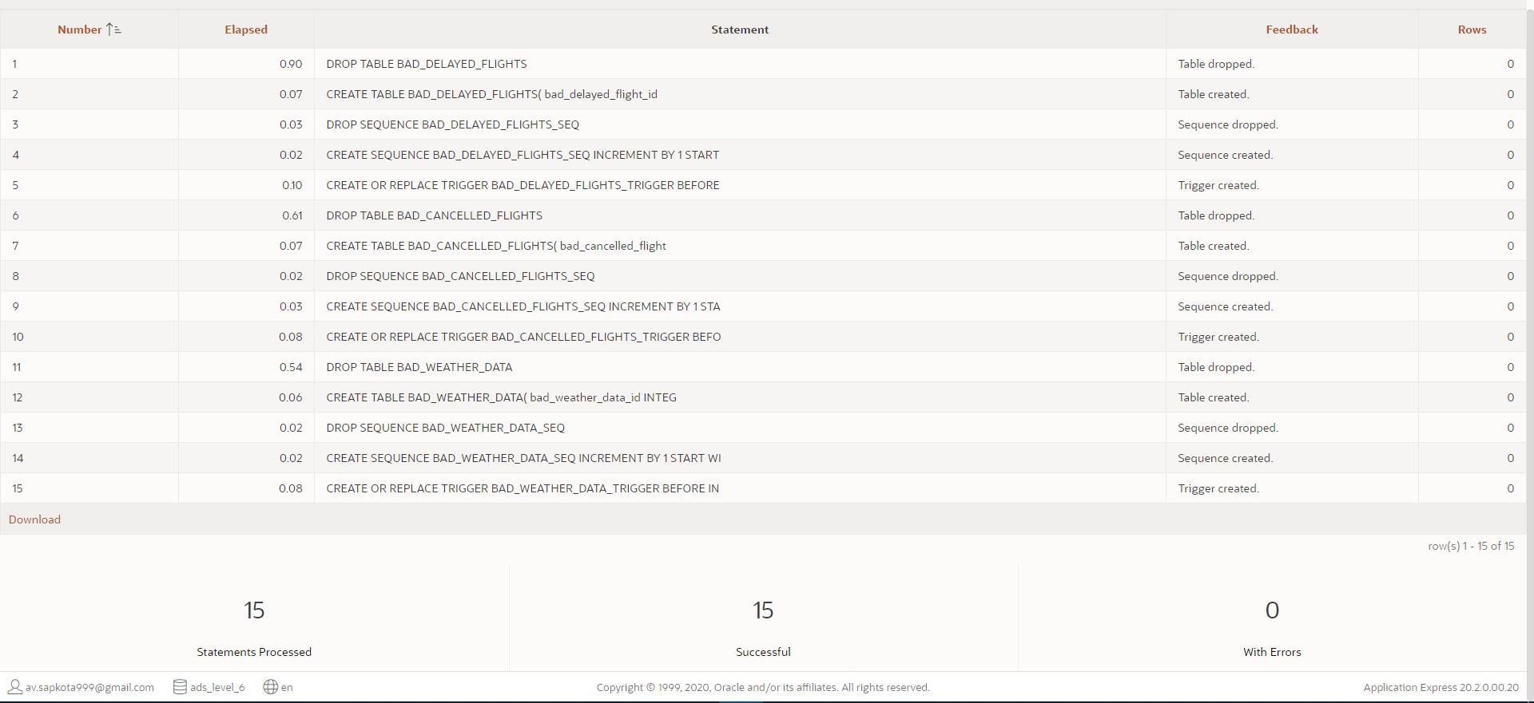

Henceforth after the creation of bad tables, bad data were identified from each staging table and were inserted into the bad tables using following code:

N.B. You can also find these codes in a separate file: ‘Task 3 - Transformation - Bad Data Insert PLSQL’ in the attached folder: ‘SQL Scripts’

---------------------------------------------------------------------------------

-- PL/SQL CODES TO IDENTIFY BAD DATA AND INSERT INTO BAD TABLE

---------------------------------------------------------------------------------

-- PROCEDURE TO IDENTIFY AND INSERT BAD DATA INTO BAD_DELAYED_FLIGHTS

CREATE OR REPLACE PROCEDURE PR_BAD_DELAYED_FLIGHTS

AS

BEGIN

-- IDENTIFYING BAD DATA AND INSERT INTO BAD TABLE

    FOR I IN (SELECT * FROM STAGING_DELAYED_FLIGHTS

              WHERE AIR_SYSTEM_DELAY IS NULL OR

              SECURITY_DELAY IS NULL OR

              AIRLINE_DELAY IS NULL OR

              LATE_AIRCRAFT_DELAY IS NULL OR

              WEATHER_DELAY IS NULL OR

              FLIGHTS_AIRLINE IS NULL

              ORDER BY DELAYED_FLIGHT_ID) LOOP

        INSERT INTO BAD_DELAYED_FLIGHTS (DELAYED_FLIGHT_ID, FLIGHT_NUMBER, TAIL_NUMBER, AIR_SYSTEM_DELAY, SECURITY_DELAY, AIRLINE_DELAY, LATE_AIRCRAFT_DELAY,

                    WEATHER_DELAY, FLIGHTS_AIRLINE, DATA_SOURCE, ERROR_DESCRIPTION, ERROR_STATUS, RESOLUTION_DATE)

        VALUES (I.DELAYED_FLIGHT_ID, I.FLIGHT_NUMBER, I.TAIL_NUMBER, I.AIR_SYSTEM_DELAY, I.SECURITY_DELAY, I.AIRLINE_DELAY, I.LATE_AIRCRAFT_DELAY, I.WEATHER_DELAY, I.FLIGHTS_AIRLINE, I.DATA_SOURCE,

                'NULL VALUES IN AIR_SYSTEM_DELAY / SECURITY_DELAY / AIRLINE_DELAY / LATE_AIRCRAFT_DELAY / WEATHER_DELAY / FLIGHTS_AIRLINE', 'UNRESOLVED', NULL);

    END LOOP;

END;

/

-- EXECUTE PROCEDURE PR_BAD_DELAYED_FLIGHTS

BEGIN

    PR_BAD_DELAYED_FLIGHTS;

END;

/

---------------------------------------------------------------------------------

---------------------------------------------------------------------------------

-- PROCEDURE TO IDENTIFY AND INSERT BAD DATA INTO BAD_CANCELLED_FLIGHTS

CREATE OR REPLACE PROCEDURE PR_BAD_CANCELLED_FLIGHTS

AS

BEGIN

-- IDENTIFYING BAD DATA AND INSERT INTO BAD TABLE

    FOR I IN (SELECT * FROM STAGING_CANCELLED_FLIGHTS

              WHERE TAIL_NUMBER IS NULL OR

              FLIGHTS_AIRLINE IS NULL OR

              LENGTH(CANCELLATION_REASON) = 1

              ORDER BY CANCELLED_FLIGHT_ID) LOOP

        INSERT INTO BAD_CANCELLED_FLIGHTS (CANCELLED_FLIGHT_ID, FLIGHT_NUMBER, TAIL_NUMBER, FLIGHTS_AIRLINE, CANCELLATION_REASON, DATA_SOURCE,

                    ERROR_DESCRIPTION, ERROR_STATUS, RESOLUTION_DATE)

        VALUES (I.CANCELLED_FLIGHT_ID, I.FLIGHT_NUMBER, I.TAIL_NUMBER, I.FLIGHTS_AIRLINE, I.CANCELLATION_REASON, I.DATA_SOURCE,

                'NULL VALUES IN TAIL_NUMBER / FLIGHTS_AIRLINE AND UNCLEAR CANCELLATION_REASON', 'UNRESOLVED', NULL);

    END LOOP;

END;

/

-- EXECUTE PROCEDURE PR_BAD_CANCELLED_FLIGHTS

BEGIN

    PR_BAD_CANCELLED_FLIGHTS;

END;

/

---------------------------------------------------------------------------------

---------------------------------------------------------------------------------

-- PROCEDURE TO IDENTIFY AND INSERT BAD DATA INTO BAD_WEATHER_DATA

CREATE OR REPLACE PROCEDURE PR_BAD_WEATHER_DATA

AS

BEGIN

-- IDENTIFYING BAD DATA AND INSERT INTO BAD TABLE

    FOR I IN (SELECT * FROM STAGING_WEATHER_DATA WHERE LENGTH(WEATHER_DATE) != 10

              ORDER BY WEATHER_DATA_ID) LOOP

        INSERT INTO BAD_WEATHER_DATA (WEATHER_DATA_ID, WEATHER_STATION, WEATHER_DATE, AWND, PRCP, TAVG, ERROR_DESCRIPTION, ERROR_STATUS, RESOLUTION_DATE)

        VALUES (I.WEATHER_DATA_ID, I.WEATHER_STATION, I.WEATHER_DATE, I.AWND, I.PRCP, I.TAVG, 'INCONSISTENT DATE VALUES CHANGE TO DD/MM/YYYY', 'UNRESOLVED', NULL);

    END LOOP;

END;

/

-- EXECUTE PROCEDURE PR_BAD_WEATHER_DATA

BEGIN

    PR_BAD_WEATHER_DATA;

END;

/

---------------------------------------------------------------------------------

---------------------------------------------------------------------------------

Screenshot: Procedure Created and Executed along with data inserted into the tables.

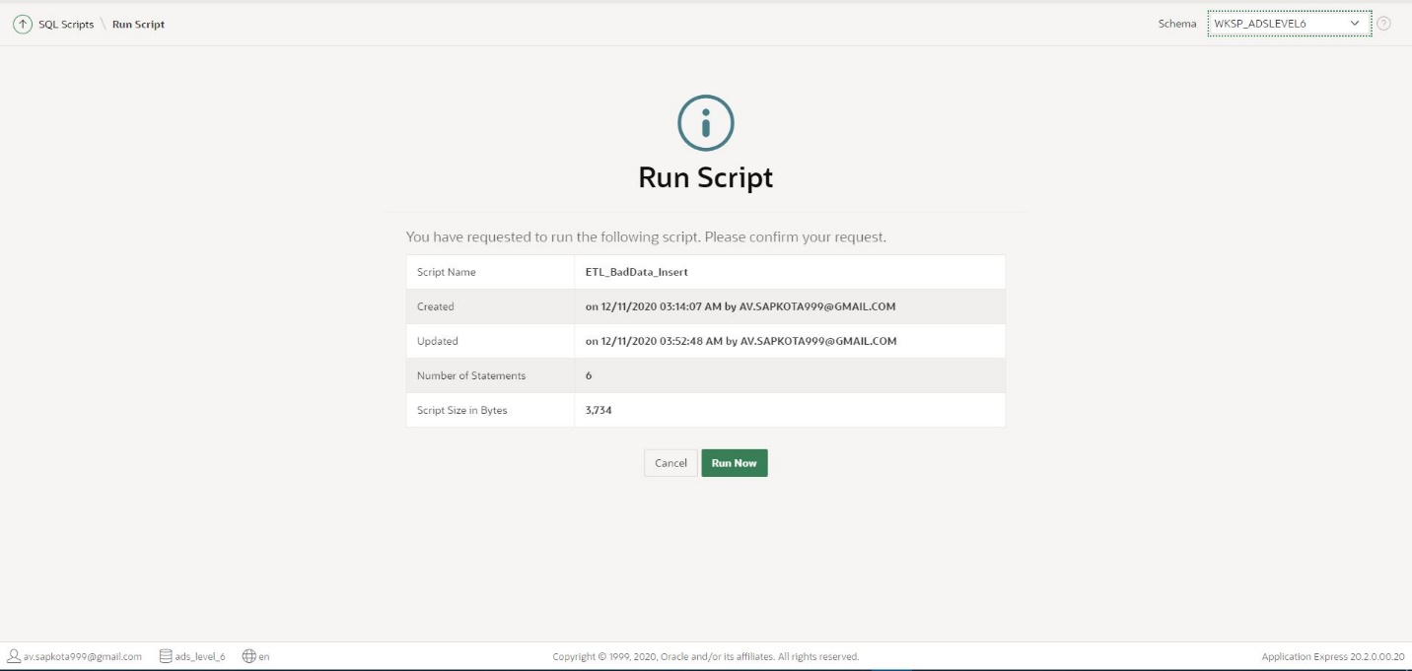

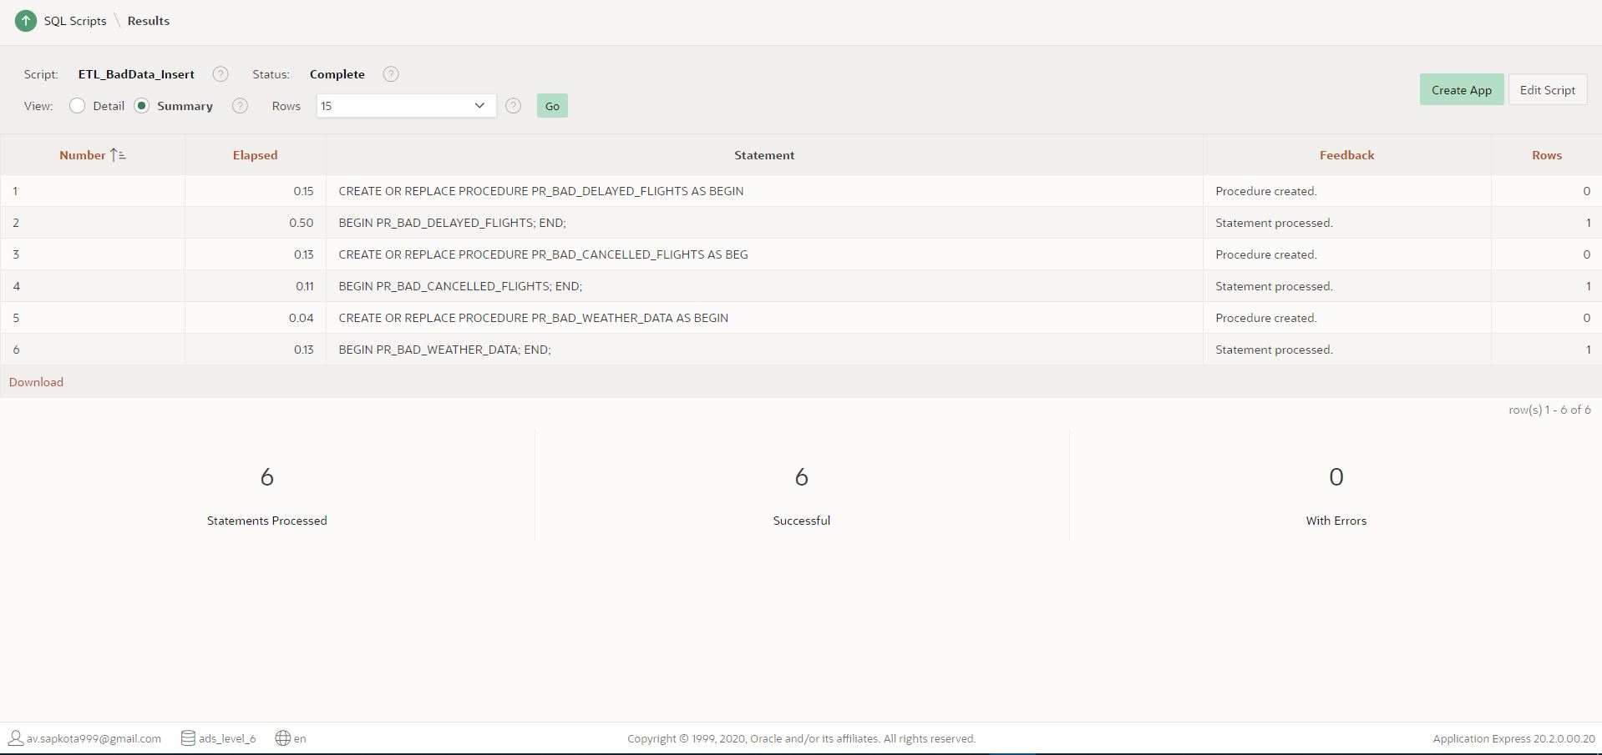

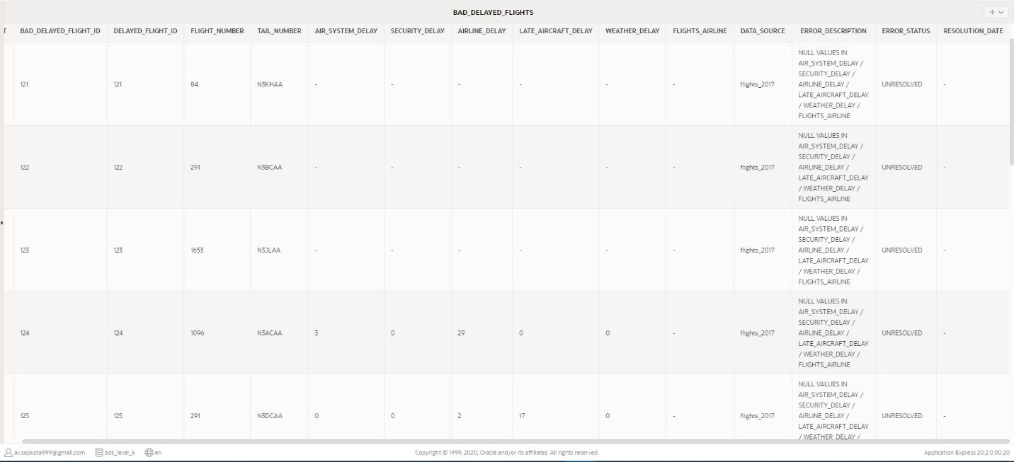 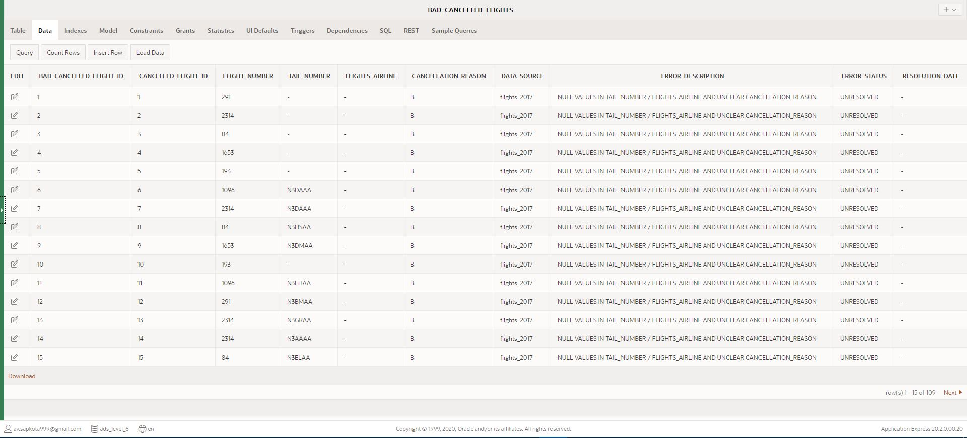 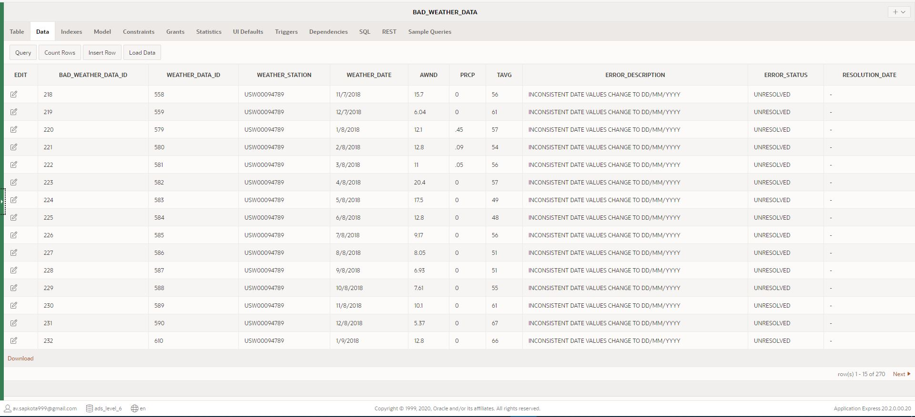

### Transformation: Good Data Identification and Insert

Secondly, good data tables are the tables which stores all the clean data from staging table or data which have been cleaned from bad tables. Good data tables were created, for each staging table, using following codes:

N.B. You can also find these codes in a separate file: ‘Task 3 - Transformation - Good Table Create SQL’ in the attached folder: ‘SQL Scripts’

----------------------------- GOOD DATA TABLES CREATION -------------------------

---------------------------------------------------------------------------------

---------------------------------------------------------------------------------

-- ALL SQL AND PL/SQL CODE REQUIRED FOR GOOD DATA TABLE: DIM_DELAYED_FLIGHTS

---------------------------------------------------------------------------------

-- DROP TABLE GOOD_DELAYED_FLIGHTS BEFORE CREATION

DROP TABLE GOOD_DELAYED_FLIGHTS;

-- CREATE TABLE GOOD_DELAYED_FLIGHTS

CREATE TABLE GOOD_DELAYED_FLIGHTS(

    delayed_flight_id   INTEGER NOT NULL,

    flight_number   INTEGER NOT NULL,

    tail_number VARCHAR(50) NOT NULL,

    air_system_delay    INTEGER,

    security_delay  INTEGER,

    airline_delay   INTEGER,

    late_aircraft_delay INTEGER,

    weather_delay   INTEGER,

    flights_airline VARCHAR(20) NOT NULL,

    Data_Source VARCHAR(20) NOT NULL,

    CONSTRAINT  pk_GOOD_DELAYED_FLIGHTS PRIMARY KEY (delayed_flight_id)

);

---------------------------------------------------------------------------------

---------------------------------------------------------------------------------

---------------------------------------------------------------------------------

-- ALL SQL AND PL/SQL CODE REQUIRED FOR GOOD TABLE: DIM_CANCELLED_FLIGHTS

---------------------------------------------------------------------------------

-- DROP TABLE GOOD_CANCELLED_FLIGHTS BEFORE CREATION

DROP TABLE GOOD_CANCELLED_FLIGHTS;

-- CREATE TABLE GOOD_CANCELLED_FLIGHTS

CREATE TABLE GOOD_CANCELLED_FLIGHTS(

    cancelled_flight_id INTEGER NOT NULL,

    flight_number   INTEGER NOT NULL,

    tail_number VARCHAR(50) NOT NULL,

    flights_airline VARCHAR(20) NOT NULL,

    cancellation_reason VARCHAR(120) NOT NULL,

    Data_Source VARCHAR(20) NOT NULL,

    CONSTRAINT  pk_GOOD_CANCELLED_FLIGHTS PRIMARY KEY (cancelled_flight_id)

);

---------------------------------------------------------------------------------

---------------------------------------------------------------------------------

---------------------------------------------------------------------------------

-- ALL SQL AND PL/SQL CODE REQUIRED FOR GOOD TABLE: DIM_WEATHER_DATA

---------------------------------------------------------------------------------

-- DROP TABLE GOOD_WEATHER_DATA BEFORE CREATION

DROP TABLE GOOD_WEATHER_DATA;

-- CREATE TABLE GOOD_WEATHER_DATA

CREATE TABLE GOOD_WEATHER_DATA(

    weather_data_id INTEGER NOT NULL,

    weather_station VARCHAR(20) NOT NULL,

    weather_date    DATE NOT NULL,

    AWND    FLOAT(8) NOT NULL,

    PRCP    FLOAT(8) NOT NULL,

    TAVG    INTEGER NOT NULL,

    CONSTRAINT  pk_GOOD_WEATHER_DATA PRIMARY KEY (weather_data_id)

);

---------------------------------------------------------------------------------

----------------------- END OF GOOD TABLE CREATION CODE -------------------------

---------------------------------------------------------------------------------

Screenshots: Good data table run and successfully created report.

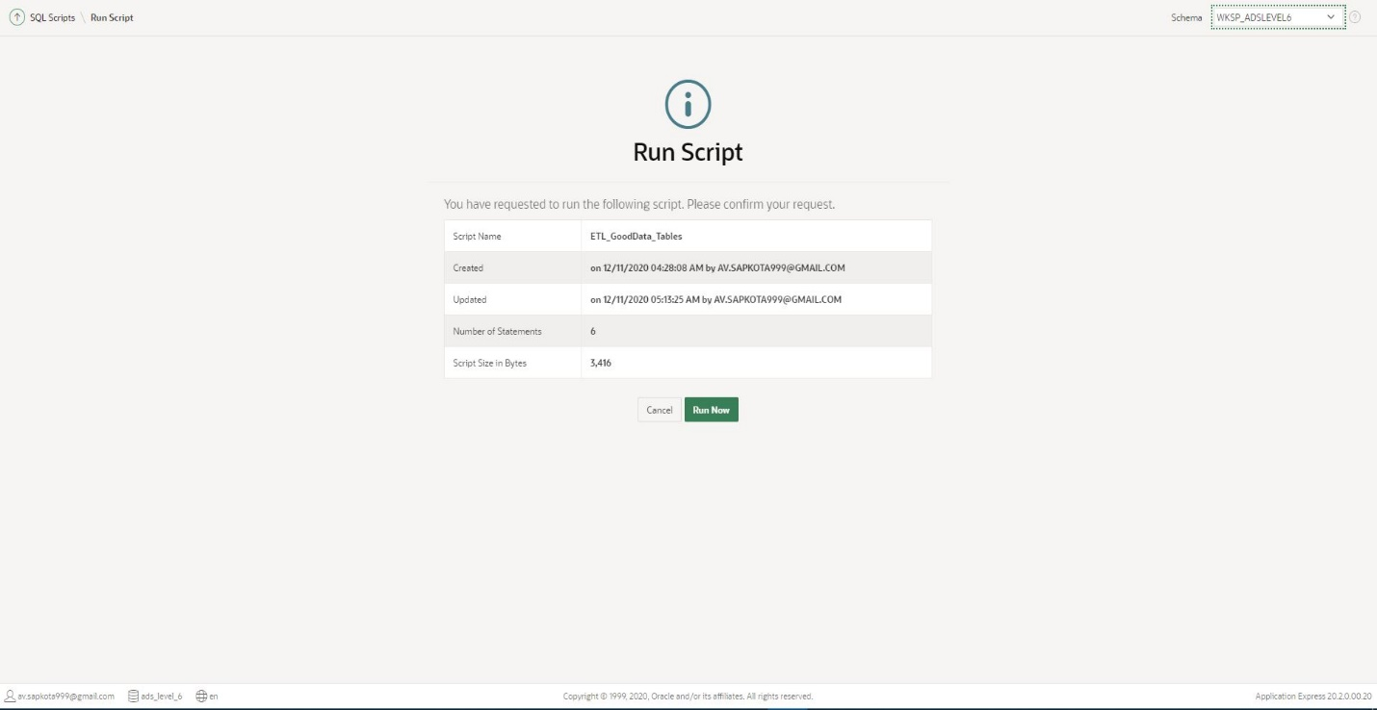

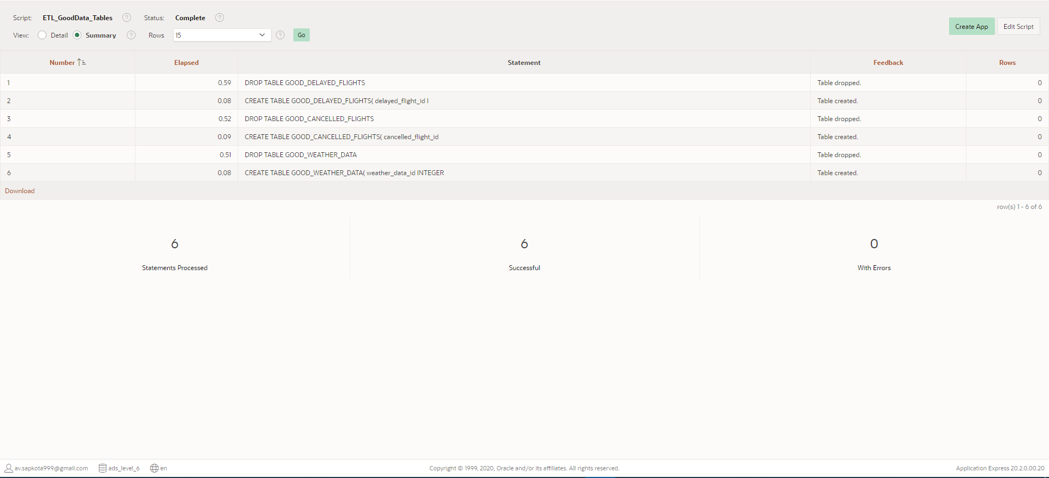

After the creation of good tables, good data were identified from each staging table and were inserted into the good tables using following code:

N.B. You can also find these codes in a separate file: ‘Task 3 - Transformation - Good Data Insert PLSQL’ in the attached folder: ‘SQL Scripts’

---------------------------------------------------------------------------------

-- PL/SQL CODES TO IDENTIFY CLEAN DATA AND INSERT INTO GOOD (CLEAN) TABLE

---------------------------------------------------------------------------------

-- PROCEDURE TO IDENTIFY AND INSERT CLEAN DATA INTO GOOD_DELAYED_FLIGHTS

CREATE OR REPLACE PROCEDURE PR_GOOD_DELAYED_FLIGHTS

AS

BEGIN

-- IDENTIFYING CLEAN DATA AND INSERT INTO GOOD TABLE

    FOR I IN (SELECT * FROM STAGING_DELAYED_FLIGHTS

              WHERE AIR_SYSTEM_DELAY IS NOT NULL AND

              SECURITY_DELAY IS NOT NULL AND

              AIRLINE_DELAY IS NOT NULL AND

              LATE_AIRCRAFT_DELAY IS NOT NULL AND

              WEATHER_DELAY IS NOT NULL AND

              FLIGHTS_AIRLINE IS NOT NULL

              ORDER BY DELAYED_FLIGHT_ID) LOOP

        INSERT INTO GOOD_DELAYED_FLIGHTS (DELAYED_FLIGHT_ID, FLIGHT_NUMBER, TAIL_NUMBER, AIR_SYSTEM_DELAY, SECURITY_DELAY,

                    AIRLINE_DELAY, LATE_AIRCRAFT_DELAY, WEATHER_DELAY, FLIGHTS_AIRLINE, DATA_SOURCE)

        VALUES (I.DELAYED_FLIGHT_ID, I.FLIGHT_NUMBER, I.TAIL_NUMBER, I.AIR_SYSTEM_DELAY, I.SECURITY_DELAY,

                    I.AIRLINE_DELAY, I.LATE_AIRCRAFT_DELAY, I.WEATHER_DELAY, I.FLIGHTS_AIRLINE, I.DATA_SOURCE);

    END LOOP;

END;

/

-- EXECUTE PROCEDURE PR_GOOD_DELAYED_FLIGHTS

BEGIN

    PR_GOOD_DELAYED_FLIGHTS;

END;

/

---------------------------------------------------------------------------------

---------------------------------------------------------------------------------

-- PROCEDURE TO IDENTIFY AND INSERT CLEAN DATA INTO GOOD_WEATHER_DATA

CREATE OR REPLACE PROCEDURE PR_GOOD_WEATHER_DATA

AS

BEGIN

-- IDENTIFYING CLEAN DATA AND INSERT INTO GOOD TABLE

FOR I IN (SELECT * FROM STAGING_WEATHER_DATA WHERE LENGTH(WEATHER_DATE) = 10

              ORDER BY WEATHER_DATA_ID) LOOP

        INSERT INTO GOOD_WEATHER_DATA (WEATHER_DATA_ID, WEATHER_STATION, WEATHER_DATE, AWND, PRCP, TAVG)

        VALUES (I.WEATHER_DATA_ID, I.WEATHER_STATION, TO_DATE(I.WEATHER_DATE, 'DD/MM/YYYY'), I.AWND, I.PRCP, I.TAVG);

    END LOOP;

END;

/

-- EXECUTE PROCEDURE PR_GOOD_WEATHER_DATA

BEGIN

    PR_GOOD_WEATHER_DATA;

END;

/

---------------------------------------------------------------------------------------------------------- END OF GOOD DATA INSERT CODE --------------------------

---------------------------------------------------------------------------------

Screenshots: Good Data Insert Script Run Report and Tables with data loaded.

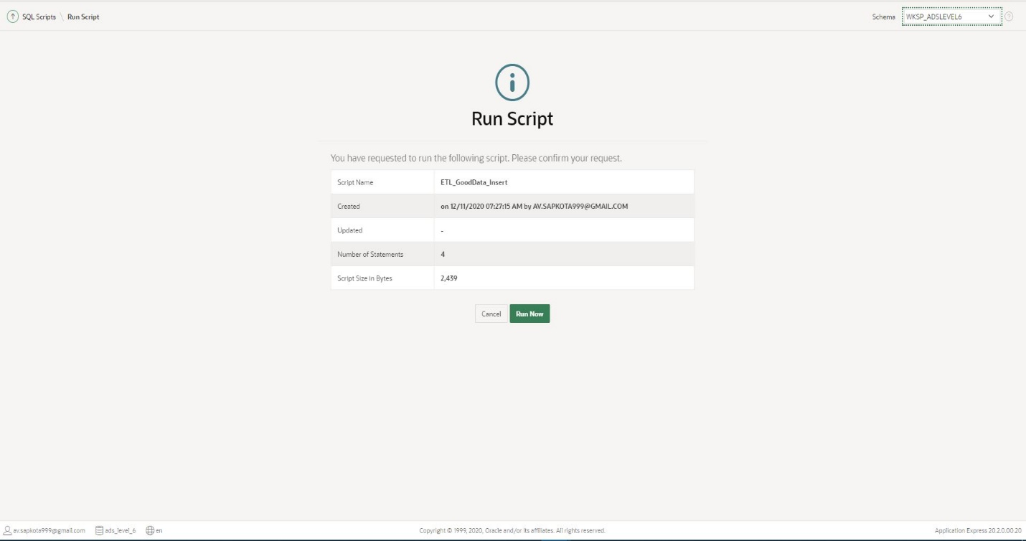

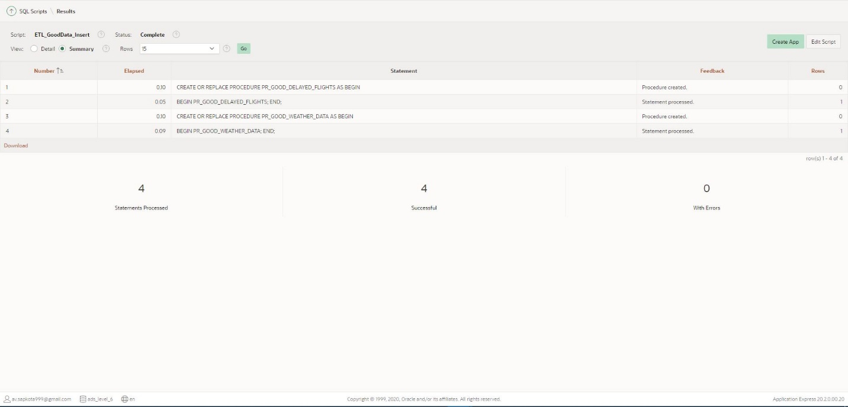

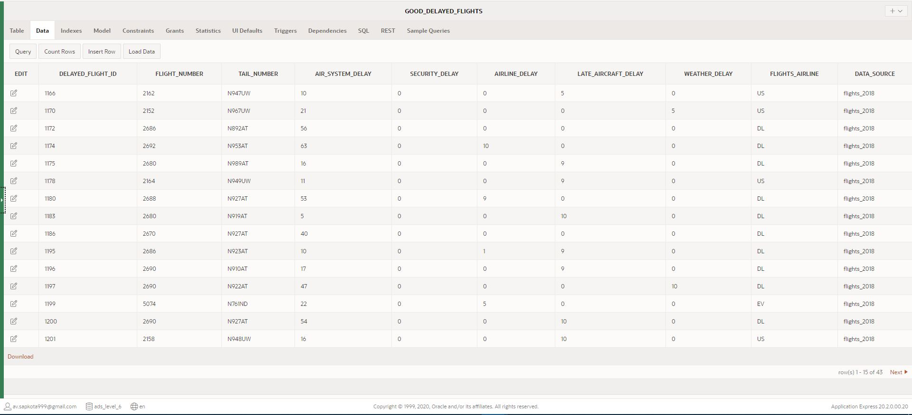

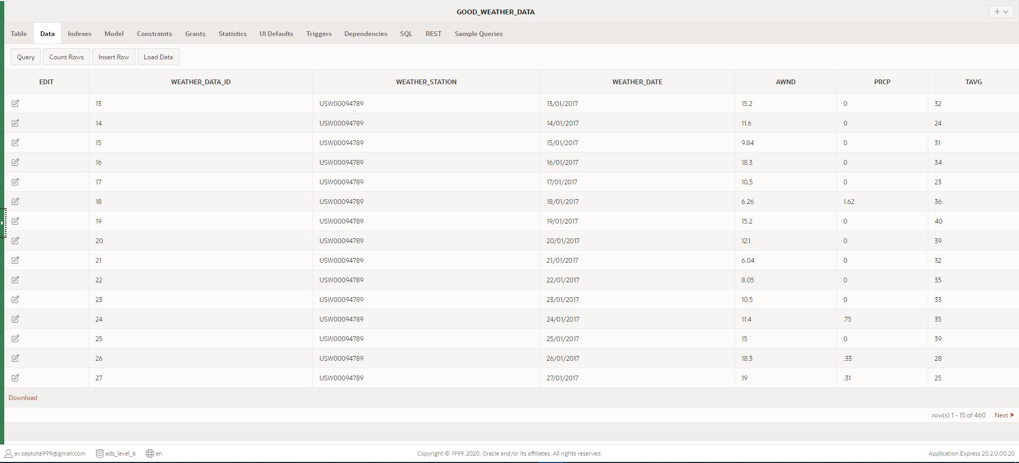

### Transformation: Bad Data Cleaning and Insert into Clean Tables

As cancelled flights did not have any good/clean data, no data has been inserted into GOOD_CANCELLED_FLIGHTS.

All the clean data has been inserted into the good tables however the bad data inserted into the bad tables from staging tables have not yet been cleaned. Hence, the following code was used to clean the bad data from bad tables and to insert those clean data to good table. The code also has updated bad table’s error status and resolution date.

N.B. You can also find these codes in a separate file: ‘Task 3 - Transformation - Bad Data Cleaning and Insert Into Good Table’ in the attached folder: ‘SQL Scripts’

---------------------------------------------------------------------------------

-- PL/SQL CODES TO IDENTIFY BAD DATA CLEAN THEM AND INSERT INTO GOOD TABLE

---------------------------------------------------------------------------------

-- PROCEDURE TO IDENTIFY BAD DATA, CLEAN THEM AND INSERT CLEAN DATA INTO GOOD_DELAYED_FLIGHTS

-- ALSO UPDATE BAD_DELAYED_FLIGHTS ON ERROR_STATUS AND RESOLUTION_DATE

CREATE OR REPLACE PROCEDURE PR_CLEAN_BAD_DELAYED_FLIGHTS

AS

    V_AIRSYSTEMDELAY NUMBER;

    V_SECURITYDELAY NUMBER;

    V_AIRLINEDELAY NUMBER;

    V_LATEAIRCRAFTDELAY NUMBER;

    V_WEATHERDELAY NUMBER;

    V_FLIGHTSAIRLINE VARCHAR(120);

    CURSOR CUR_DELAYED_FLIGHTS IS SELECT * FROM BAD_DELAYED_FLIGHTS;

BEGIN

    FOR C IN CUR_DELAYED_FLIGHTS LOOP

        V_AIRSYSTEMDELAY :='';

        V_SECURITYDELAY :='';

        V_AIRLINEDELAY :='';

        V_LATEAIRCRAFTDELAY :='';

        V_WEATHERDELAY :='';

        V_FLIGHTSAIRLINE :='';

        -- CLEANING THE BAD DATA

        IF C.AIR_SYSTEM_DELAY IS NOT NULL THEN

            V_AIRSYSTEMDELAY := C.AIR_SYSTEM_DELAY;

        ELSE

            V_AIRSYSTEMDELAY := 0;

        END IF;

        IF C.SECURITY_DELAY IS NOT NULL THEN

            V_SECURITYDELAY := C.SECURITY_DELAY;

        ELSE

            V_SECURITYDELAY := 0;

        END IF;

        IF C.AIRLINE_DELAY IS NOT NULL THEN

            V_AIRLINEDELAY := C.AIRLINE_DELAY;

        ELSE

            V_AIRLINEDELAY := 0;

        END IF;

        IF C.LATE_AIRCRAFT_DELAY IS NOT NULL THEN

            V_LATEAIRCRAFTDELAY := C.LATE_AIRCRAFT_DELAY;

        ELSE

            V_LATEAIRCRAFTDELAY := 0;

        END IF;

        IF C.WEATHER_DELAY IS NOT NULL THEN

            V_WEATHERDELAY := C.WEATHER_DELAY;

        ELSE

            V_WEATHERDELAY := 0;

        END IF;

        IF C.FLIGHTS_AIRLINE IS NOT NULL THEN

            V_FLIGHTSAIRLINE := C.FLIGHTS_AIRLINE;

        ELSE

            V_FLIGHTSAIRLINE := 'UNKNOWN';

        END IF;

        -- INSERTING THE CLEAN DATA

        MERGE INTO GOOD_DELAYED_FLIGHTS GDF

        USING (SELECT * FROM BAD_DELAYED_FLIGHTS WHERE DELAYED_FLIGHT_ID=C.DELAYED_FLIGHT_ID)  BDF

        ON (GDF.DELAYED_FLIGHT_ID = BDF.DELAYED_FLIGHT_ID)

        WHEN MATCHED

            THEN UPDATE SET

                GDF.FLIGHT_NUMBER = BDF.FLIGHT_NUMBER,

                GDF.TAIL_NUMBER = BDF.TAIL_NUMBER,

                GDF.DATA_SOURCE = BDF.DATA_SOURCE

        WHEN NOT MATCHED

            THEN

                INSERT (DELAYED_FLIGHT_ID, FLIGHT_NUMBER, TAIL_NUMBER, AIR_SYSTEM_DELAY, SECURITY_DELAY, AIRLINE_DELAY, LATE_AIRCRAFT_DELAY, WEATHER_DELAY, FLIGHTS_AIRLINE, DATA_SOURCE)

                VALUES (BDF.DELAYED_FLIGHT_ID, BDF.FLIGHT_NUMBER, BDF.TAIL_NUMBER, V_AIRSYSTEMDELAY, V_SECURITYDELAY, V_AIRLINEDELAY, V_LATEAIRCRAFTDELAY, V_WEATHERDELAY, V_FLIGHTSAIRLINE, BDF.DATA_SOURCE);

        -- UPDATING BAD_DELAYED_FLIGHTS TABLE

        UPDATE BAD_DELAYED_FLIGHTS SET ERROR_STATUS = 'RESOLVED', RESOLUTION_DATE = SYSDATE WHERE DELAYED_FLIGHT_ID = C.DELAYED_FLIGHT_ID;

    END LOOP;

END;

/

-- EXECUTE PROCEDURE PR_CLEAN_BAD_DELAYED_FLIGHTS

BEGIN

    PR_CLEAN_BAD_DELAYED_FLIGHTS;

END;

/

---------------------------------------------------------------------------------

---------------------------------------------------------------------------------

-- PROCEDURE TO IDENTIFY BAD DATA, CLEAN THEM AND INSERT CLEAN DATA INTO GOOD_CANCELLED_FLIGHTS

-- ALSO UPDATE BAD_CANCELLED_FLIGHTS ON ERROR_STATUS AND RESOLUTION_DATE

CREATE OR REPLACE PROCEDURE PR_CLEAN_BAD_CANCELLED_FLIGHTS

AS

    V_TAILNUMBER VARCHAR(20);

    V_FLIGHTSAIRLINE VARCHAR(20);

    V_CANCELLATIONREASON VARCHAR(120);

    CURSOR CUR_CANCELLED_FLIGHTS IS SELECT * FROM BAD_CANCELLED_FLIGHTS;

BEGIN

    FOR C IN CUR_CANCELLED_FLIGHTS LOOP

        V_TAILNUMBER := '';

        V_FLIGHTSAIRLINE := '';

        V_CANCELLATIONREASON := '';

        -- CLEANING THE BAD DATA

        IF C.TAIL_NUMBER IS NOT NULL THEN

            V_TAILNUMBER := C.TAIL_NUMBER;

        ELSE

            V_TAILNUMBER := 'UNKNOWN';

        END IF;

        IF C.FLIGHTS_AIRLINE IS NOT NULL THEN

            V_FLIGHTSAIRLINE := C.FLIGHTS_AIRLINE;

        ELSE

            V_FLIGHTSAIRLINE := 'UNKNOWN';

        END IF;

        IF C.CANCELLATION_REASON = 'A' THEN

            V_CANCELLATIONREASON := 'ADVERSE WEATHER CONDITION';

        ELSIF C.CANCELLATION_REASON = 'B' THEN

            V_CANCELLATIONREASON := 'AIR TRAFFIC RESTRICTIONS';

        ELSE

            V_CANCELLATIONREASON := 'AIR SYSTEM / MECHANICAL ISSUES';

        END IF;

        MERGE INTO GOOD_CANCELLED_FLIGHTS GCF

        USING (SELECT * FROM BAD_CANCELLED_FLIGHTS WHERE CANCELLED_FLIGHT_ID = C.CANCELLED_FLIGHT_ID) BCF

        ON (GCF.CANCELLED_FLIGHT_ID = BCF.CANCELLED_FLIGHT_ID)

        -- INSERTING INTO GOOD_CANCELLED_FLIGHTS

        WHEN MATCHED

            THEN UPDATE SET

                GCF.FLIGHT_NUMBER = BCF.FLIGHT_NUMBER

        WHEN NOT MATCHED

            THEN

                INSERT (CANCELLED_FLIGHT_ID, FLIGHT_NUMBER, TAIL_NUMBER, FLIGHTS_AIRLINE, CANCELLATION_REASON, DATA_SOURCE)

                VALUES (BCF.CANCELLED_FLIGHT_ID, BCF.FLIGHT_NUMBER, V_TAILNUMBER, V_FLIGHTSAIRLINE, V_CANCELLATIONREASON, BCF.DATA_SOURCE);

        -- UPDATING BAD_CANCELLED_FLIGHTS TABLE

        UPDATE BAD_CANCELLED_FLIGHTS SET ERROR_STATUS = 'RESOLVED', RESOLUTION_DATE = SYSDATE WHERE CANCELLED_FLIGHT_ID = C.CANCELLED_FLIGHT_ID;

    END LOOP;

END;

/

-- EXECUTE PROCEDURE PR_CLEAN_BAD_CANCELLED_FLIGHTS

BEGIN

    PR_CLEAN_BAD_CANCELLED_FLIGHTS;

END;

/

---------------------------------------------------------------------------------

---------------------------------------------------------------------------------

-- PROCEDURE TO IDENTIFY BAD DATA, CLEAN THEM AND INSERT CLEAN DATA INTO GOOD_WEATHER_DATA

-- ALSO UPDATE BAD_WEATHER_DATA ON ERROR_STATUS AND RESOLUTION_DATE

CREATE OR REPLACE PROCEDURE PR_CLEAN_BAD_WEATHER_DATA

AS

    V_WEATHERDATE DATE;

    CURSOR CUR_WEATHER_DATA IS SELECT * FROM BAD_WEATHER_DATA;

BEGIN

    FOR C IN CUR_WEATHER_DATA LOOP

        -- CLEANING THE BAD DATA

        V_WEATHERDATE := TO_DATE(C.WEATHER_DATE, 'DD/MM/YYYY');

        -- INSERTING INTO GOOD_WEATHER_DATA

        MERGE INTO GOOD_WEATHER_DATA GWD

        USING (SELECT * FROM BAD_WEATHER_DATA WHERE WEATHER_DATA_ID = C.WEATHER_DATA_ID) BWD

        ON (GWD.WEATHER_DATA_ID = BWD.WEATHER_DATA_ID)

        WHEN MATCHED

            THEN UPDATE SET

               GWD.WEATHER_STATION = BWD.WEATHER_STATION

        WHEN NOT MATCHED

            THEN

                INSERT(WEATHER_DATA_ID, WEATHER_STATION, WEATHER_DATE, AWND, PRCP, TAVG)

                VALUES(BWD.WEATHER_DATA_ID, BWD.WEATHER_STATION, V_WEATHERDATE, BWD.AWND, BWD.PRCP, BWD.TAVG);

        -- UPDATING BAD_WEATHER_DATA TABLE

        UPDATE BAD_WEATHER_DATA SET ERROR_STATUS = 'RESOLVED', RESOLUTION_DATE = SYSDATE WHERE WEATHER_DATA_ID = C.WEATHER_DATA_ID;

        V_WEATHERDATE := '';

    END LOOP;

END;

/

-- EXECUTE PROCEDURE PR_CLEAN_BAD_WEATHER_DATA

BEGIN

    PR_CLEAN_BAD_WEATHER_DATA;

END;

/

---------------------------------------------------------------------------------

------ END OF BAD DATA IDENTIFICATION, CLEANING AND INSERT INTO GOOD TABLES -----

---------------------------------------------------------------------------------

Screenshots: Procedure Statements Run Report along with Clean data Inserted into the good tables, bad tables updated and total number of rows in all three tables compared to staging tables.

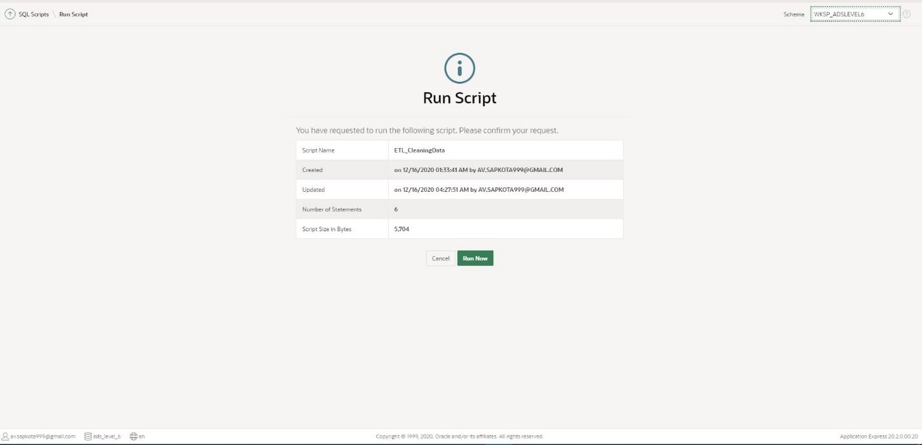

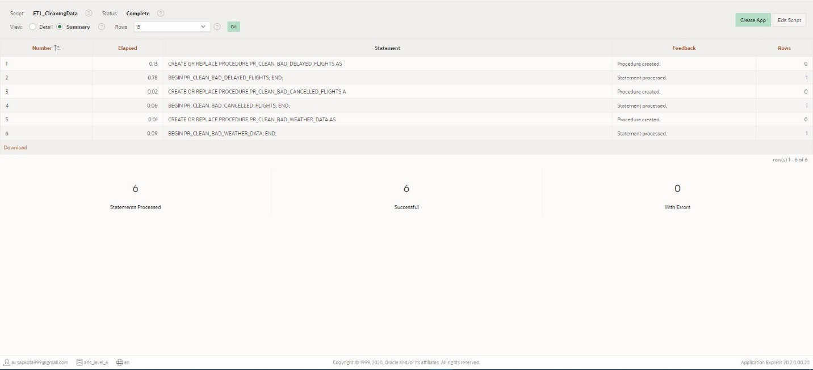

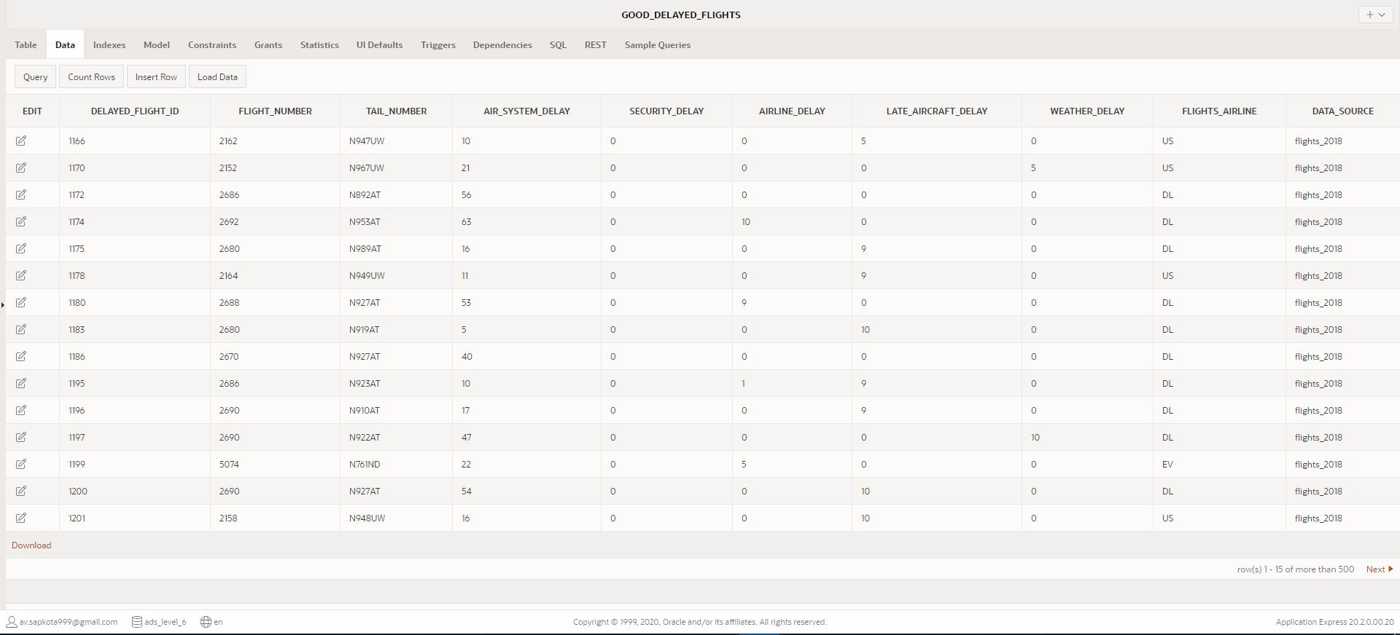

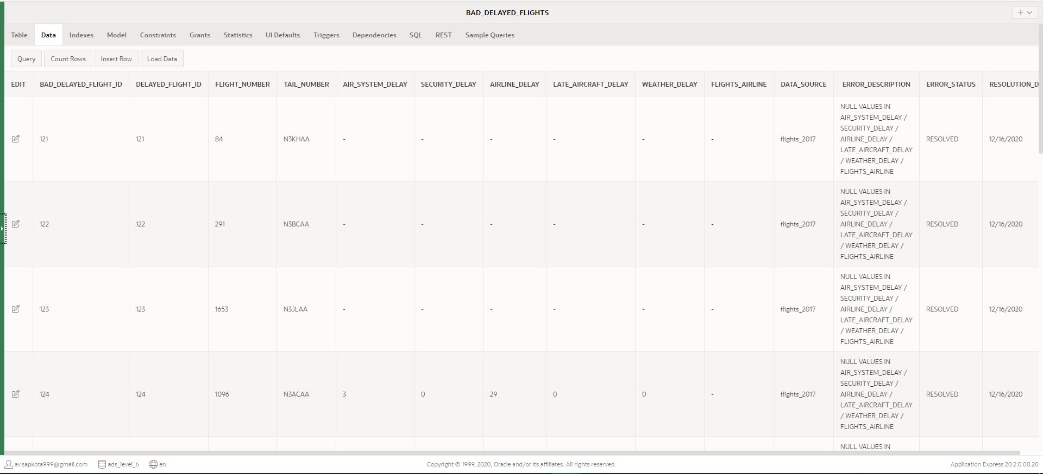

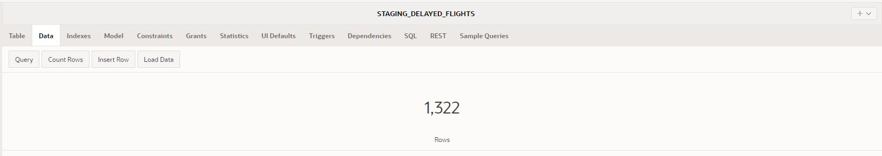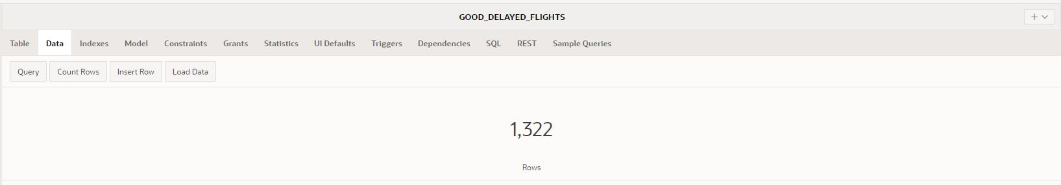

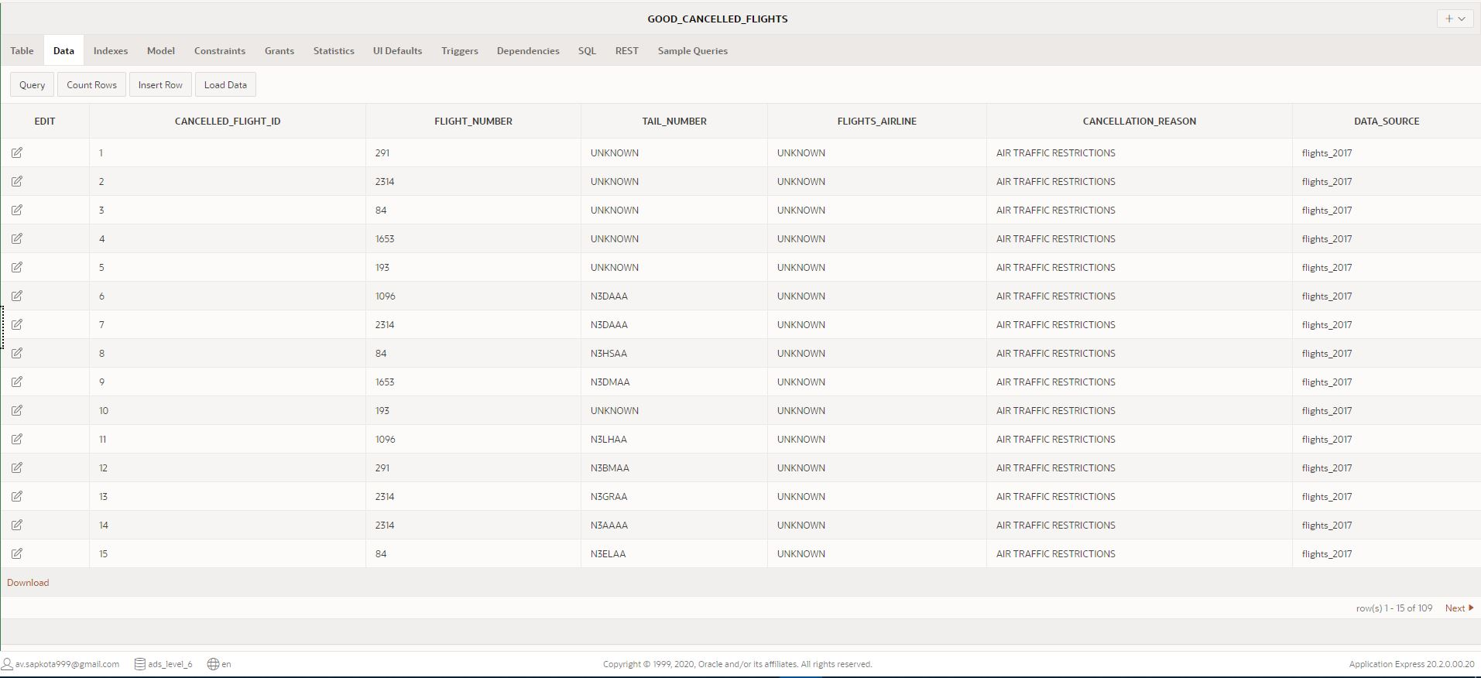

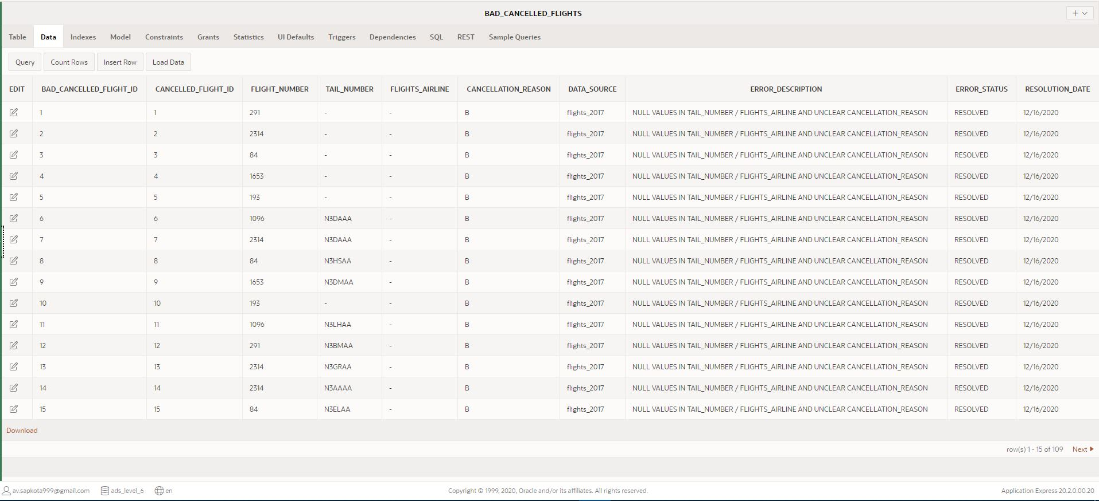

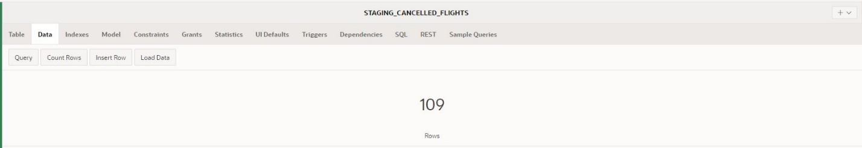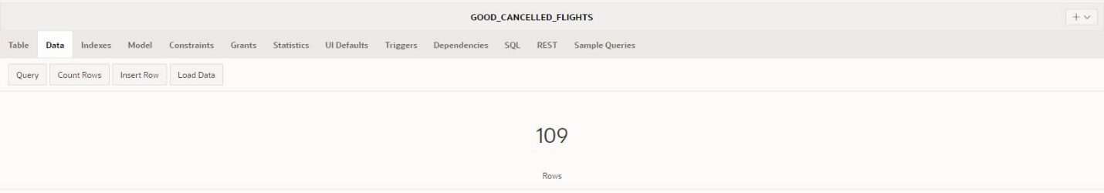

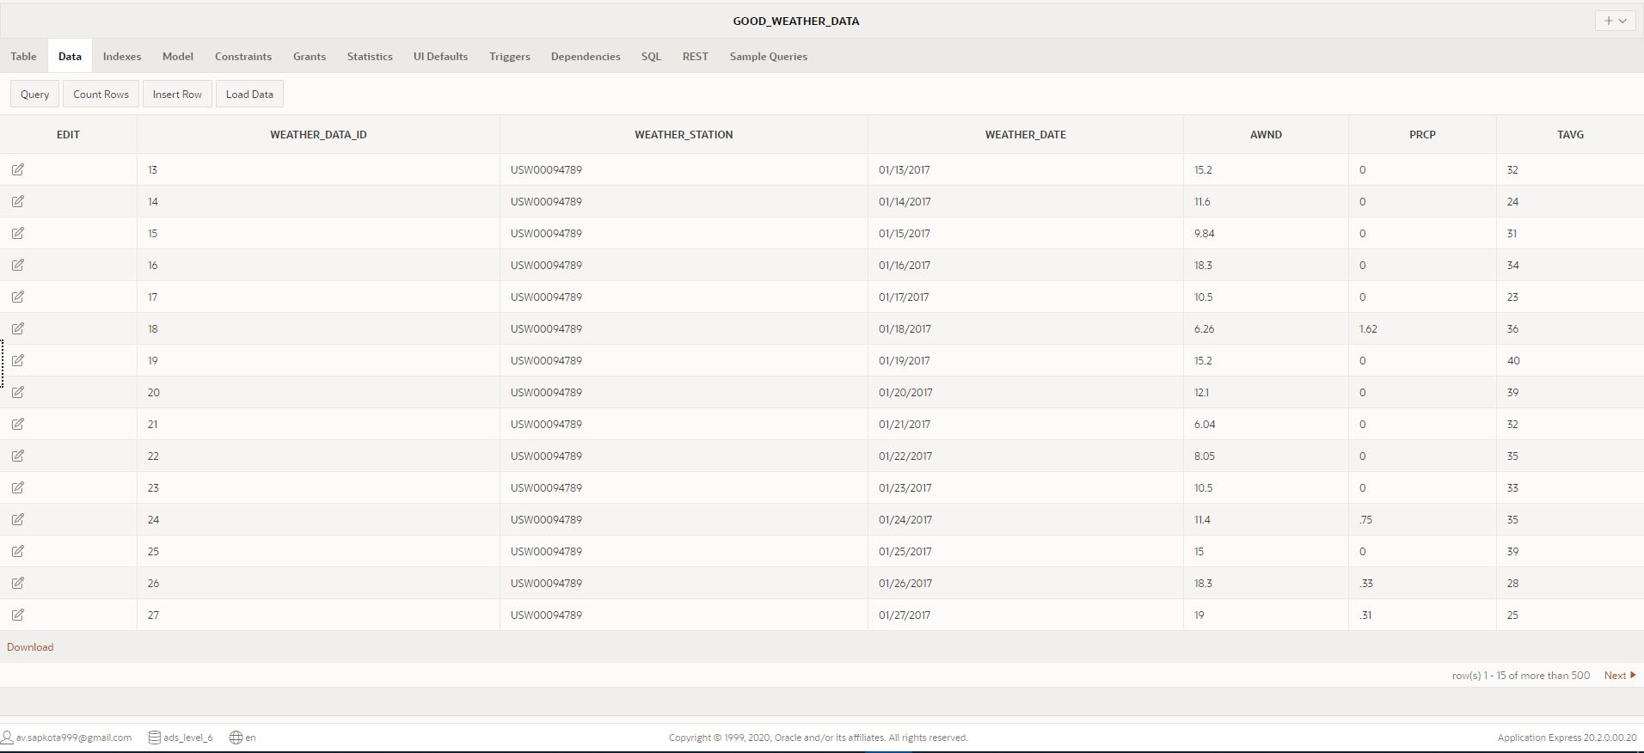

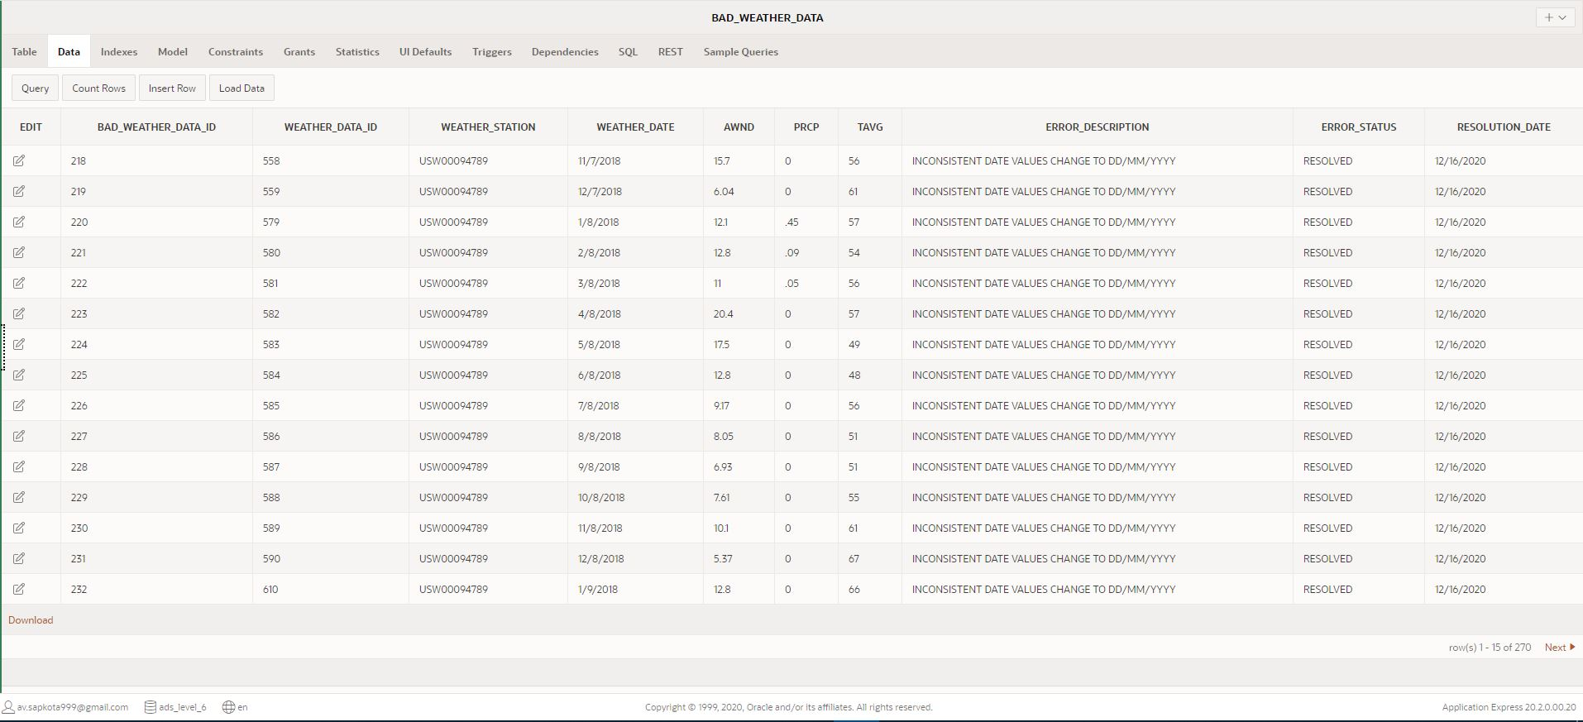

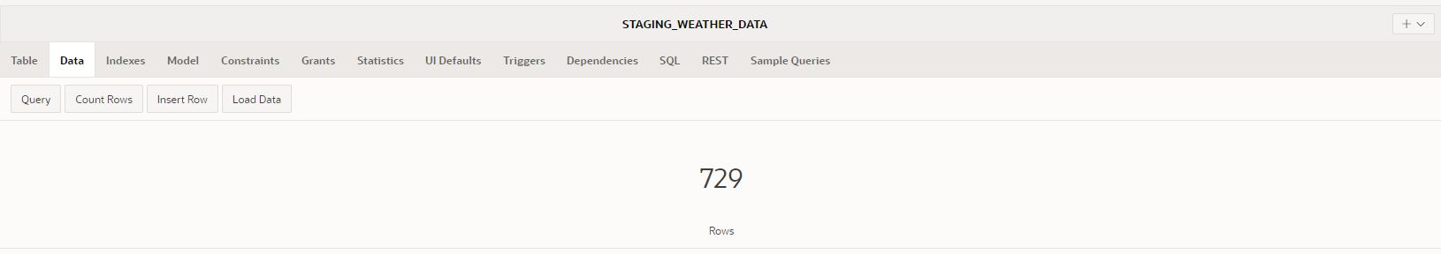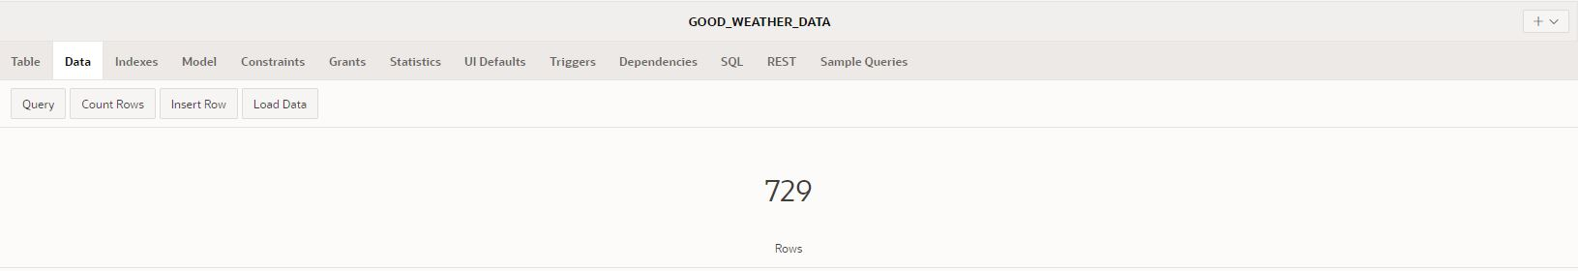

### Transformation: Into Transform Tables

In order to transform the clean data from good tables, transformation tables have to be created. Thus, three transformation table for delayed flights, cancelled flights and weather data have been created using following code:

N.B. You can also find these codes in a separate file: ‘Task 3 - Transformation - Transformation Table Create SQL’ in the attached folder: ‘SQL Scripts’

--------------------------- TRANSFORMATION DATA TABLES --------------------------

---------------------------------------------------------------------------------

---------------------------------------------------------------------------------

-- ALL SQL AND PL/SQL CODE REQUIRED FOR TRANSFORMATION TABLE: DIM_DELAYED_FLIGHTS

---------------------------------------------------------------------------------

-- DROP TABLE TRANSFORM_DELAYED_FLIGHTS BEFORE CREATION

DROP TABLE TRANSFORM_DELAYED_FLIGHTS;

-- CREATE TABLE TRANSFORM_DELAYED_FLIGHTS

CREATE TABLE TRANSFORM_DELAYED_FLIGHTS(

    delayed_flight_id   INTEGER NOT NULL,

    flight_number   INTEGER NOT NULL,

    tail_number VARCHAR(50) NOT NULL,

    air_system_delay    INTEGER NOT NULL,

    security_delay  INTEGER NOT NULL,

    airline_delay   INTEGER NOT NULL,

    late_aircraft_delay INTEGER NOT NULL,

    weather_delay   INTEGER NOT NULL,

    flights_airline VARCHAR(20) NOT NULL,

    Data_Source VARCHAR(20) NOT NULL,

    CONSTRAINT  pk_TRANSFORM_DELAYED_FLIGHTS PRIMARY KEY (delayed_flight_id)

);

---------------------------------------------------------------------------------

---------------------------------------------------------------------------------

---------------------------------------------------------------------------------

--ALL SQL AND PL/SQL CODE REQUIRED FOR TRANSFORMATION TABLE: DIM_CANCELLED_FLIGHTS

---------------------------------------------------------------------------------

-- DROP TABLE TRANSFORM_CANCELLED_FLIGHTS BEFORE CREATION

DROP TABLE TRANSFORM_CANCELLED_FLIGHTS;

-- CREATE TABLE TRANSFORM_CANCELLED_FLIGHTS

CREATE TABLE TRANSFORM_CANCELLED_FLIGHTS(

    cancelled_flight_id INTEGER NOT NULL,

    flight_number   INTEGER NOT NULL,

    tail_number VARCHAR(50) NOT NULL,

    flights_airline VARCHAR(20) NOT NULL,

    cancellation_reason VARCHAR(120) NOT NULL,

    Data_Source VARCHAR(20) NOT NULL,

    CONSTRAINT  pk_TRANSFORM_CANCELLED_FLIGHTS PRIMARY KEY (cancelled_flight_id)

);

---------------------------------------------------------------------------------

---------------------------------------------------------------------------------

---------------------------------------------------------------------------------

-- ALL SQL AND PL/SQL CODE REQUIRED FOR TRANSFORMATION TABLE: DIM_WEATHER_DATA

---------------------------------------------------------------------------------

-- DROP TABLE TRANSFORM_WEATHER_DATA BEFORE CREATION

DROP TABLE TRANSFORM_WEATHER_DATA;

-- CREATE TABLE TRANSFORM_WEATHER_DATA

CREATE TABLE TRANSFORM_WEATHER_DATA(

    weather_data_id INTEGER NOT NULL,

    weather_station VARCHAR(20) NOT NULL,

    weather_date    DATE NOT NULL,

    AWND    FLOAT(8) NOT NULL,

    PRCP    FLOAT(8) NOT NULL,

    TAVG    INTEGER NOT NULL,

    CONSTRAINT  pk_TRANSFORM_WEATHER_DATA PRIMARY KEY (weather_data_id)

);

------------------------------------------------------------------------------------------------------- END OF TRANSFORMATION TABLE CREATION CODE ----------------

---------------------------------------------------------------------------------

Screenshots: Transformation Tables created run and report

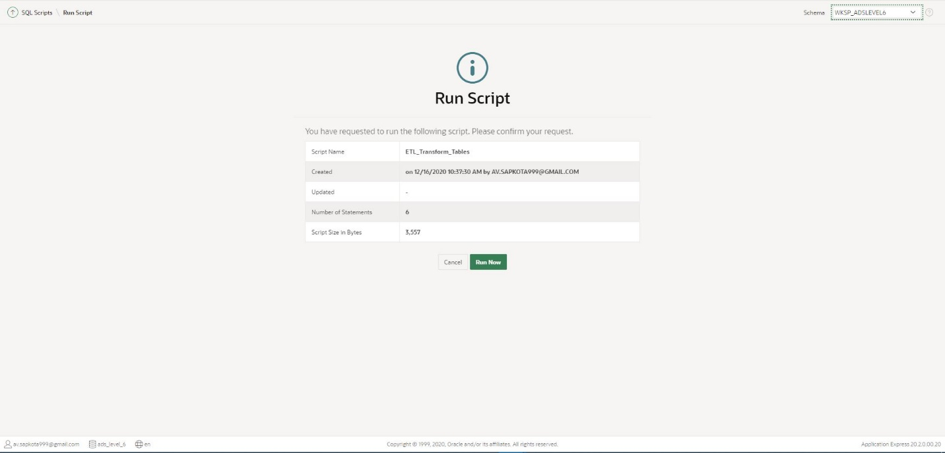

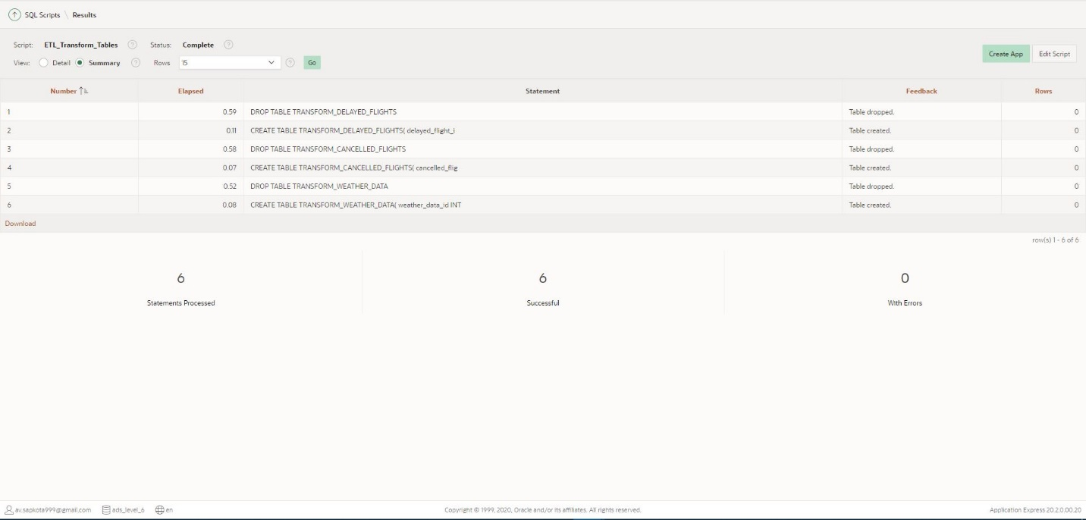

Creation of transformation table is the prerequisites to insert data from clean tables. So, data were inserted into these transformation tables using the following code:

N.B. You can also find these codes in a separate file: ‘Task 3 - Transformation - Insert Data into Transform Table PLSQL’ in the attached folder: ‘SQL Scripts’

---------------------------------------------------------------------------------

-- PL/SQL CODES TO INSERT THE DATA FROM GOOD TABLES INTO TRANSFORMATION TABLES

---------------------------------------------------------------------------------

-- PROCEDURE TO INSERT DATA FROM GOOD_DELAYED_FLIGHTS INTO TRANSFORM_DELAYED_FLIGHTS

CREATE OR REPLACE PROCEDURE PR_INSERT_TRANSFORM_DELAYED_FLIGHTS

AS

BEGIN

-- MERGING ALL DATA INTO TRANSFORMATION TABLE

    MERGE INTO TRANSFORM_DELAYED_FLIGHTS TDF

    USING GOOD_DELAYED_FLIGHTS GDF

    ON (TDF.DELAYED_FLIGHT_ID = GDF.DELAYED_FLIGHT_ID)

-- UPDATE DATA IF MATCHED

    WHEN MATCHED THEN

        UPDATE SET

            TDF.FLIGHT_NUMBER = GDF.FLIGHT_NUMBER,

            TDF.TAIL_NUMBER = GDF.TAIL_NUMBER,

            TDF.AIR_SYSTEM_DELAY = GDF.AIR_SYSTEM_DELAY,

            TDF.SECURITY_DELAY = GDF.SECURITY_DELAY,

            TDF.AIRLINE_DELAY = GDF.AIRLINE_DELAY,

            TDF.LATE_AIRCRAFT_DELAY = GDF.LATE_AIRCRAFT_DELAY,

            TDF.WEATHER_DELAY = GDF.WEATHER_DELAY,

            TDF.FLIGHTS_AIRLINE = GDF.FLIGHTS_AIRLINE,

            TDF.DATA_SOURCE = GDF.DATA_SOURCE

-- INSERT DATA IF NOT MATCHED

    WHEN NOT MATCHED THEN

        INSERT (DELAYED_FLIGHT_ID, FLIGHT_NUMBER, TAIL_NUMBER, AIR_SYSTEM_DELAY, SECURITY_DELAY, AIRLINE_DELAY, LATE_AIRCRAFT_DELAY, WEATHER_DELAY, FLIGHTS_AIRLINE, DATA_SOURCE)

        VALUES (GDF.DELAYED_FLIGHT_ID, GDF.FLIGHT_NUMBER, GDF.TAIL_NUMBER, GDF.AIR_SYSTEM_DELAY, GDF.SECURITY_DELAY, GDF.AIRLINE_DELAY, GDF.LATE_AIRCRAFT_DELAY, GDF.WEATHER_DELAY, GDF.FLIGHTS_AIRLINE, GDF.DATA_SOURCE);

END;

/

-- EXECUTE PR_INSERT_TRANSFORM_DELAYED_FLIGHTS

BEGIN

    PR_INSERT_TRANSFORM_DELAYED_FLIGHTS;

END;

/

---------------------------------------------------------------------------------

---------------------------------------------------------------------------------

-- PROCEDURE TO INSERT DATA FROM GOOD_CANCELLED_FLIGHTS INTO TRANSFORM_CANCELLED_FLIGHTS

CREATE OR REPLACE PROCEDURE PR_INSERT_TRANSFORM_CANCELLED_FLIGHTS

AS

BEGIN

-- MERGING ALL DATA INTO TRANSFORMATION TABLE

    MERGE INTO TRANSFORM_CANCELLED_FLIGHTS TCF

    USING GOOD_CANCELLED_FLIGHTS GCF

    ON (TCF.CANCELLED_FLIGHT_ID = GCF.CANCELLED_FLIGHT_ID)

-- UPDATE DATA IF MATCHED

    WHEN MATCHED THEN

        UPDATE SET

            TCF.FLIGHT_NUMBER = GCF.FLIGHT_NUMBER,

            TCF.TAIL_NUMBER = GCF.TAIL_NUMBER,

            TCF.FLIGHTS_AIRLINE =  GCF.FLIGHTS_AIRLINE,

            TCF.CANCELLATION_REASON = GCF.CANCELLATION_REASON,

            TCF.DATA_SOURCE = GCF.DATA_SOURCE

-- INSERT DATA IF NOT MATCHED

    WHEN NOT MATCHED THEN

        INSERT (CANCELLED_FLIGHT_ID, FLIGHT_NUMBER, TAIL_NUMBER, FLIGHTS_AIRLINE, CANCELLATION_REASON, DATA_SOURCE)

        VALUES (GCF.CANCELLED_FLIGHT_ID, GCF.FLIGHT_NUMBER, GCF.TAIL_NUMBER, GCF.FLIGHTS_AIRLINE, GCF.CANCELLATION_REASON, GCF.DATA_SOURCE);

END;

/

-- EXECUTE PR_INSERT_TRANSFORM_CANCELLED_FLIGHTS

BEGIN

    PR_INSERT_TRANSFORM_CANCELLED_FLIGHTS;

END;

/

---------------------------------------------------------------------------------

---------------------------------------------------------------------------------

-- PROCEDURE TO INSERT DATA FROM GOOD_WEATHER_DATA INTO TRANSFORM_WEATHER_DATA

CREATE OR REPLACE PROCEDURE PR_INSERT_TRANSFORM_WEATHER_DATA

AS

BEGIN

-- MERGING ALL DATA INTO TRANSFORMATION TABLE

    MERGE INTO TRANSFORM_WEATHER_DATA TWD

    USING GOOD_WEATHER_DATA GWD

    ON (TWD.WEATHER_DATA_ID = GWD.WEATHER_DATA_ID)

-- UPDATE DATA IF MATCHED

    WHEN MATCHED THEN

        UPDATE SET

            TWD.WEATHER_STATION = GWD.WEATHER_STATION,

            TWD.WEATHER_DATE = GWD.WEATHER_DATE,

            TWD.AWND = GWD.AWND,

            TWD.PRCP = GWD.PRCP,

            TWD.TAVG = GWD.TAVG

-- INSERT DATA IF NOT MATCHED

    WHEN NOT MATCHED THEN

        INSERT (WEATHER_DATA_ID, WEATHER_STATION, WEATHER_DATE, AWND, PRCP, TAVG)

        VALUES (GWD.WEATHER_DATA_ID, GWD.WEATHER_STATION, GWD.WEATHER_DATE, GWD.AWND, GWD.PRCP, GWD.TAVG);

END;

/

-- EXECUTE PR_INSERT_TRANSFORM_WEATHER_DATA

BEGIN

    PR_INSERT_TRANSFORM_WEATHER_DATA;

END;

/

---------------------------------------------------------------------------------

----------------- END OF INSERT INTO TRANSFORMATION TABLE CODES -----------------

---------------------------------------------------------------------------------

Screenshots: Procedure Statements Run Report, Data Inserted into Transformation Table.

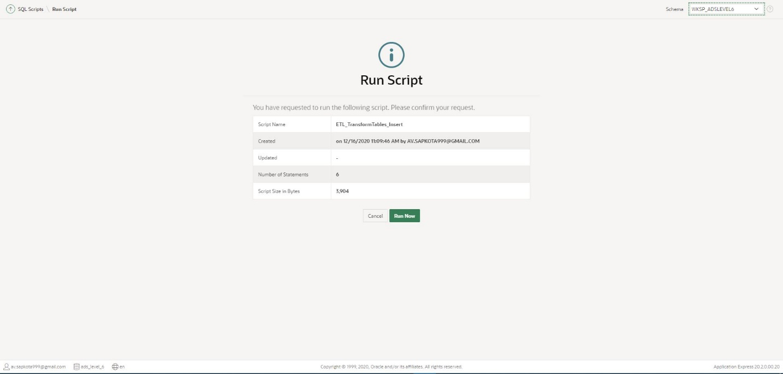

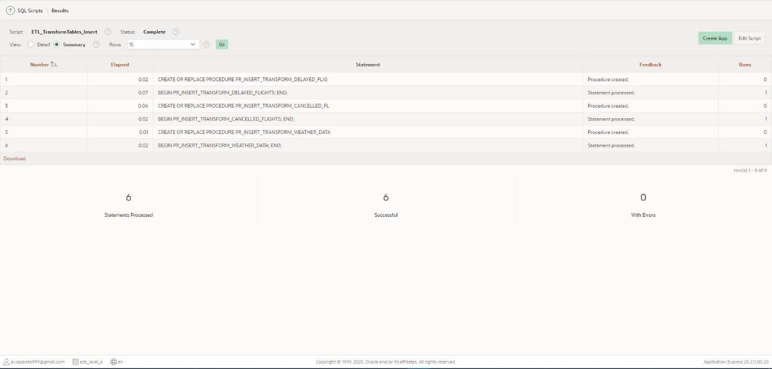

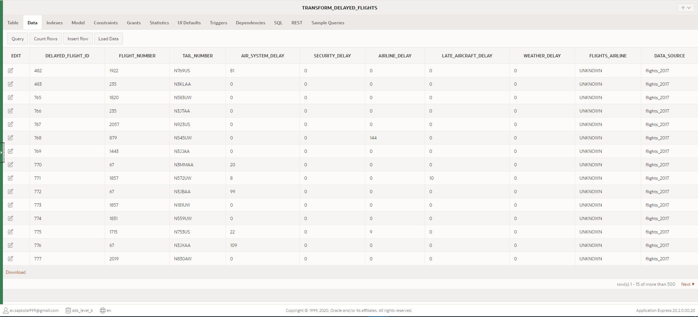

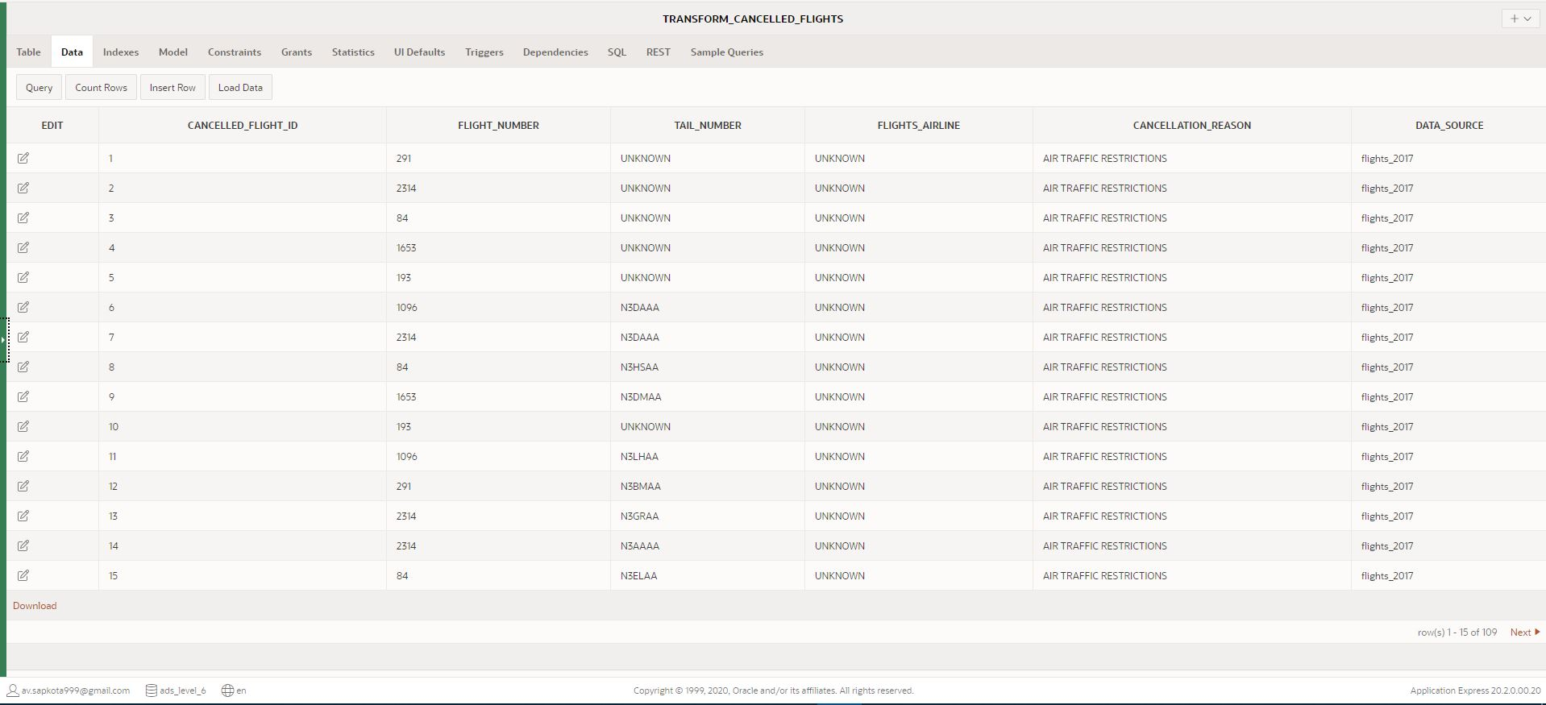

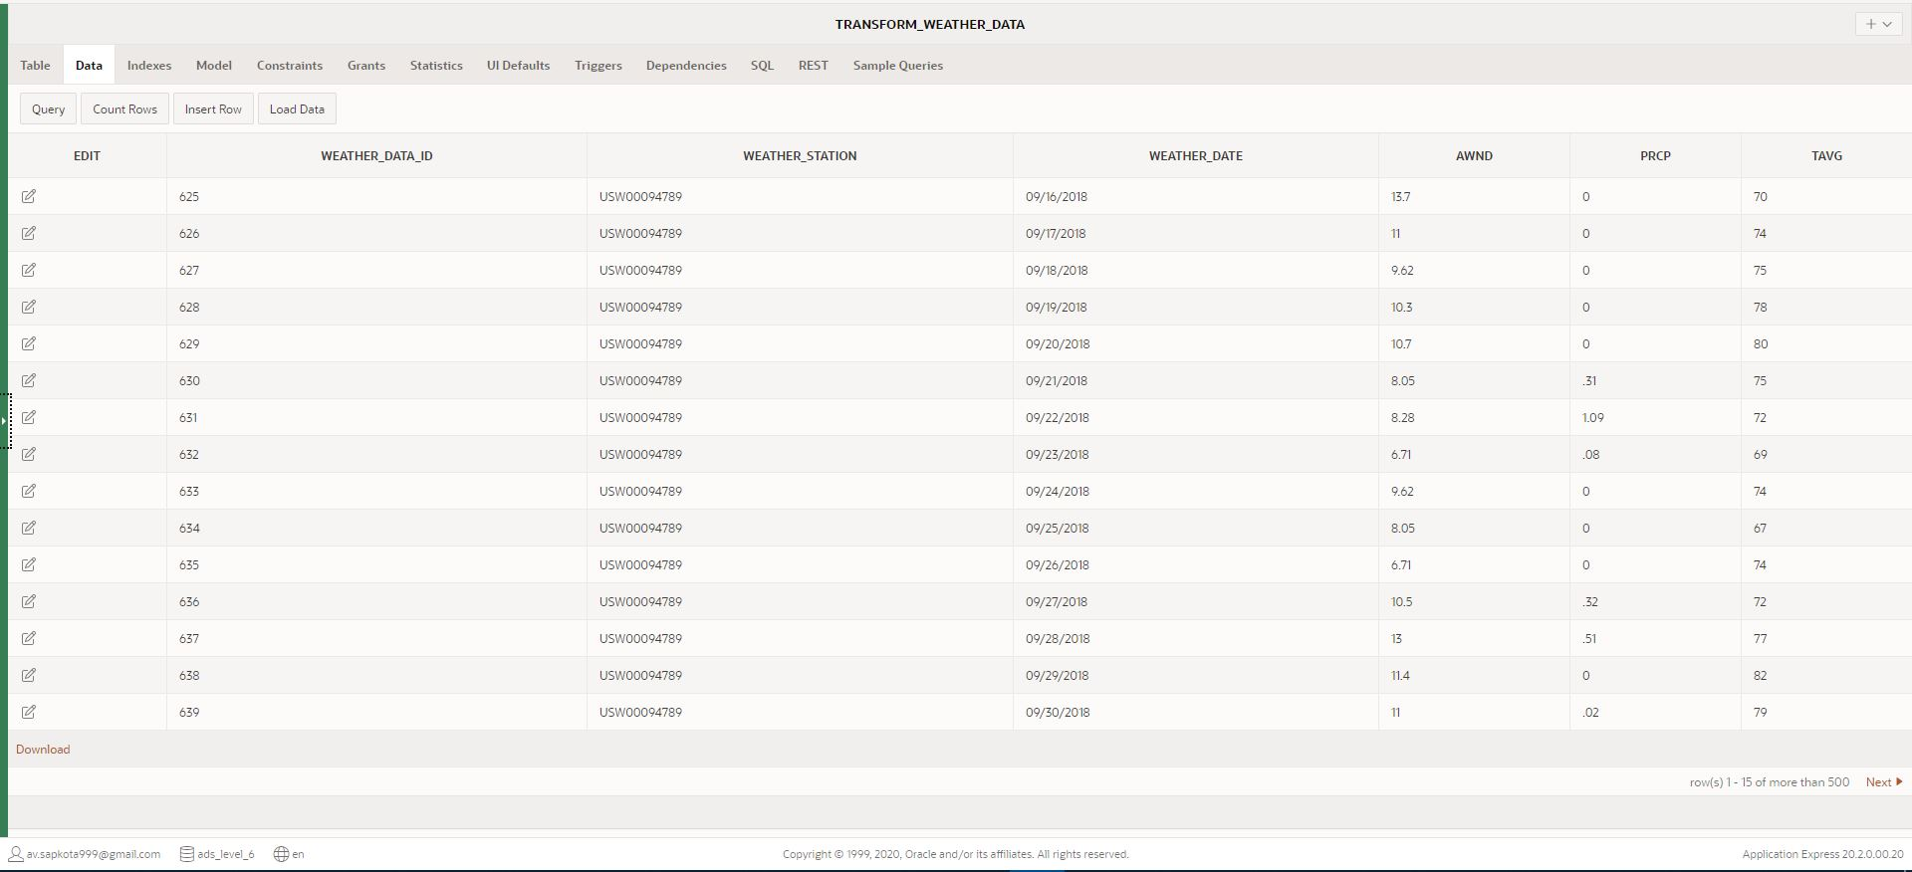

## Loading

Loading data into the target data warehouse is the last step of ETL process. Huge volume of data is inserted into fact and dim tables from transformation tables. Firstly, to start the loading of data from transformation table had to be inserted into dim tables, which has been performed using the following code:

N.B. You can also find these codes in a separate file: ‘Task 3 - Loading - Insert data into Dim table PLSQL’ in the attached folder: ‘SQL Scripts’

---------------------------------------------------------------------------------

-- PL/SQL INSERT DATA INTO DIM TABLES

---------------------------------------------------------------------------------

-- PROCEDURE TO INSERT DATA FROM TRANSFORMATION TABLES INTO DIM TABLES

CREATE OR REPLACE PROCEDURE PR_INSERT_INTO_DIM_TABLES

AS

    CURSOR CURR_DELAYED_FLIGHTS IS SELECT * FROM TRANSFORM_DELAYED_FLIGHTS;

    CURSOR CURR_CANCELLED_FLIGHTS IS SELECT * FROM TRANSFORM_CANCELLED_FLIGHTS;

    CURSOR CURR_WEATHER_DATA IS SELECT * FROM TRANSFORM_WEATHER_DATA;

BEGIN

    -- INSERTING DATA INTO DIM_DELAYED_FLIGHTS

    FOR CDF IN CURR_DELAYED_FLIGHTS LOOP

        INSERT INTO DIM_DELAYED_FLIGHTS (DELAYED_FLIGHT_ID, FLIGHT_NUMBER, TAIL_NUMBER, AIR_SYSTEM_DELAY, SECURITY_DELAY, AIRLINE_DELAY, LATE_AIRCRAFT_DELAY, WEATHER_DELAY, FLIGHTS_AIRLINE, DATA_SOURCE)

        VALUES (CDF.DELAYED_FLIGHT_ID, CDF.FLIGHT_NUMBER, CDF.TAIL_NUMBER, CDF.AIR_SYSTEM_DELAY, CDF.SECURITY_DELAY, CDF.AIRLINE_DELAY, CDF.LATE_AIRCRAFT_DELAY, CDF.WEATHER_DELAY, CDF.FLIGHTS_AIRLINE, CDF.DATA_SOURCE);

    END LOOP;

    -- INSERTING DATA INTO DIM_CANCELLED_FLIGHTS

    FOR CCF IN CURR_CANCELLED_FLIGHTS LOOP

        INSERT INTO DIM_CANCELLED_FLIGHTS (CANCELLED_FLIGHT_ID, FLIGHT_NUMBER, TAIL_NUMBER, FLIGHTS_AIRLINE, CANCELLATION_REASON, DATA_SOURCE)

        VALUES (CCF.CANCELLED_FLIGHT_ID, CCF.FLIGHT_NUMBER, CCF.TAIL_NUMBER, CCF.FLIGHTS_AIRLINE, CCF.CANCELLATION_REASON, CCF.DATA_SOURCE);

    END LOOP;

    -- INSERTING DATA INTO DIM_WEATHER_DATA

    FOR CWD IN CURR_WEATHER_DATA LOOP

        INSERT INTO DIM_WEATHER_DATA (WEATHER_DATA_ID, WEATHER_STATION, WEATHER_DATE, AWND, PRCP, TAVG)

        VALUES (CWD.WEATHER_DATA_ID, CWD.WEATHER_STATION, CWD.WEATHER_DATE, CWD.AWND, CWD.PRCP, CWD.TAVG);

    END LOOP;

END;

/

-- EXECUTE PROCEDURE PR_INSERT_INTO_DIM_TABLES

BEGIN

    PR_INSERT_INTO_DIM_TABLES;

END;

/

---------------------------------------------------------------------------------

---------------------------------------------------------------------------------

-- DROP SEQUENCE DIM_TIME_SEQ BEFORE CREATION

DROP SEQUENCE DIM_TIME_SEQ;

-- CREATE SEQUENCE DIM_TIME_SEQ

CREATE SEQUENCE DIM_TIME_SEQ INCREMENT BY 1 START WITH 1;

-- CREATE TRIGGER WHICH INCREASES THE VALUE OF PRIMARY KEY EVERY TIME A NEW DATA IS INSERTED.

CREATE OR REPLACE TRIGGER DIM_TIME_TRIGGER

BEFORE INSERT ON DIM_TIME

FOR EACH ROW

BEGIN

    :new.time_id := DIM_TIME_SEQ.NEXTVAL;

END;

/

-- PL/SQL TO INSERT ONLY THE YEAR INTO DIM TIME SO THAT FLIGHTS DETAILS WHOSE MONTH IS NOT SPECIFIED CAN BE LINKED.

CREATE OR REPLACE PROCEDURE PR_YEAR_INSERT_INTO_DIM_TIME

AS

    CURSOR CUR_TIME IS (

        SELECT DISTINCT YEAR FROM FLIGHTS_2017

        UNION

        SELECT DISTINCT YEAR FROM FLIGHTS_2018

        UNION

        SELECT DISTINCT FLIGHT_THE_YEAR FROM FLYU_FLIGHTS

        UNION

        SELECT DISTINCT EXTRACT(YEAR FROM WEATHER_DATE) FROM TRANSFORM_WEATHER_DATA);

BEGIN

    FOR I IN CUR_TIME LOOP

        INSERT INTO DIM_TIME (YEAR) VALUES (I.YEAR);

    END LOOP;

END;

/

-- EXECUTE PROCEDURE PR_YEAR_INSERT_INTO_DIM_TIME

BEGIN

    PR_YEAR_INSERT_INTO_DIM_TIME;

END;

/

-- CREATE PROCEDURE TO INSERT DATA INTO DIM TIME TABLE

CREATE OR REPLACE PROCEDURE PR_INSERT_INTO_DIM_TIME

AS

    V_YEAR NUMBER;

    V_MONTH NUMBER;

    V_QUARTER NUMBER;

    CURSOR CUR_YEAR IS (

        SELECT DISTINCT YEAR FROM FLIGHTS_2017

        UNION

        SELECT DISTINCT YEAR FROM FLIGHTS_2018

        UNION

        SELECT DISTINCT FLIGHT_THE_YEAR FROM FLYU_FLIGHTS

        UNION

        SELECT DISTINCT EXTRACT(YEAR FROM WEATHER_DATE) FROM TRANSFORM_WEATHER_DATA

    );

    CURSOR CUR_MONTH IS SELECT DISTINCT EXTRACT(MONTH FROM WEATHER_DATE) MONTH FROM TRANSFORM_WEATHER_DATA ORDER BY MONTH ASC;

BEGIN

    FOR CY IN CUR_YEAR LOOP

-- CHECKS THE YEAR FROM DATA SOURCE

        IF (CY.YEAR = 2017) THEN

            V_YEAR := 2017;

        ELSE

            V_YEAR := 2018;

        END IF;

-- CHECKS THE MONTH FROM DATA SOURCE AND IDENTIFIES WHICH QUARTER OF THE YEAR

        FOR CM IN CUR_MONTH LOOP

            V_MONTH := CM.MONTH;

            IF V_MONTH=3 OR V_MONTH=4 OR V_MONTH=5 THEN

                V_QUARTER := 1;

            ELSIF V_MONTH=6 OR V_MONTH=7 OR V_MONTH=8 THEN

                V_QUARTER := 2;

            ELSIF V_MONTH=9 OR V_MONTH=10 OR V_MONTH=11 THEN

                V_QUARTER := 3;

            ELSE

                V_QUARTER := 4;

            END IF;

            INSERT INTO DIM_TIME (MONTH, QUARTER, YEAR) VALUES (V_MONTH, V_QUARTER, V_YEAR);

            V_MONTH := '';

            V_QUARTER := '';

        END LOOP;

        V_YEAR := '';

    END LOOP;

END;

/

-- EXECUTE PROCEDURE PR_INSERT_INTO_DIM_TIME

BEGIN

    PR_INSERT_INTO_DIM_TIME;

END;

/

-----------------------------------------------------------------------------------

----------------- END OF LOADING DATA INTO DIM TABLES CODE --------------------

---------------------------------------------------------------------------------

Screenshots: Script Run, Report and Data loaded into Dim tables:

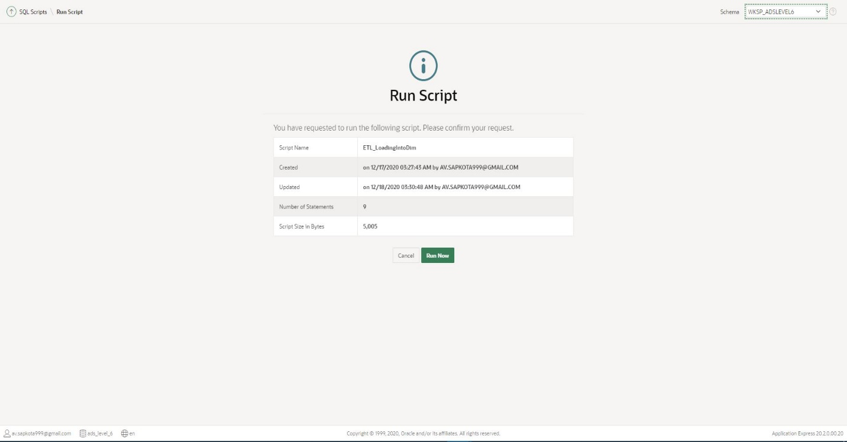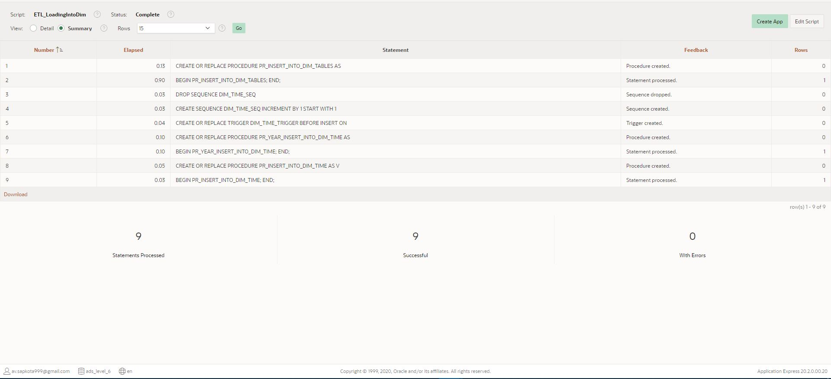

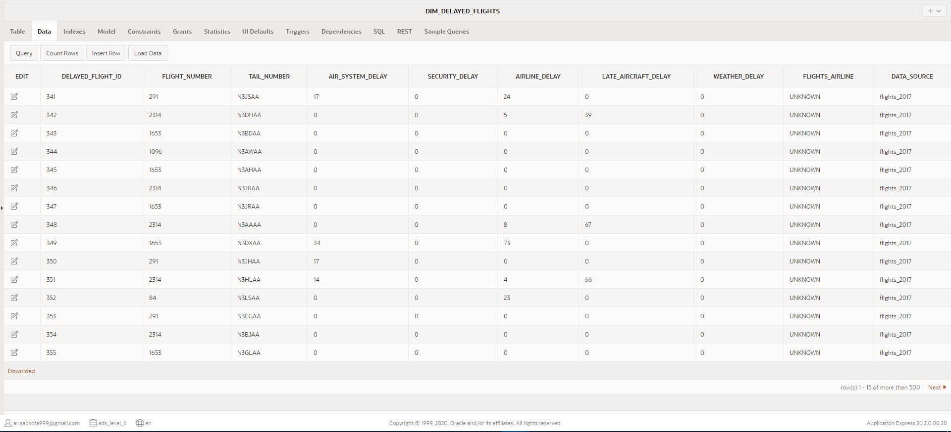

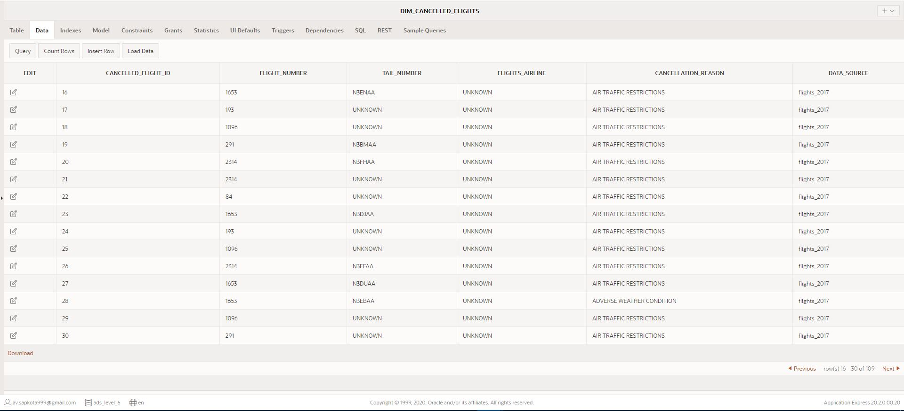

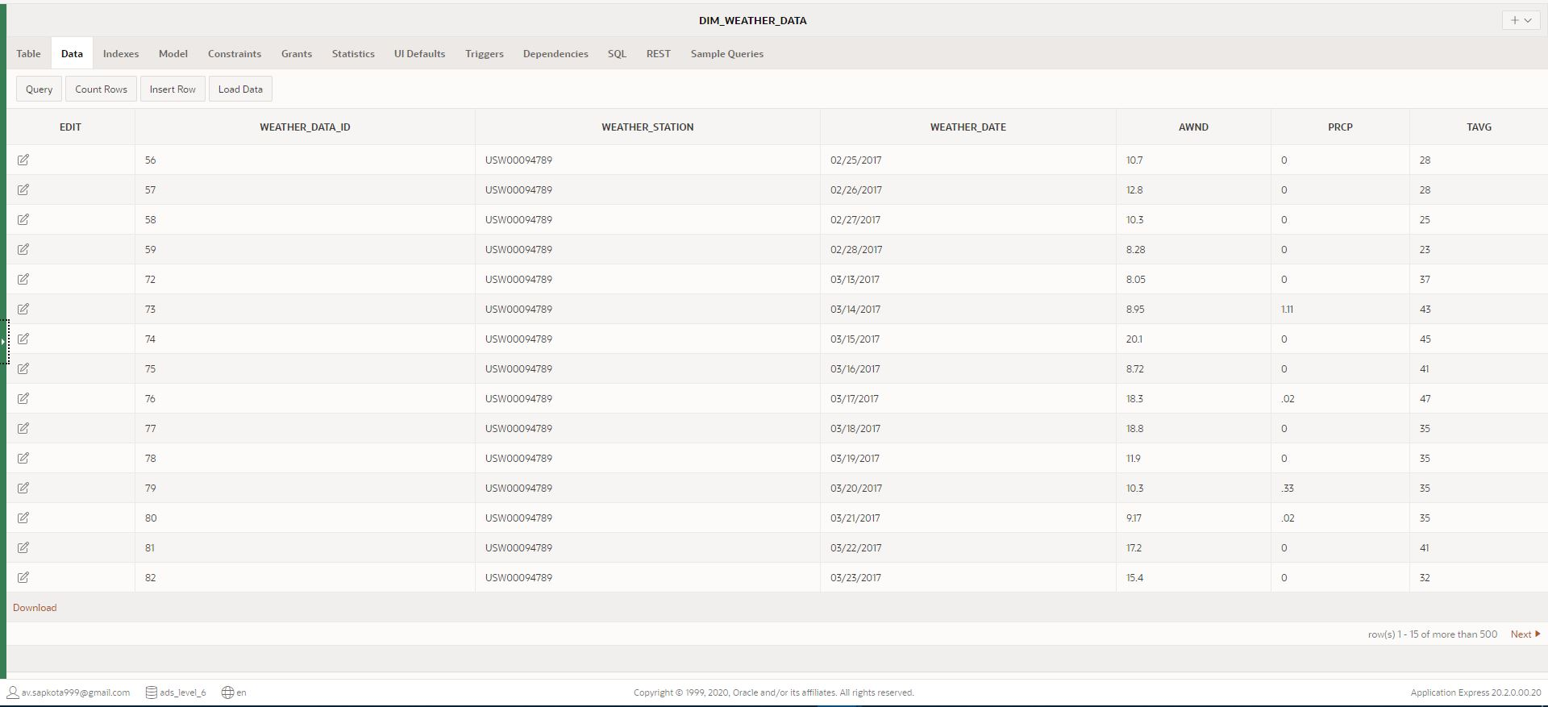

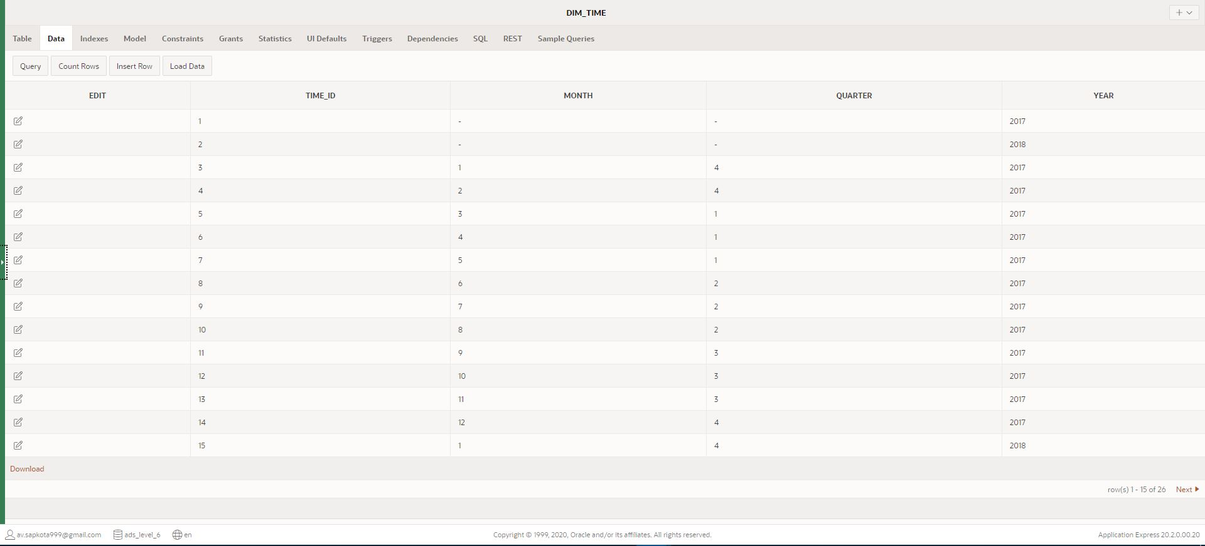

Finally, data for fact table were calculated and were loaded into Fact table using the data and measures from dim tables, using the following code:

N.B. You can also find these codes in a separate file: ‘Task 3 - Loading - Insert data into Fact Table PLSQL’ in the attached folder: ‘SQL Scripts’

---------------------------------------------------------------------------------

---------------------------------------------------------------------------------

-- DROP SEQUENCE FACT_FLIGHTS_SEQ BEFORE CREATION

DROP SEQUENCE FACT_FLIGHTS_SEQ;

-- CREATE SEQUENCE FACT_FLIGHTS_SEQ

CREATE SEQUENCE FACT_FLIGHTS_SEQ INCREMENT BY 1 START WITH 1;

-- CREATE TRIGGER WHICH INCREASES THE VALUE OF PRIMARY KEY EVERY TIME A NEW DATA IS INSERTED.

CREATE OR REPLACE TRIGGER FACT_FLIGHTS_TRIGGER

BEFORE INSERT ON FACT_FLIGHTS

FOR EACH ROW

BEGIN

    :new.surrogate_flight_id := FACT_FLIGHTS_SEQ.NEXTVAL;

END;

/

-- CREATE PROCEDURE TO INSERT DATA INTO FACT_FLIGHTS

CREATE OR REPLACE PROCEDURE PR_INSERT_INTO_FACT_FLIGHTS

AS

    V_ARRIVALDELAY NUMBER;

    V_YEAR NUMBER;

    V_MONTH NUMBER;

    V_DAY NUMBER;

    V_TIMEID NUMBER;

    V_WEATHERID NUMBER;

    CURSOR CR_DELAYED_FLIGHTS IS SELECT * FROM DIM_DELAYED_FLIGHTS ORDER BY DELAYED_FLIGHT_ID;

    CURSOR CR_CANCELLED_FLIGHTS IS SELECT * FROM DIM_CANCELLED_FLIGHTS ORDER BY CANCELLED_FLIGHT_ID;

    CURSOR CR_DIM_TIME IS SELECT * FROM DIM_TIME ORDER BY TIME_ID;

    CURSOR CR_WEATHER_DATA IS SELECT * FROM DIM_WEATHER_DATA ORDER BY WEATHER_DATA_ID;

BEGIN

-- CALCULATES MEASURES, IDENTIFIES FOREIGN KEYS AND INSERTS DATA FROM DIM_DELAYED_FLIGHTS

    FOR CDF IN CR_DELAYED_FLIGHTS LOOP

        V_ARRIVALDELAY := CDF.AIR_SYSTEM_DELAY + CDF.SECURITY_DELAY + CDF.AIRLINE_DELAY + CDF.LATE_AIRCRAFT_DELAY + CDF.WEATHER_DELAY;

        IF CDF.DATA_SOURCE = 'flights_2017' THEN

            V_YEAR := 2017;

            SELECT TIME_ID INTO V_TIMEID FROM DIM_TIME WHERE YEAR=V_YEAR AND MONTH IS NULL;

            INSERT INTO FACT_FLIGHTS (FLIGHT_SERIAL_NO, CANCELLATION_FLAG, ARRIVAL_DELAY, WEATHER_DELAY, FK1_DELAYED_FLIGHT_ID, FK3_TIME_ID)

                VALUES (CDF.FLIGHT_NUMBER, 0, V_ARRIVALDELAY, CDF.WEATHER_DELAY, CDF.DELAYED_FLIGHT_ID, V_TIMEID);

        ELSE

-- IDENTIFIES YEAR, MONTH AND DAY TO FIND FOREIGN KEY FOR TIME

            FOR I IN (SELECT YEAR, MONTH, DAY FROM FLIGHTS_2018

                WHERE FLIGHT_NUMBER = CDF.FLIGHT_NUMBER AND

                TAIL_NUMBER = CDF.TAIL_NUMBER AND

                ARRIVAL_DELAY = V_ARRIVALDELAY) LOOP

                V_YEAR := I.YEAR;

                V_MONTH := I.MONTH;

                V_DAY := I.DAY;

                SELECT TIME_ID INTO V_TIMEID FROM DIM_TIME WHERE YEAR=V_YEAR AND MONTH=V_MONTH;

         -- IDENTIFIES WEATHER_ID FROM WEATHER DATA ON THE BASIS OF DATE AND TIME

                SELECT WEATHER_DATA_ID INTO V_WEATHERID FROM TRANSFORM_WEATHER_DATA WHERE EXTRACT(YEAR FROM WEATHER_DATE)=V_YEAR

                            AND EXTRACT(MONTH FROM WEATHER_DATE)=V_MONTH AND EXTRACT(DAY FROM WEATHER_DATE)=V_DAY;

-- INSERTS ALL IDENTIFIED DATA, MEASURES, AND FOREIGN KEYS TO FACT TABLE FROM DIM DELAYED FLIGHTS

                INSERT INTO FACT_FLIGHTS (FLIGHT_SERIAL_NO, CANCELLATION_FLAG, ARRIVAL_DELAY, WEATHER_DELAY, FK1_DELAYED_FLIGHT_ID, FK3_TIME_ID, FK4_WEATHER_DATA_ID)

                VALUES (CDF.FLIGHT_NUMBER, 0, V_ARRIVALDELAY, CDF.WEATHER_DELAY, CDF.DELAYED_FLIGHT_ID, V_TIMEID, V_WEATHERID);

            END LOOP;

        END IF;

        V_ARRIVALDELAY := '';

        V_YEAR := '';

        V_MONTH := '';

        V_DAY := '';

        V_TIMEID := '';

        V_WEATHERID := '';

    END LOOP;

-- CALCULATES MEASURES, IDENTIFIES FOREIGN KEYS AND INSERTS DATA FROM DIM_CANCELLED_FLIGHTS

    FOR CCF IN CR_CANCELLED_FLIGHTS LOOP

        IF CCF.DATA_SOURCE = 'flights_2017' THEN

            V_YEAR := 2017;

            SELECT TIME_ID INTO V_TIMEID FROM DIM_TIME WHERE YEAR=V_YEAR AND MONTH IS NULL;

            INSERT INTO FACT_FLIGHTS (FLIGHT_SERIAL_NO, CANCELLATION_FLAG, ARRIVAL_DELAY, WEATHER_DELAY,  FK2_CANCELLED_FLIGHT_ID, FK3_TIME_ID)

            VALUES (CCF.FLIGHT_NUMBER, 1, 0, 0, CCF.CANCELLED_FLIGHT_ID, V_TIMEID);

        ELSIF CCF.DATA_SOURCE = 'flights_2018' THEN

-- IDENTIFIES YEAR, MONTH AND DAY TO FIND FOREIGN KEY FOR TIME

            FOR I IN (SELECT YEAR, MONTH, DAY FROM FLIGHTS_2018

                WHERE FLIGHT_NUMBER = CCF.FLIGHT_NUMBER AND

                TAIL_NUMBER = CCF.TAIL_NUMBER AND

                CANCELLED=1) LOOP

                V_YEAR := I.YEAR;

                V_MONTH := I.MONTH;

                V_DAY := I.DAY;

                SELECT TIME_ID INTO V_TIMEID FROM DIM_TIME WHERE YEAR=V_YEAR AND MONTH=V_MONTH;

         -- IDENTIFIES WEATHER_ID FROM WEATHER DATA ON THE BASIS OF DATE AND TIME

                SELECT WEATHER_DATA_ID INTO V_WEATHERID FROM TRANSFORM_WEATHER_DATA WHERE EXTRACT(YEAR FROM WEATHER_DATE)=V_YEAR

                            AND EXTRACT(MONTH FROM WEATHER_DATE)=V_MONTH AND EXTRACT(DAY FROM WEATHER_DATE)=V_DAY;

  -- INSERTS ALL IDENTIFIED DATA, MEASURES, AND FOREIGN KEYS TO FACT TABLE FROM DIM CANCELLED FLIGHTS

                INSERT INTO FACT_FLIGHTS (FLIGHT_SERIAL_NO, CANCELLATION_FLAG, ARRIVAL_DELAY, WEATHER_DELAY,  FK2_CANCELLED_FLIGHT_ID, FK3_TIME_ID, FK4_WEATHER_DATA_ID)

                VALUES (CCF.FLIGHT_NUMBER, 1, 0, 0, CCF.CANCELLED_FLIGHT_ID, V_TIMEID, V_WEATHERID);

            END LOOP;

        ELSE

-- CALCULATES MEASURES, IDENTIFIES FOREIGN KEYS AND INSERTS DATA FROM FLYU_FLIGHTS

           FOR I IN (SELECT FLIGHT_THE_YEAR, THE_MONTH, THE_DAY FROM FLYU_FLIGHTS

                WHERE FLIGHT_NUMBER = CCF.FLIGHT_NUMBER AND

                TAIL_NUMBER = CCF.TAIL_NUMBER AND

                CANCELLED=1) LOOP

                V_YEAR := I.FLIGHT_THE_YEAR;

                V_MONTH := I.THE_MONTH;

                V_DAY := I.THE_DAY;

                SELECT TIME_ID INTO V_TIMEID FROM DIM_TIME WHERE YEAR=V_YEAR AND MONTH=V_MONTH;

-- IDENTIFIES WEATHER_ID FROM WEATHER DATA ON THE BASIS OF DATE AND TIME

                SELECT WEATHER_DATA_ID INTO V_WEATHERID FROM TRANSFORM_WEATHER_DATA WHERE EXTRACT(YEAR FROM WEATHER_DATE)=V_YEAR

                            AND EXTRACT(MONTH FROM WEATHER_DATE)=V_MONTH AND EXTRACT(DAY FROM WEATHER_DATE)=V_DAY;

-- INSERTS ALL IDENTIFIED DATA, MEASURES, AND FOREIGN KEYS TO FACT TABLE

                INSERT INTO FACT_FLIGHTS (FLIGHT_SERIAL_NO, CANCELLATION_FLAG, ARRIVAL_DELAY, WEATHER_DELAY, FK2_CANCELLED_FLIGHT_ID, FK3_TIME_ID, FK4_WEATHER_DATA_ID)

                VALUES (CCF.FLIGHT_NUMBER, 1, 0, 0, CCF.CANCELLED_FLIGHT_ID, V_TIMEID, V_WEATHERID);

            END LOOP;

        END IF;

        V_ARRIVALDELAY := '';

        V_YEAR := '';

        V_MONTH := '';

        V_DAY := '';

        V_TIMEID := '';

        V_WEATHERID := '';

    END LOOP;

END;

/

-- EXECUTE PROCEDURE PR_INSERT_INTO_FACT_FLIGHTS

BEGIN

    PR_INSERT_INTO_FACT_FLIGHTS;

END;

/

----------------------------------------------------------------------------------

---------------------- END OF INSERT DATA INTO FACT TABLE ------------------------

----------------------------------------------------------------------------------

Screenshots: Script Run, report and Fact table with loaded data

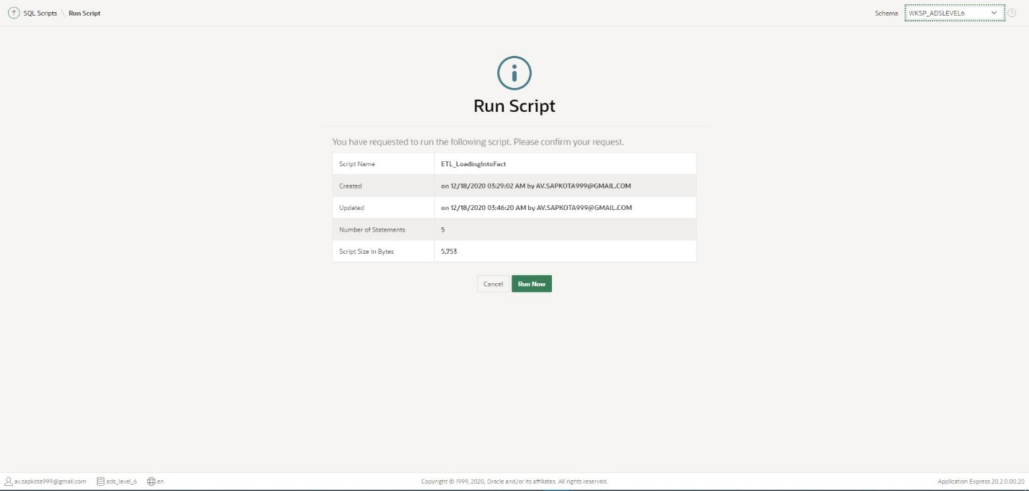

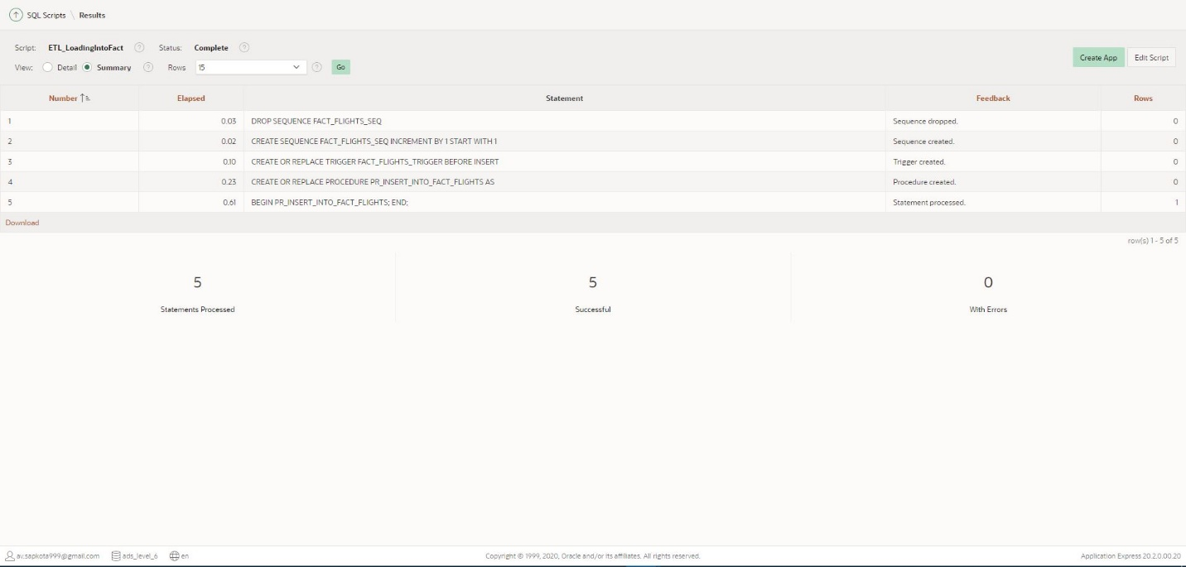

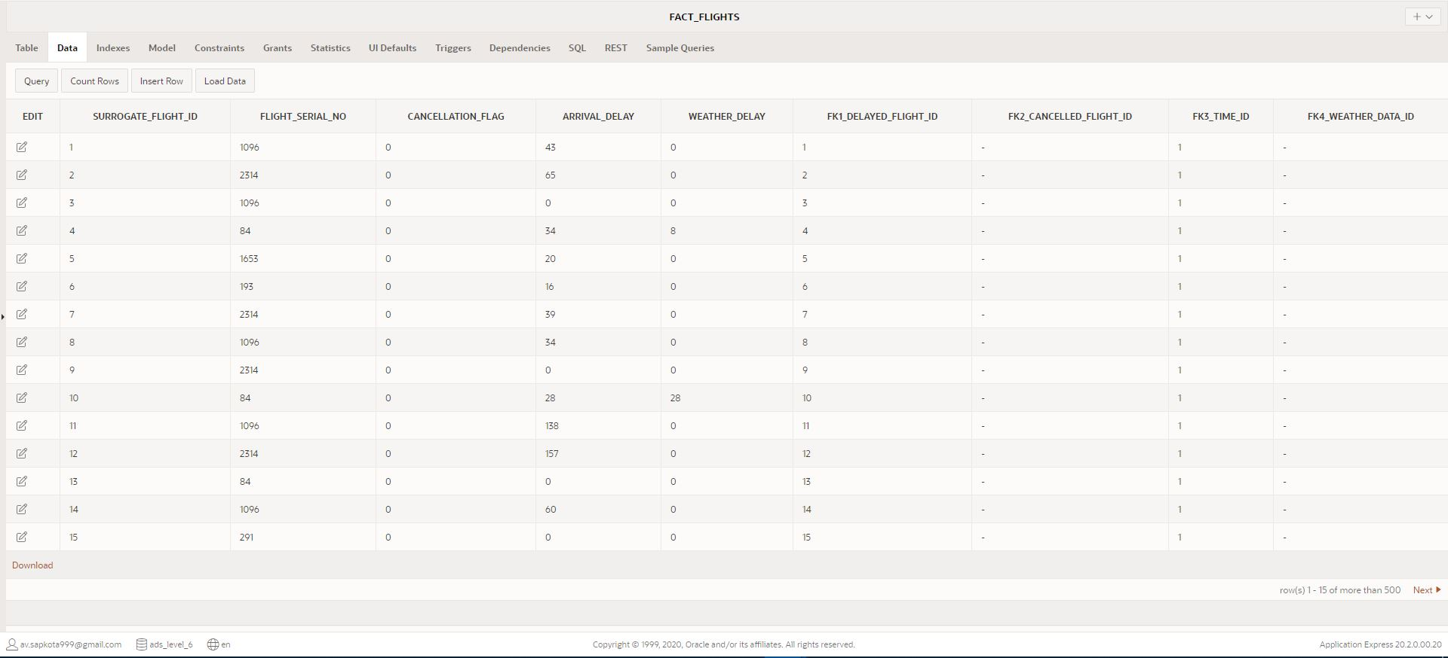

# Task 4: Data Analysis/OLAP/Mining Investigation

## Data Analysis

Data analysis is a process of extracting, transforming, and demonstrating raw data and mining them to produce required and meaningful information which are relevant to business objectives. The primary purpose of data analysis is to extract useful information from data which will help making decisions in the future. Data analysis and data warehouse comes hand in hand as data warehouse designs and manages data into one database which can be analyzed to produce meaning results further supporting Business Intelligence. Data analysis is being used by everyone around who are good at decision making. For instance, the process of thinking what we did in the past to make decisions being based on the past actions is a data analysis in general terms. However, data analysis is a broad topic and which has various methods which are based on qualitative and quantitative data analysis. Furthermore, there are several phases that occur simultaneously in data analysis which includes: Data requirement specification, data collection, data processing, data cleaning, data analysis and communication (Tutorialspoint, 2020)

## Business Intelligence

Business Intelligence is a process of analyzing data to make business decision. It is a similar term as data analysis however data analysis is about extracting the data whereas business intelligence is the decision-making phase. Business Intelligence is a suite of software and services which transforms data into visual data organization formats. It supports and performs data analysis and create reports, charts, maps, graphs, and dashboards with detail information which supports decision making and strategic planning to increase revenue, improve operational efficiency and growth of the company. Some benefits of business intelligence include speed and improved decision-making, increased productivity, identify evolving market tendencies, develop business techniques, etc. (Tutorialspoint, 2020).

## Online Analytical Processing (OLAP)

Online Analytical Processing (OLAP) is a database software which allows users to extract, and analyze data and information from multiple databases. It supports 3-dimensional data warehousing. In general, the information and data loaded into OLAP system are extracted from Online Transaction Processing (OLTP) systems. Data warehousing comes under OLAP where data from various sources are organized and managed in such a way that reports and other visual representation of data is easy to produce and generate. There are four basic analytical operations in OLAP which includes Roll-up, Drill-down, slice and dice and pivot. Some advantages of OLAP systems are:

* It is a database platform for business planning, analysis, reporting and financing.
* It makes Information gathering and calculation consistent.
* It provides basic infrastructures for business modelling, data analysis, mining and business intelligence (Guru99, 2020).

## Tableau: Reports, Charts and Dashboards

Tableau Data Source has been imported from the data warehouse created after ETL process and the fact was uploaded into the data source of tableau. In addition, all the dim tables were uploaded into the tableau as a connection of fact flights. The connection of each dim table with fact flight was made possible because of the foreign keys from dim tables into the fact table.

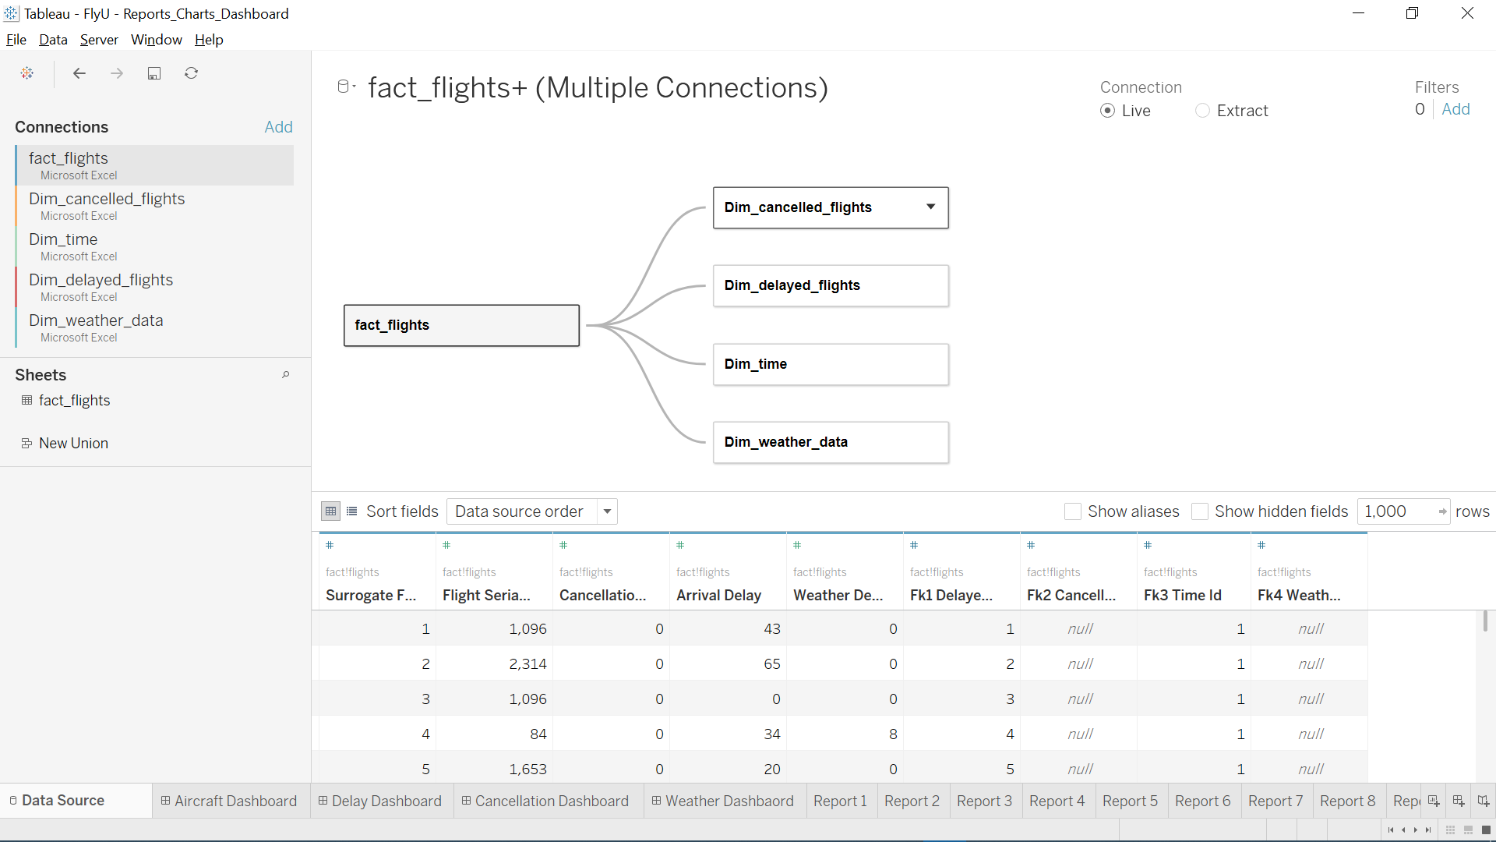

Henceforth, the facts and dimensions loaded into tableau were analysed to produce reports identified in task 1 of the assignment has been produced using pivot function and data visualization tools of the ‘Tableau’ software.

N.B. All the reports pasted in the document have been separately attached in a folder: ‘Report’ which contains excel sheet reports and tableau file containing all reports and dashboards designed for FlyU airlines company.

**Report 1: Total number of flights cancelled on the basis of cancellation reasons.**

The report below shows distinct cancellation reason due to which flights were cancelled on the horizontal pane and the total number of flights cancelled on the vertical pane. This report can perhaps be useful in order to identify the cancellation reason due to which most of the flights have been cancelled. For instance, on the basis of the report presented above, most of the flights of FlyU airline company were cancelled due to air traffic restrictions, adverse weather condition and air system or mechanical issues in decreasing order. Thus, FlyU airline company can plan their flights, for future, in such time interval when the total number of flights to take off is low. Similarly, they can be aware about the weather condition and predictions before they place a flight for booking. Finally, they may as well repair every aircraft or replace the damaged aircraft before booking a new flight in the future which will eventually reduce the number of cancelled flights hence the quality of service of FlyU company will perhaps improve.

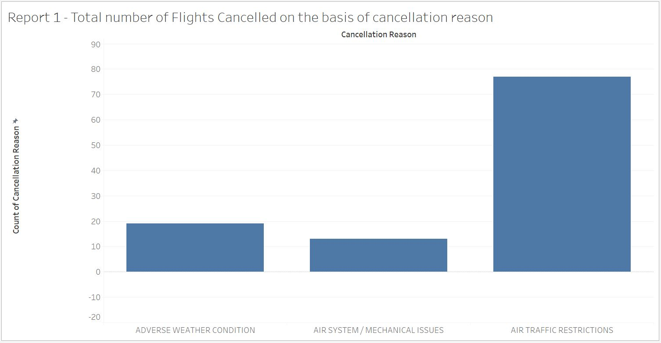

**Report 2: List of airlines whose flights were delayed, in the year 2018, along with total delayed time**

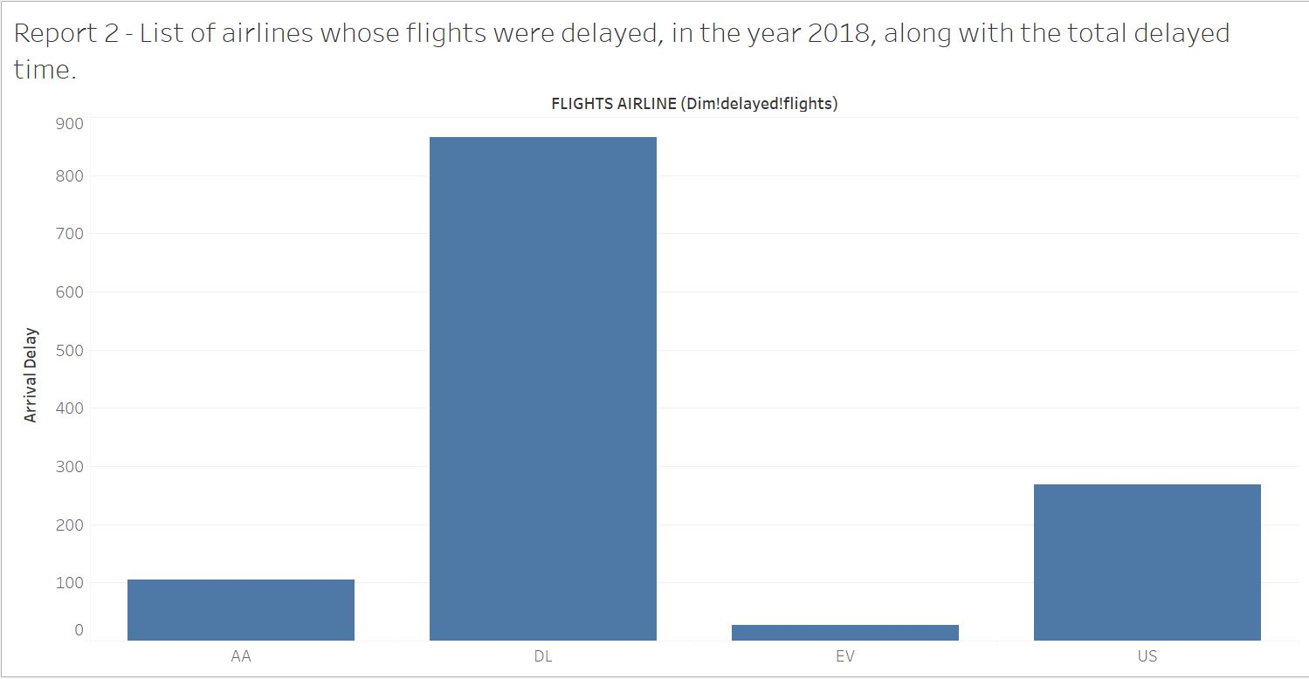

The report above demonstrates total minutes delayed for arrival on the vertical pane and list of distinct airline companies on the horizontal pane. It is basically total arrival delay of each airline company. The report can be used to identify the airline company’s whose flights are being delayed for more minutes. Hence, for instance, FlyU airline company can report and complain the associate airline companies in order to decrease the total arrival delay time which will eventually uplift the quality of service delivered by FlyU.

**Report 3: List of top 10 aircraft delayed due to air system delay including their delayed time**

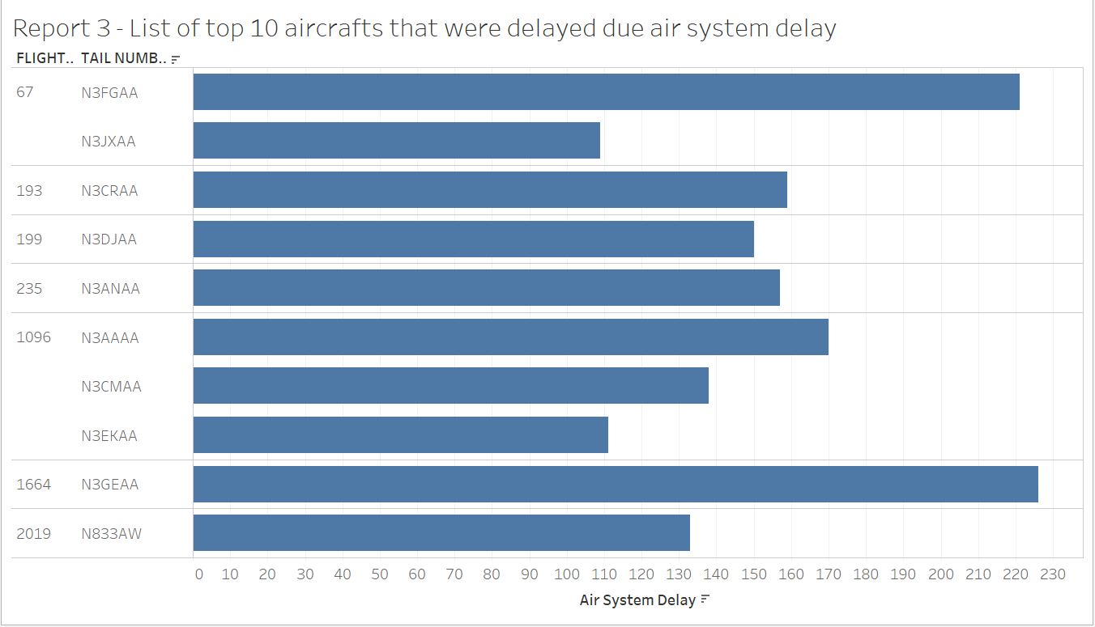

The report above represents the list of aircrafts’ tail number along with the flight number on the vertical pane and total minutes each flight and aircraft were delayed due to air system delay on the horizontal pane. The report above can be used to analyse the aircraft’s condition. For example, this is the list of top 10 aircraft delayed due to air system delay. Air system delay basically refers to the delay cause due to some mechanical issues on the aircraft. Hence FlyU can identify the top 10 aircraft which are problematic hence they can discard the aircraft in the future until it is completely issue free or can add on a new aircraft rather than using an old problematic aircraft.

**Report 4: Total arrival delay time for each month in the year 2018**

The report below portrays months of the year 2018 on the horizontal pane and total sum of arrival delay on the vertical pane. The data below can be analysed to find out the total minutes delayed in each month which can further be analysed with other data to make decisions on monthly basis. For instance, FlyU airline company can analyse the data below to plan the number of flights to take off every month as delay are high during first 5 months of the year whereas low during the second half of the year. Thus, they can book more flights for the second half of the year which will ensure increase revenue along with quality service.

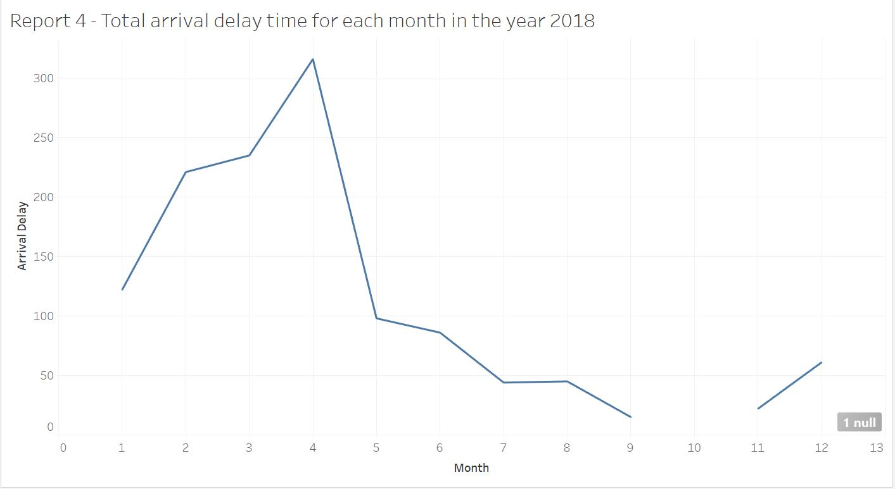

**Report 5: List of average PRCP, average AWND, average TAVG of weather data on the basis of quarter of the year**

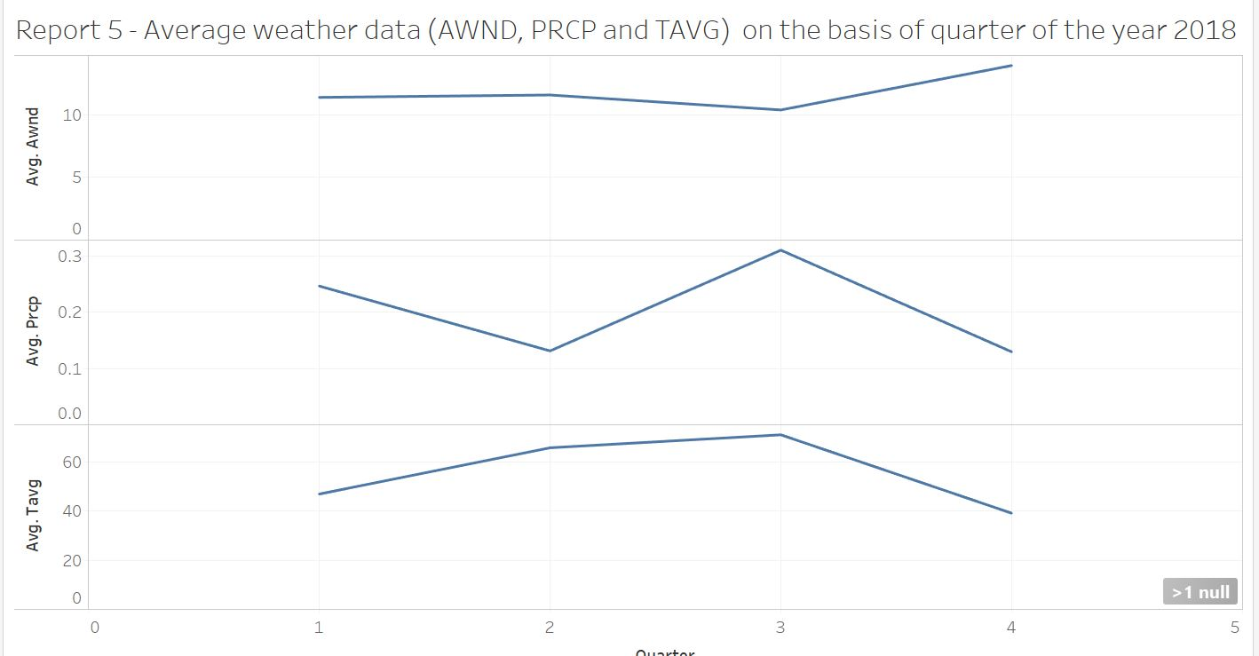

The report above represents average TAVG, average PRCP and average AWND, which are weather reports, on the vertical pane and quarter on the basis of seasons (fall, spring, autumn, and summer). The weather report above can be used to predict the weather. For instance, FlyU can book less flights when average TAVG, AWND and PRCP is high as the adverse weather can affect (delay or cancel) the flights which will decrease the number of delayed or cancelled flights ensuring the improved quality of service.

In addition to the reports identified on the task 1 on the basis of segregated KPI, some more reports were produced using the data managed and maintained in the data warehouse which would further help FlyU airline company to plan sustainable strategies and make profitable decisions. Therefore, the reports presented below were produced using the data warehouse designed and populated in the previous tasks however they can benefit the company on various basis to ensure quality service, customer satisfaction and also help to make decisions which will gradually grow the company.

**Report 6: Total number of flights delayed in every month of the year 2018.**

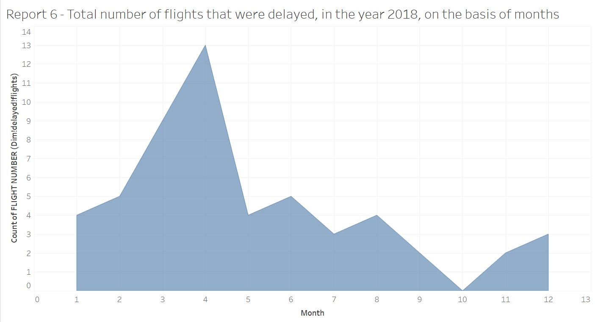

**Report 7: Top 5 aircraft that were cancelled along with the number of times they were cancelled.**

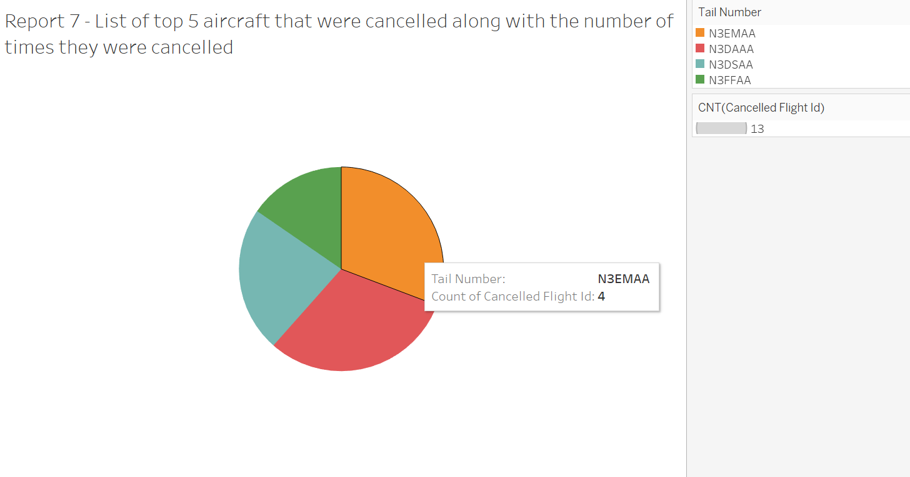

**Report 8: List of aircraft, on the basis of flight number, which was delayed due to weather condition along with the total delayed time in minutes.**

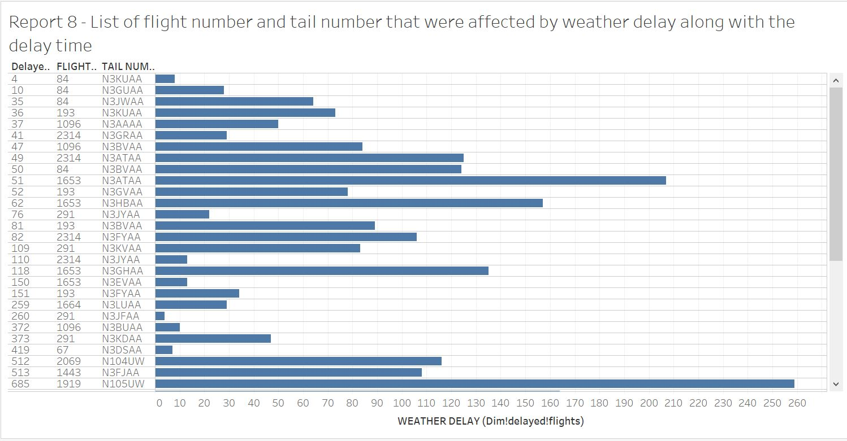

**Report 9: List of 10 aircraft whose flights were delayed on the basis of total minutes delayed for each aircraft.**

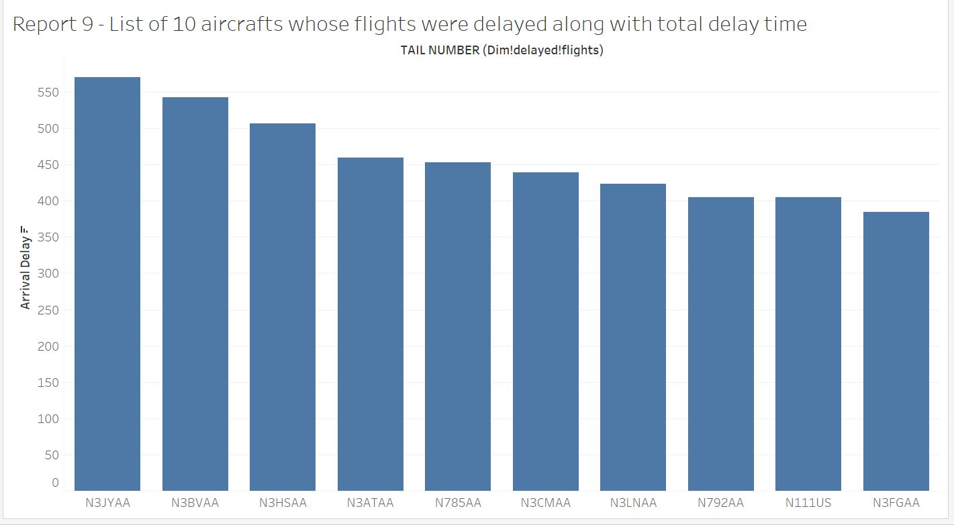

**Report 10: Average weather data on the basis of month of the year 2018**

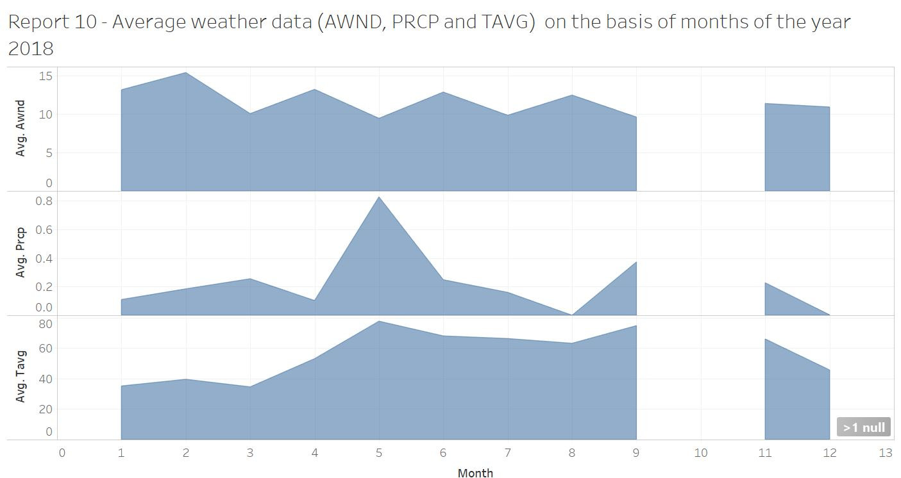

The reports identified and created above are useful and will change dynamically on every data changes. Hence, dashboards have been created which groups different reports on some condition or data which will make data analysis easier and more convenient for FlyU airline company.

**Aircraft Dashboard**

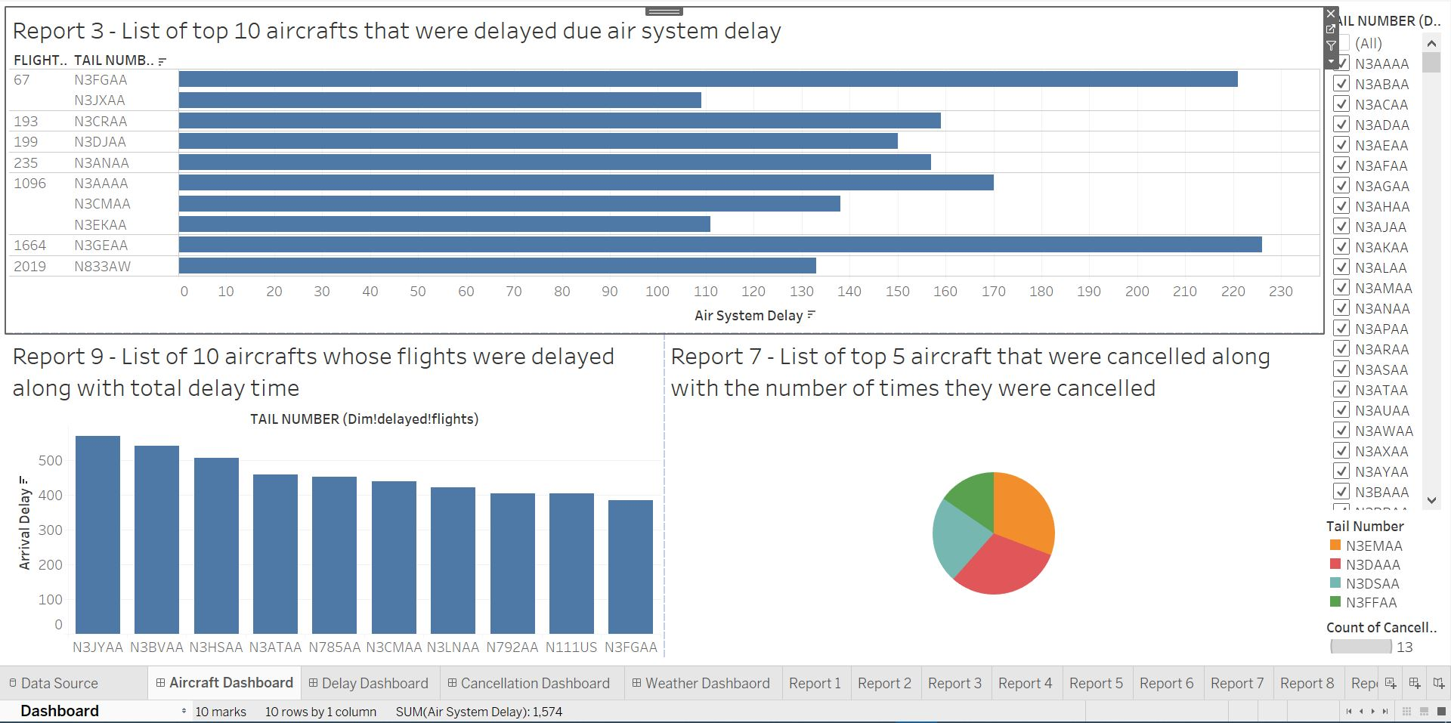

The aircraft dashboard shows the reports which are relevant to aircraft details, thus in order to analyze the data related to aircraft FlyU can directly browse the dashboard rather than viewing reports separately.

**Delay Dashboard**

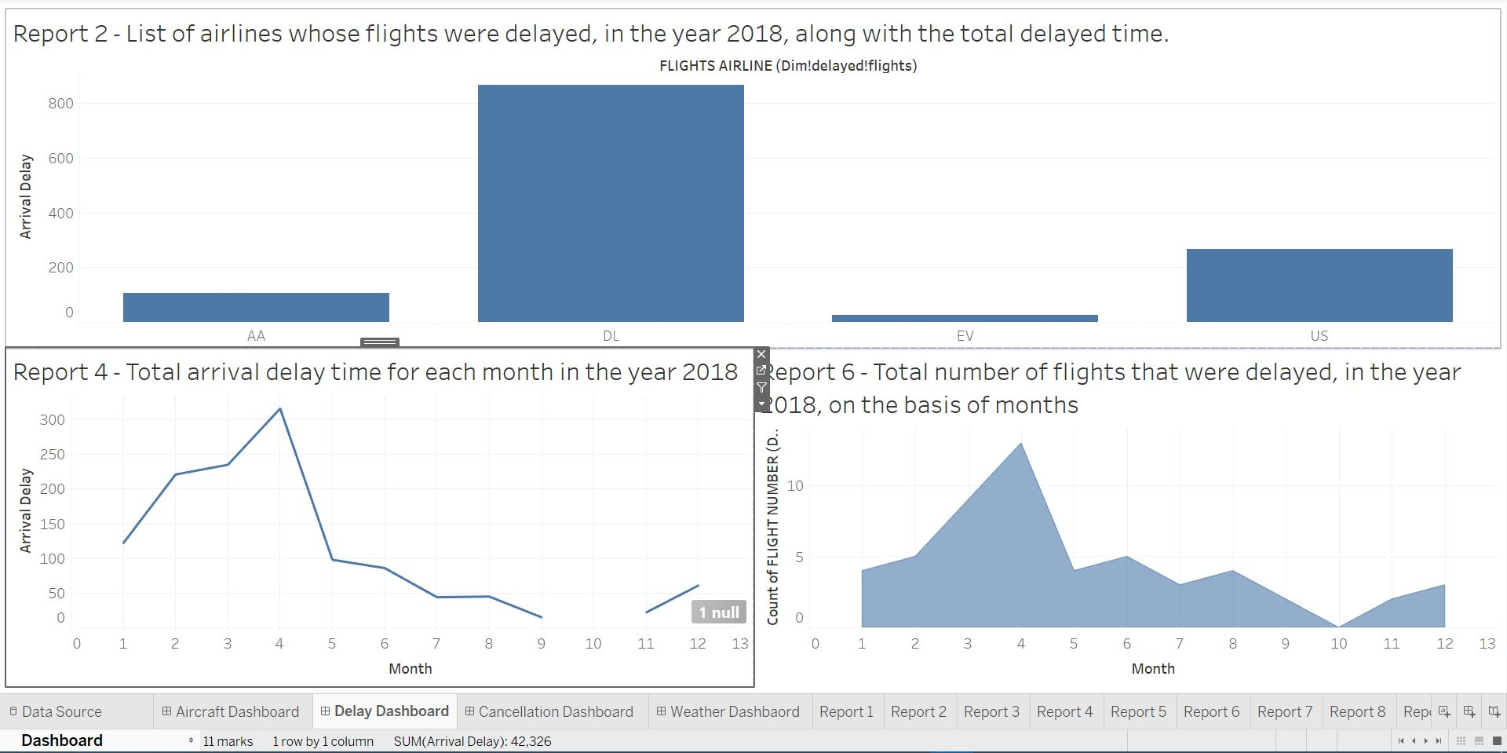

The delay dashboard shows all the reports related to flight delays. Therefore, FlyU can open the dashboard to view multiple reports at once to analyse delayed data.

**Cancellation Dashboard**

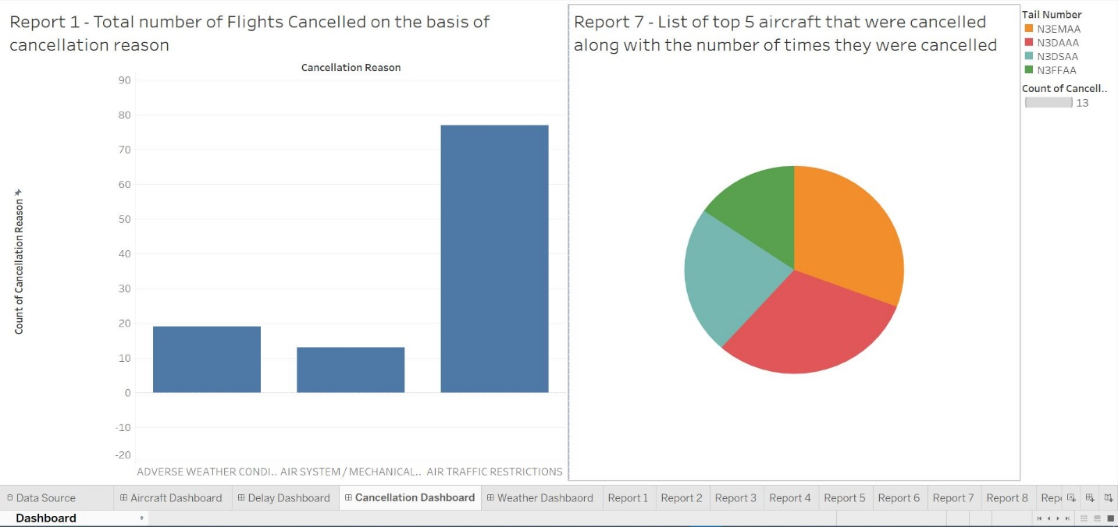

Similarly, the cancellation dashboard shows all the report and chart which are relevant to flight cancellation.

**Weather Dashboard**

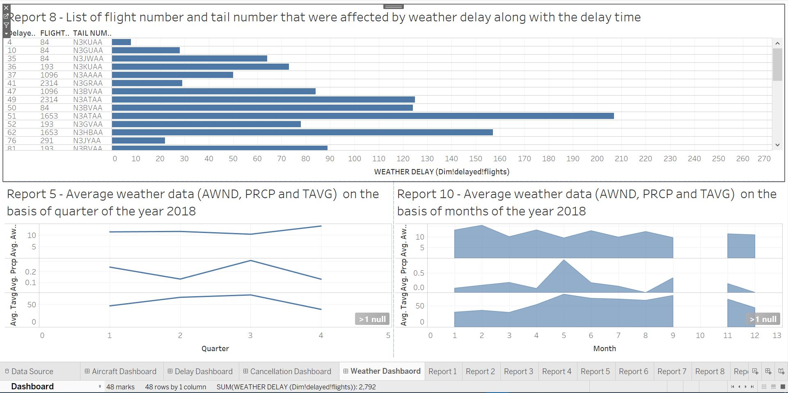

Finally, the weather dashboard shows all the data related to weather and flights which will help the company to analyse flights affected due to weather conditions in the past.

## Additional Excel Sheet Reports

Furthermore, although complaint data was not used in the data warehouse, it can also be used for data analysis. Hence, some more reports were generated using complaint data and other raw data provided by FlyU airline company using excel sheets and pivot table and data visualization functions of MS Excel.

**Excel Report 1: Total sum of compensation amount paid per month.**

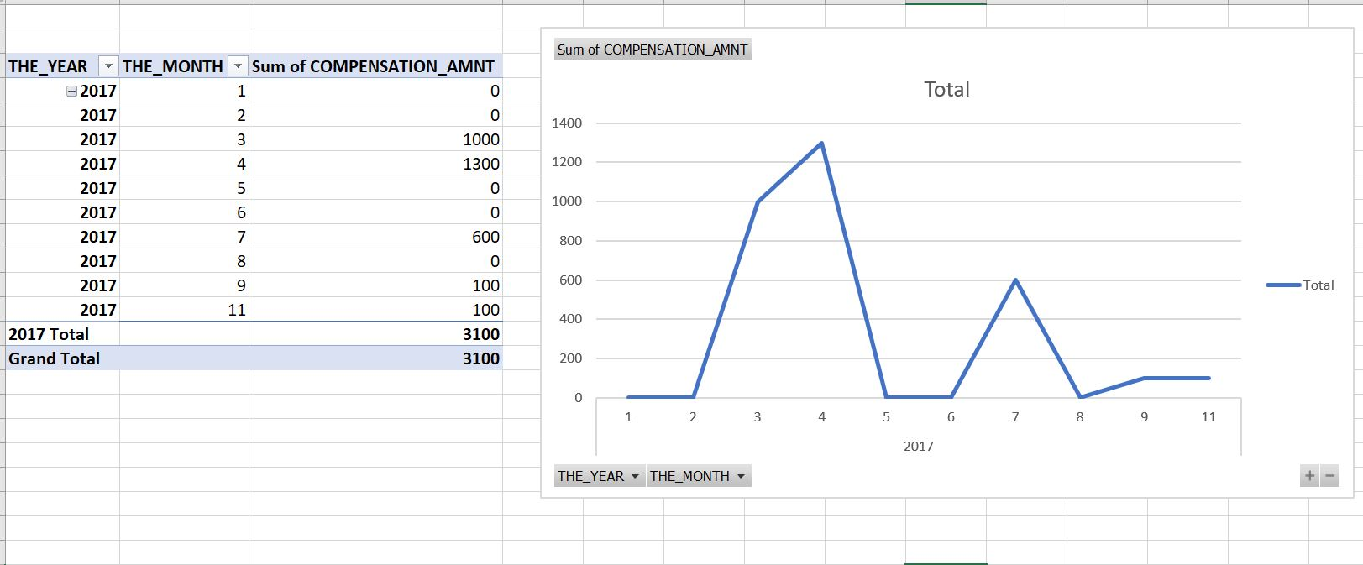

**Excel Report 2: Total number of complaints reported per month.**

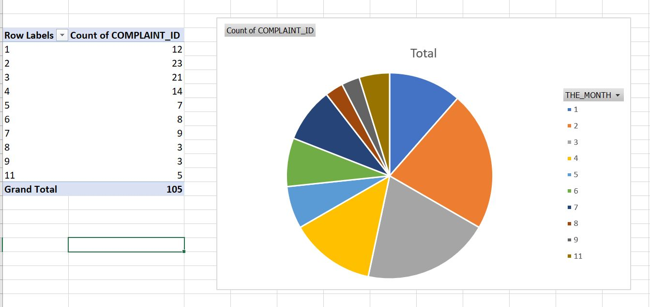

**Excel Report 3: Delay reasons along with total delay time per month.**

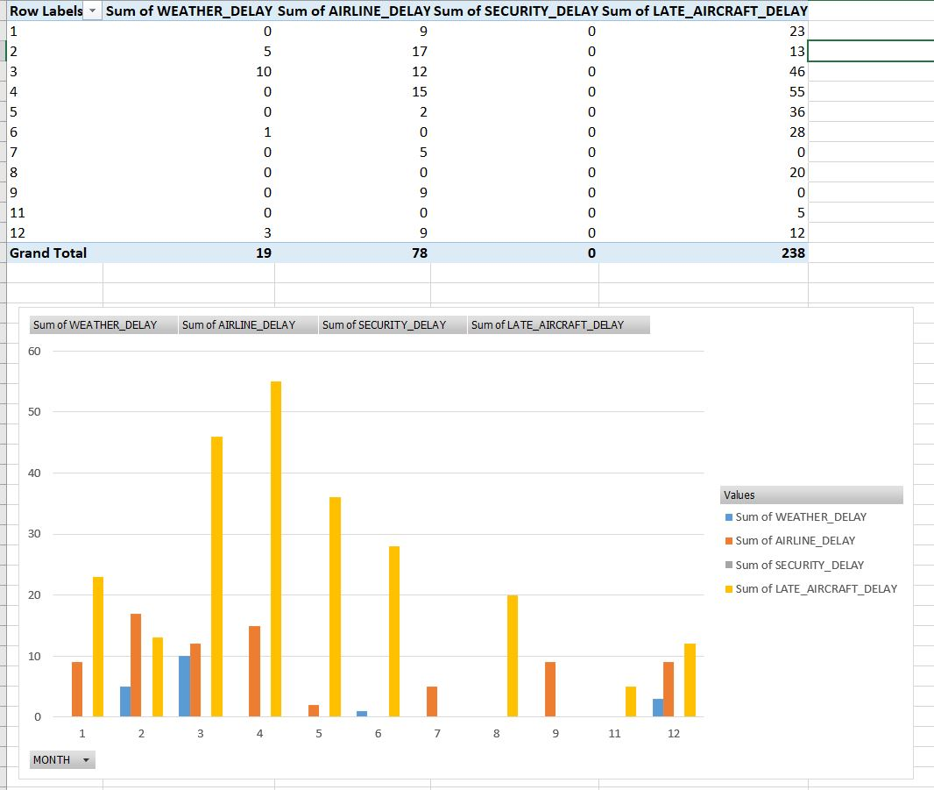

Finally, some more drilled down reports were produced, within the excel itself, in order to analyze multiple data fields at once from the size table which will make the data representation more convenient as multiple columns of data can be view on a same platform.

## Drilled Down Reports

**Sum of arrival delay with respect to airline, flight number and tail number.**

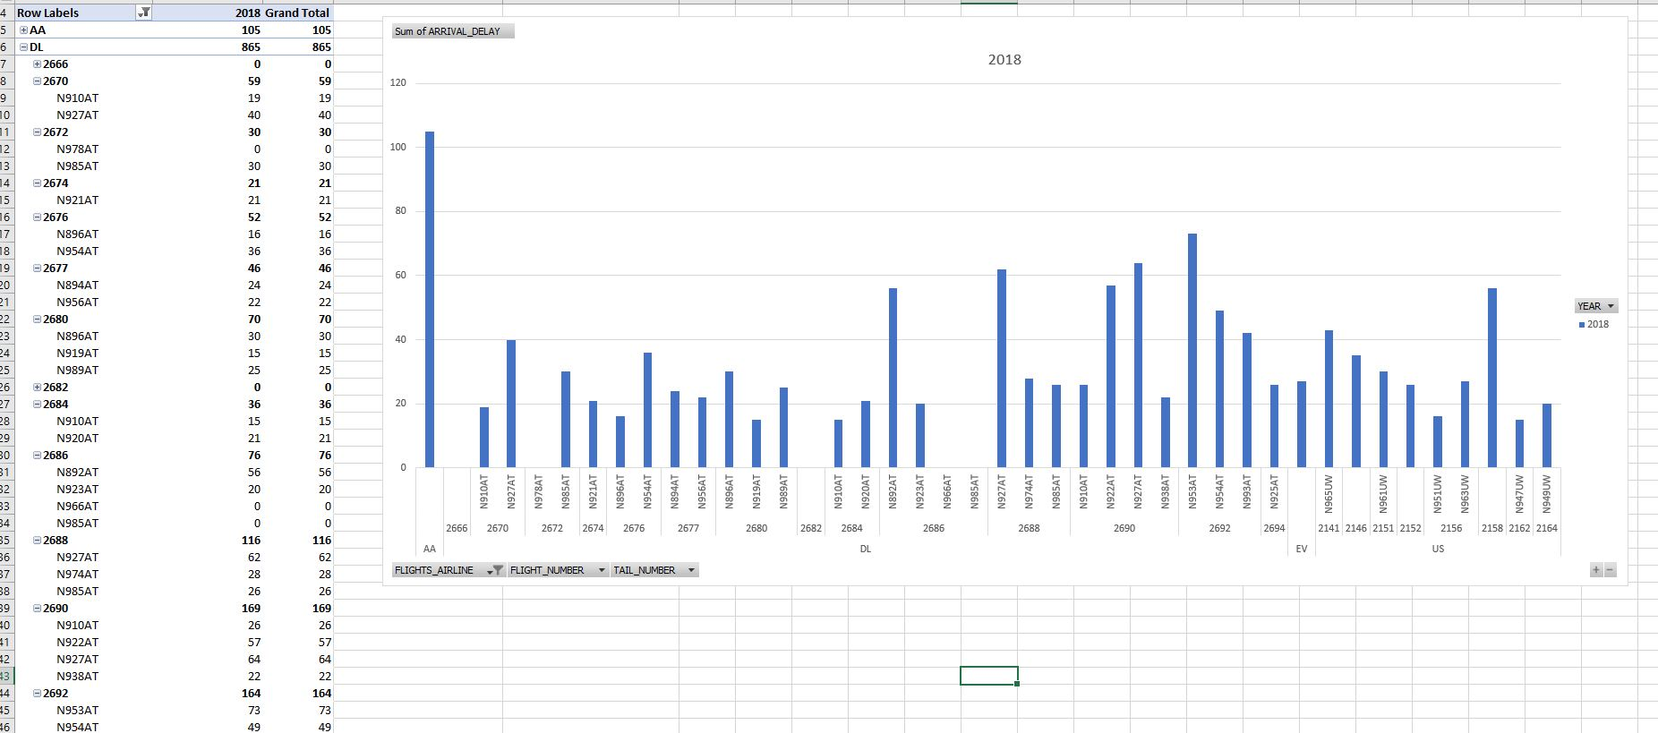

**Drilled Down Report: Sum of compensation amount with respect to month and complaint type.**

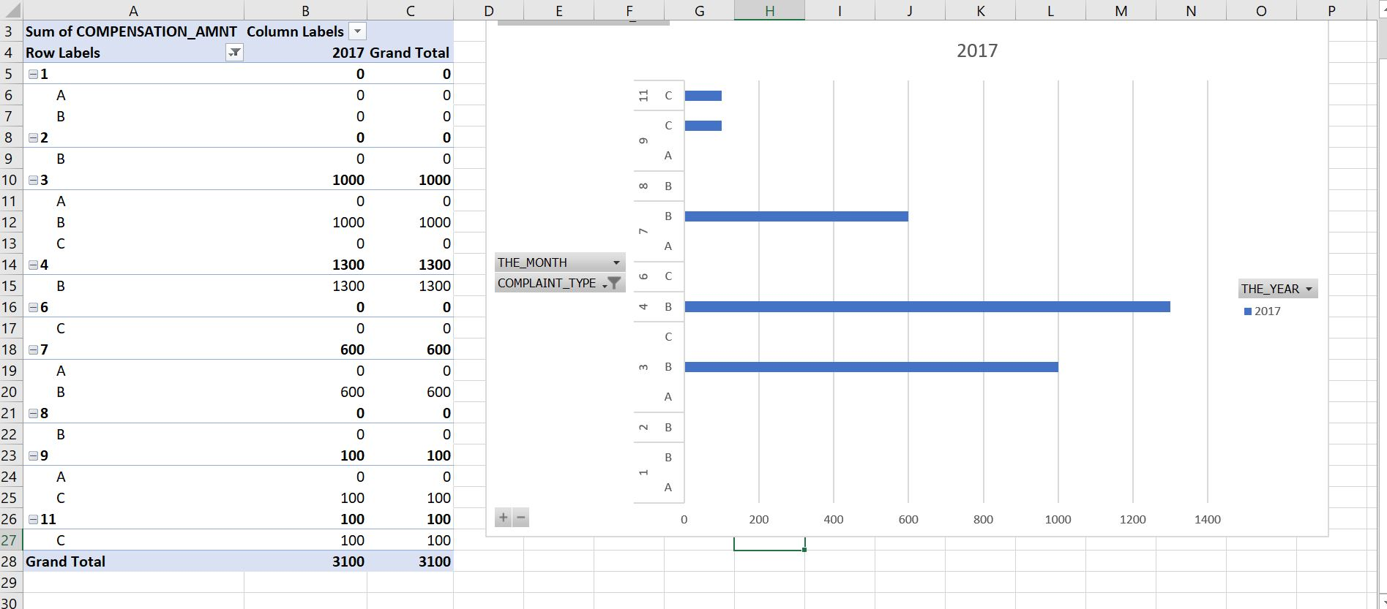

**Drilled Down Report: Sum of air time travelled by each aircraft on the basis of flight number.**

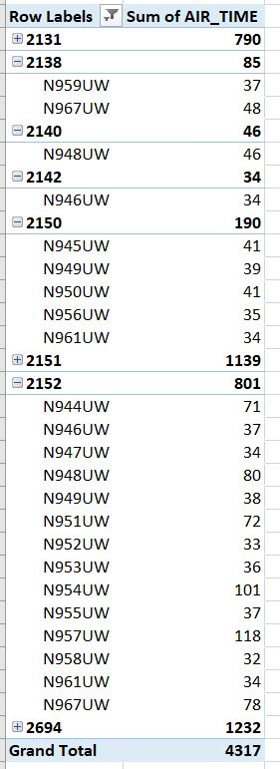

# Task 5

Consider and reflect on data warehousing approaches with respect to FlyU. Draw on the models of Kimball and Inmon in considering solutions for supporting an enterprise (business) and the business processes and functions.

## Introduction

Data warehouse is a relational database management system construct to correlate broad business data from various sources into one comprehensive database which provides insights on businesses. As stated in the first task, the primary purpose of data warehouse is to produce meaningful information which can be used for sustainable business decision making and evaluating future strategies using Business Intelligence, data analytics dashboards and applications. It must be designed in order to support these features. There are two common approaches used to design a data warehouse: top-down approach and bottom-up approach proposed by Bill Inmon and Ralph Kimball respectively. Bill Inmon, the father of data warehousing, defines data warehouse as a collection of integrated, subject-oriented databases designed to support the DSS function, where each unit of data is non-volatile and relevant. In Inmon’s approach a normalized data model is designed then the dimensional data marts, which contains data required for business processes, are created from within the data warehouse. In contrast, Ralph Kimball’s introduced the bottom-up approach where the data identified first, which are further correlated to develop a data warehouse (Computerweekly, 2020)

The FlyU airline company, case study presented as assignment, is concerned to analyse their data in order to make business decisions which will perhaps enhance the quality of service they deliver, ensure customer satisfaction, and grow the company. FlyU has provided with a number of raw data sets which has the details of flights, customers, weather and complaints. Hence, data warehouse can be used to develop meaningful information which will help FlyU to make decisions to support their business objectives. Thus, FlyU case study can been used in order to reflect on data warehouse approaches proposed by Inmon and Kimball.

## Bill Inmon’s Approach

The top-down approach proposed by Inmon to design a data warehouse, firstly, identifies the main subject area and entities of a business. In case of FlyU the main entities are: complaints, flights, weather_data, cancelled_flights, and successful_flights Secondly, a logical model is created for every primary entity. The approach uses a normalized form of entity structure which results in identifying business requirements without any data duplication. Thirdly, the normalized physical model for the data warehouse is constructed. The physical model in case of FlyU airline company is as follows:



The ERD Model for FlyU airline company presented above supports Inmon’s top-down approach. Firstly, the main entities were identified and their logical table was identified in reference to data provided by FlyU. Finally, the ERD was designed. In the data warehouse architecture above, flights is the main entity which correlates all other tables of the database. The data inside complaints, customer, cancelled_flights, successful_flights, delayed_flights and weather_data will be uploaded in normalized form which will reduce data redundancy. Also, Complaints, cancelled_flights, successful_flights and weather_data have one to many relationship with flights because they are the dimensions which will relate with flights in order to produce reports to support business objectives of FlyU. However, customer has one to many relation with complaints as one customer can report multiple complaints and customer’s details is only required if the data mart complaint is used to produce a report. Finally, delayed_flights has one to one relation with successful_flights as all delayed_flights are successful. In addition, delayed_flight will be used to produce report only if successful_flights is chosen as data mart to support the business determinations. The data warehouse model above supports business objectives of FlyU flights as it can be used to produce reports and charts which will help the FlyU airline company to make decisions which will impact their business.

In Inmon’s approach data in DW is integrated as it works as a unified source. Similarly, the possibility of data duplication is very low which makes the ETL process to be easy and less likely to fail. Also, the approach offers flexibility to update data in case of change of data in the original source. However, complexity to deal with multiple tables increases as time is inserted into each table. The increase in complexity results in more time, thus, it is a little more time consuming. Moreover, additional ETL operation is required since data marts are created after data warehouse. Finally, in order to manage a data warehouse effectively, expertise in data warehousing is necessary (Astera, 2020)

## Ralph Kimball’s Approach

Kimball’s bottom-up approach is initiated with data marts. Firstly, data marts are identified on the basis of business objectives. The data marts identified are documented in a star schema. Star schema is the physical design model where one fact table is identified and surrounded by many other associated dimension tables. The star schema for FlyU airline company has been presented below. Secondly, the data sources provided are evaluated and filtered in accordance to the business objectives and data marts. These data sources are analysed via ETL process where data is uploaded to staging area from various sources. Good data and bad data are identified in the staging area and filtered. Then, good data are inserted into clean table and bad data are inserted into bad table where data are cleaned and finally inserted into clean table. Finally, data is segregated into multiple tables in the transformation phase and all the data from transformation phase are loaded to Data warehouse.



The ERD Model for FlyU airline company presented above supports Kimball’s bottom-up approach. Firstly, the data marts which supports the business objectives are identified in this approach. However, all tables in the data source have been identified as data marts rather than breaking down for different KPI in order to portray the similar number of entities as compared to Inmon’s approach. Fact_flights is the fact table with measures arrival_delay, cancellation, and complaint_status. Likewise, Dim_Customer, Dim_complaints, Dim_cancelled_flights, Dim_delayed_flights, Dim_successful_flights, dim_weather_data and Dim_time are the dimensions to support the fact table. Dim_time is a dimension which will corelate to every other dim tables via fact table. However, updating data is complex and there are possibilities of redundant data in the star schema presented above. The star schema will be referenced to design data warehouse and the ETL process will be initiated before loading all the data into data warehouse. The data warehouse model above supports the business process of FlyU airlines as the data warehouse can produce reports which will determine and show their past reports on complaints, customer, delayed and cancelled flights which will perhaps help them make business decisions to uplift their service quality, customer satisfaction and also help them grow.

The Kimball’s approach to data warehouse is fast and less time consuming as data are not normalized. Also, data retrieval from data warehouse is fast as data is divided into facts and dimensions. Furthermore, it emphases on individual business areas and processes which requires smaller team of designers and developers as query optimization is expectable, straightforward and well-disciplined. In contrast, some data irregularities can occur when data is updated in this approach as data is not normalized. Moreover, it may not support all BI requirements as it focuses on data marts rather than on the entire business processes (Astera, 2020).

## Key Differences between Ralph Kimball’s Approach and Bill Inmon’s Approach

|  |  |  |
| --- | --- | --- |
| PARAMETERS | KIMBALL | INMON |
| Approach | It has Bottom-Up Approach for implementation. | It has Top-Down Approach for implementation. |
| Data Integration | It focuses Individual business areas. | It focuses Enterprise-wide areas. |
| Building Time | It is efficient and takes less time. | It is complex and consumes a lot of time. |
| Cost | It has iterative steps and is cost effective. | Initial cost is huge and development cost is low. |
| Skills Required | It does not need such skills but a generic team will do job. | It needs specialized skills to make work. |
| Data Model | It prefers data to be in De-normalized model. | It prefers data to be in normalized model. |
| Data Store Systems | In this, source systems are highly stable. | In this, source systems have high rate of change. |
| GeeksforGeeks, 2020 | | |

## Conclusion

Data warehouse is the collection of raw business data which can be analyzed to generate meaningful information which will perhaps support decision making and business intelligence. There are two commonly used approaches to design a data warehouse introduced by Bill Inmon and Ralph Kimball. Bill Inmon’s top-down approach identifies normalized entities then dimensional data marts are created using ER Model. This approach features integrated data with low data redundancy, has flexibility to change and update data and can handle wide reporting business ambitions although it is a complex, time consuming and expensive approach. On the other hand, Ralph Kimball’s bottom-up approach firstly identifies data marts which are documented into star schema and loaded into data warehouse only after the ETL process where data are cleaned and divided into facts and dimensions. Kimball’s approach is fast and less time consuming. In addition, data retrieval is easier and the approach is less expensive compared to Inmon’s approach. However, updating data into data warehouse is complex and less flexible and the approach may not support all BI requirements. In conclusion, both the approaches are used widely in designing data warehouse and both have their effectiveness and faultiness. However, to accomplish business objectives of FlyU airlines company Ralph Kimball’s approach has been used in task 1 of the assignment.

Word Count: 1475 approx.

# References

*Data Warehousing Definition & Example | InvestingAnswers* (2020). Available at: https://investinganswers.com/dictionary/d/data-warehousing (Accessed: 7 December 2020).

*Data Mart vs. Data Warehouse* (2020). Available at: https://panoply.io/data-warehouse-guide/data-mart-vs-data-warehouse/ (Accessed: 7 December 2020).

*Tony Alessandra Quote* (2020). Available at: https://www.azquotes.com/quote/773686?ref=quality-service (Accessed: 7 December 2020).

*What is Data Warehouse? Types, Definition & Example* (2020). Available at: https://www.guru99.com/data-warehousing.html (Accessed: 21 December 2020).

*Star and Snowflake Schema in Data Warehouse with Examples* (2020). Available at: https://www.guru99.com/star-snowflake-data-warehousing.html (Accessed: 7 December 2020).

*What Is a Data Dictionary? - DATAVERSITY* (2017). Available at: https://www.dataversity.net/what-is-a-data-dictionary/# (Accessed: 8 December 2020).

*Data Analysis - Process - Tutorialspoint* (2020). Available at: https://www.tutorialspoint.com/excel_data_analysis/data_analysis_process.htm (Accessed: 20 December 2020).

*Data Analysis - Process - Tutorialspoint* (2020). Available at: https://www.tutorialspoint.com/excel_data_analysis/data_analysis_process.htm (Accessed: 20 December 2020).

*What is OLAP? Cube, Operations & Types in Data Warehouse* (2020). Available at: https://www.guru99.com/online-analytical-processing.html#4 (Accessed: 20 December 2020).

*Inmon or Kimball: Which approach is suitable for your data warehouse?* (2020). Available at: https://www.computerweekly.com/tip/Inmon-or-Kimball-Which-approach-is-suitable-for-your-data-warehouse (Accessed: 20 December 2020).

*Data Warehouse Concepts: Kimball vs. Inmon Approach | Astera* (2020). Available at: https://www.astera.com/type/blog/data-warehouse-concepts/ (Accessed: 20 December 2020).

*Difference between Kimball and Inmon - GeeksforGeeks* (2020). Available at: https://www.geeksforgeeks.org/difference-between-kimball-and-inmon/ (Accessed: 21 December 2020).